# Prediction for Academic Performance Level of Graduating Elementary Students

A Thesis Project

Presented to the Faculty of the

School of Computing

Holy Angel University



In Partial Fulfillment

of the Requirements for the Degree

Bachelor of Science in Computer Science

Baltazar, Gabriel Paolo I.

Reyes, Lee Randell C.

Sumang, Pauline Yvonn V.

Yap, Carl Gabriel S.

October 2024

# **APPROVAL SHEET**

This thesis entitled **“Prediction for Academic Performance Level of Graduating Elementary Students”,** prepared and submitted in partial fulfillment of the requirements for the degree Bachelor of Science in Computer Science, has been examined and is recommended for acceptance and oral examination.

________________________________

**Ms. Carisma A. Caro**

Adviser

**ORAL EXAMINATION**

Approved by the committee of oral examiners on

October 3, 2024

_________________________________

**Dr. Mary Jane C. Rabena**

Panel Chair

**_________________________________**

**Dr. Alma Theresa D. Manaloto**

Panel Member

**_________________________________**

**Mr. Enrico Buenafe**

Panel Member

**APPROVAL**

Accepted and approved in partial fulfillment of the requirements for the degree Bachelor of Science in Computer Science.

______________________________

**Ms. Ma. Louella M. Salenga**

Program Chairperson

Computer Science

______________________________

**Dr. Marlon I. Tayag**

Dean, School of Computing

# **Acknowledgment**

The research team extends its sincere gratitude to all those who generously supported the successful completion of this research.

The team acknowledges the divine guidance and strength that enabled us to persevere throughout this research endeavor. Without Him, the team would not have been able to complete their thesis.

The team is deeply indebted to their thesis adviser, Ms. Carisma Caro, for her unwavering guidance, patience, and encouragement. Her support, particularly during times of stress and uncertainty, was invaluable.

The team is grateful to the teachers at San Pedro Elementary School (SPES) for their mentorship and collaboration. Their support was essential to the successful completion of the research.

The team offers special thanks to the experts, Mr. Arian Yambao and Mr. Josh Delarosa, for their valuable advice and unwavering patience. Their commitment to providing feedback and guidance, particularly on the development of our website application, is greatly appreciated.

*Laus De Semper!*

# **Table of Contents**

Page

Cover Page i

Approval Sheet ii

Acknowledgment iii

Table of Contents iv

List of Figures v

List of Tables v

**Title Page** 1

**Abstract** 2

**Introduction** 3

Review of Related Literature and Studies 7

Conceptual Framework 16

Objectives of the Study 17

Scope of the Study 18

Delimitations of the Study 19

Significance of the Study 20

**Methods** 21

Research Design 22

Sources of Data 24

Research Instrument 26

Participants 28

Statistical Treatment of Data 30

Research Procedures 33

Ethical Considerations 55

**Results** 56

**Discussion** 78

Conclusion 81

Recommendations 85

References 87

**Appendices**

Appendix A Cover Letter

Appendix B Interview Question

Appendix C Interview Transcript with Artificial Intelligence (AI) Professional

Appendix D Interview Transcripts with Website Development Professional

Appendix E Interview Transcript on Factors affecting Academic Performance

Appendix F Survey Questionnaire

Appendix G Informed Consent

Appendix H Website Evaluation Questionnaire (Teachers)

Appendix I Website Evaluation Questionnaire (Experts)

Appendix J Project Description

Appendix K Software and Hardware Specifications

Appendix L Entity Relationship Diagram

Appendix M JSON Schema

Appendix N Pseudocode

Appendix O Flowcharts

Appendix P Data Flow and Use Case Diagrams

Appendix Q UML Class Diagram

Appendix R Model Performance

Appendix S Project Schedule

Appendix T Predicted and Actual Grades

Appendix U Experts’ Curriculum Vitae

Appendix V Editor’s Note

Appendix W University Plagiarism Certificate

Appendix X Researcher’s Curriculum Vitae

# 

# **List of Figures**

Figure 1 Conceptual Framework

Figure 2 Machine Learning Model-Development Life Cycle by Hu (2021)

Figure 3 Web Development Life Cycle (WDLC)

Figure 4 Illustrated Comparison Between Predicted and Actual Grades

Figure 5 Refined Model Performance Metrics

Figure 6 FURPS Website Evaluation Illustrated Results by Requirements (Elementary School Teachers)

Figure 7 FURPS Website Evaluation Illustrated Average Scores (Elementary School Teachers)

Figure 8 FURPS Website Evaluation Illustrated Standard Deviation (Elementary School Teachers)

Figure 9 FURPS Website Evaluation Illustrated Results by Requirements (Field Experts)

Figure 10 FURPS Website Evaluation Illustrated Average Scores (Field Experts)

Figure 11 FURPS Website Evaluation Illustrated Standard Deviation (Field Experts)

# **List of Tables**

Table 1 5-point Likert Scale Interpretation (Website Evaluation)

Table 2 5-point Likert Scale Interpretation (Factors Affecting Academic Performance)

Table 3 Validation Set Baseline

Table 4 Test Set Baseline

Table 5 Feature Importance Baseline

Table 6 Validation Set Evaluation (First Hyperparameter Grid)

Table 7 Validation Set Evaluation (Refined Hyperparameter Grid)

Table 8 Test Set Evaluation (Final Model Evaluation)

Table 9 Comparison Between Iterations

Table 10 Feature Importance (Refined Model)

Table 11 Gathered and Pre-processed Data Sample

Table 12 Tabulated Comparison Between Predicted and Actual Grades

Table 13FURPS Website Evaluation Tabulated Results by Requirements (Elementary School Teachers)

Table 14 FURPS Website Evaluation Tabulated Results by Item (Elementary School Teachers)

Table 15 FURPS Website Evaluation Tabulated Results by Requirements (Field Experts)

Table 16 FURPS Website Evaluation Tabulated Summary by Item (Field Experts)

# Prediction for Academic Performance Level of Graduating Elementary Students

Baltazar, Gabriel Paolo I.

Reyes, Lee Randell C.

Sumang, Pauline Yvonn V.

Yap, Carl Gabriel S.

Holy Angel University

# **Abstract**

As students progress through elementary school, a positive learning environment becomes increasingly important. Many students, however, face challenges that may impede their ability to graduate. Some graduating elementary students experience inconsistent academic performance due to a variety of factors, including family financial situation, learning environment, class attendance, and historical grades. This research aims to: (1) collect students' GPA records, (2) develop a predictive model using the Random Forest algorithm, (3) evaluate the model's accuracy and efficiency, (4) create a website incorporating the predictive model, and (5) assess the website's applicability. This tool serves as a GPA predictor and can identify various levels of student GPA. This study employed a quantitative approach, utilizing survey interviews and questionnaires administered to selected individuals. A dataset of 76 sixth-grade students from San Pedro Elementary School (SPES) was used to train a predictive model. This model, which included factors such as financial situation, learning environment, class attendance, and historical grades, achieved an R2 score of 0.743 in predicting student GPA. Notably, attendance records were a significant predictor, contributing 0.488 to the model's overall accuracy.

**Keywords:** *Random Forest Algorithm, Machine Learning, Academic Performance, Prediction, GPA, Dataset*

# Prediction for Academic Performance Level of Graduating Elementary Students

Over the years, education has had a big impact on students' lives. Education improves students' learning experiences while enhancing their learning ability. Students are the prospective leaders of tomorrow, and their accomplishments and academic success may help the country progress in society and the economy(Al-Tameemi, et al., 2023). However, studies show that students' academic accomplishment may predict their future success or failure, with a higher GPA resulting in a greater salary, more and better employment options, and more benefits (Tentama & Abdillah, 2019). Furthermore, students with lower GPAs are more likely to be provided with fewer work opportunities, which might affect their employment prospects in the future. This study aimed to identify factors influencing student academic performance and predict which students might struggle, improve, or maintain academic standards using the Random Forest algorithm.

The COVID-19 pandemic (2019-2022) disrupted education, limiting access to learning materials and forcing students to adopt online learning. The National Assessment of Education Progress (NAEP) in the United States assessed the math and reading scores of fourth and eighth graders and found significant declines. Average math scores decreased by 5 points for fourth graders and 8 points for eighth graders. Reading scores fell by 3 points for both grades. These data demonstrate the pandemic's substantial impact on students' educational experiences and academic performance (Camera, 2022).

The Philippines was dealing with a serious learning crisis even before the COVID-19 pandemic. Statistics indicated that nine out of ten ten-year-olds could not read simple texts. Despite the constitutional mandate for affordable, high-quality education, the Philippine educational system had shortcomings. The Philippine educational system continues to have flaws in spite of this. This became even worse when the COVID-19 pandemic's unexpected breakout caught the nation's educational system off guard. Lockdown restrictions implemented in 2020 caused the school system's gaps to widen even more, leaving more students behind and leading to a widening of learning gaps at all levels. More than a million children were unable to enroll in 2020 as a result of the Department of Education's (DepEd) decision to close schools and shift to blended learning, which means a modular learning system or online learning system is implemented. But even with efforts to give students options for learning that work for them, 25% of parents said that their kids aren't learning enough because they lack enough resources, a bad learning environment, or not enough teachers to handle the increasing number of students in public schools (State of Philippine Education Report, 2023).

This leaves it unclear why inconsistencies occur in students' performance in school. There are students who underperform in their prior academic year(s) but succeed in their current year. While, others do the opposite, there are other students who perform better in their previous academic year(s) than in their current school year. Additionally, there are students whose academic performance remains consistent over the years, showing no significant change. The purpose of determining students' academic performance is to pinpoint student/s who are struggling, improving or maintaining ahead of time considering the factors affecting their academic performance. This study aims to identify students who are struggling, improving, or maintaining academically by analyzing student data. With the use of data analytics, it will provide an early-on factor/s that affects their academic performance and prediction of academic performance, providing a clear understanding that the identified factor caused the student to perform well, struggle or maintain in his/her academic performance. This helps ensure assistance on students as it enables teachers and school administrators provide their individual needs. As such, the researchers looked into some of the elements that might influence a student's academic performance and make a student struggle, improve or maintain their grades.

This study aimed to predict the academic performance of graduating elementary students at San Pedro Elementary School (SPES) in Pampanga, Philippines. Specifically, it examined the impact of academic and attendance records, learning environment, and financial support on students' performance. A random forest algorithm was employed to develop a predictive model based on these factors. This study included a diverse group of students from various educational institutions, with a particular focus on students enrolled at San Pedro Elementary School. The students' academic performance was assessed using their Grade Point Average (GPA), a measure of their overall success throughout the academic year.

The study collected GPA records, attendance data, and information on the learning environment and financial situation of students at the research’s locale, San Pedro Elementary School (SPES), specifically in the province of Pampanga in San Pedro, Guagua. Established in May 1968, the school initially operated as a primary school during the academic years 1997-1998, and by the school year 1998-1999, it became an independent elementary school, offering basic education from kindergarten to grade six. Over the years, under the leadership of various principals, SPES has continuously enhanced its facilities, educational programs, and services. Currently, the school is managed by a staff of twelve (12) teachers, a head teacher, and one (1) school principal, who oversees the school’s operations.

This research targeted students identified as academically struggling, improving, or maintaining, focusing solely on factors related to previous GPA records, attendance, learning environment, and family financial situation on student achievement. (1) Previous academic performance, a quantifiable factor, is a reliable predictor of future success (Abdullah & Mirza, 2019). The study calculated the Grade Point Average (GPA) of graduating elementary students based on their grades from third to fifth grade to assess their past academic performance. The (2) attendance records of the graduating students indicated the number of classes they attended throughout the school year. Cattan et al. (2022) found that absences can negatively affect academic performance. (3) An effective learning environment, characterized by the effective use of teaching materials, contributes to better student outcomes (Hussaini & Hussain, 2023; Wankasi, 2022). The study assessed the learning environment of graduating elementary students by considering factors such as classroom comfort, space, organization, teaching effectiveness, student engagement, social-emotional support, and access to learning tools (textbooks/computers and school supplies). (4) Family financial situation can impact a student's academic performance, particularly when there is a lack of family support (Biitikoro et al., 2023). The study examined the budgeting, monthly income, and employment situation of parents/guardians to assess their financial circumstances. This study focused solely on the aforementioned factors and did not consider broader societal aspects or external data source; this research sought to conduct a comprehensive analysis of the subject through data analysis.

A large array of works of literature connected to identifying factors affecting academic performance among students have been and continue to exist in recent years, as academic accomplishment among students has been a global issue. Review relevant literature on the benefits of data analytics in educational institutions, highlighting positive impacts from similar research. The results of data analysis on student records will help learning institutions systematically predict which students have struggled, improved, or maintained their performance. Furthermore, projected outcomes might demonstrate that variables influencing student performance corresponded to the system's ability to detect struggling, improving or maintaining performing students based on student record data.

This research explores the potential benefits and challenges associated with education for students' future careers. It aims to predict which students may struggle academically and develop strategies to support their improvement. The research includes a literature review, conceptual framework, research objectives, and methodological approach, providing a clear roadmap for the study.

The primary objective of this research is to statistically analyze the factors that influence students' academic performance. Specifically, it seeks to develop a predictive model using regression analysis to measure the likelihood of students struggling, improving, or maintaining their academic standing.

## Review of Related Literature and Studies

Extensive research has examined the various factors that can impact students' academic performance. Studies have identified financial concerns, the teaching environment, prior academic performance, and attendance records as significant contributors to academic success or failure.

***Factors Affecting Students’ Academic Performance***

Grading systems are a fundamental component of education, providing a clear assessment of students' academic performance. A study conducted among Moroccan High School Students focused on factors affecting their academic performance, particularly looking into psychological, educational and social effects on the impact of grades on the attitudes and beliefs of these high school students towards educational success (Qasserras et al., 2023).

Hossain (2022) found that financial circumstances significantly affect the performance of 571 students across different universities in Bangladesh which was gathered by a structured questionnaire via Google Form. Tuition fees can cause stress on the student which can pressure them and cost their grades. Inability to pay tuition fees may force students to drop out of school, highlighting the importance of family support (Abdullah et al., 2020).

Biitikoro et al. (2023) conducted a study on the relationship between the academic performance of students and family income status among 286 students and 5 head teachers by a cross-sectional research design, applying both qualitative and quantitative techniques. Conduction of instrument utilized survey questionnaires on the students and interview guides on the head teachers. They discovered that students from low-income families are more likely to be distracted by environmental stressors, such as insecurity, housing issues, and community violence. As a result, students from wealthier families tend to outperform their peers from lower-income families on academic exams. Additionally, students from wealthier families may have higher absenteeism rates, behavioral problems, and a lack of motivation for academic achievement.

Recent research suggests that intergenerational income elasticity decreases as family size increases (Mu, X., & Chen, S., 2022). This is because limited financial resources among low-income families can negatively impact the quantity-quality trade-off in education (Mu, X., & Chen, S., 2022).

A study on "Parental Occupation and Its Effect on The Academic Performance of Children" found that parents' professions significantly influence their children's education and academic achievement (Shah, S. O., & Hussain, M., 2021). Parents in higher-class occupations often provide a sense of security for their children, allowing them to handle emergencies and unexpected expenses (Shah, S. O., & Hussain, M., 2021). A phenomenological study in the Philippines utilizing “*pakikipagkwentuhan”* revealed that extreme poverty limits families' options for sending their children to school (Garcia & De Guzman, M. R. T., 2020). Many low-income families rely on public schools due to their free tuition (Garcia & De Guzman, M. R. T., 2020).

Hussaini, M. A., and Hussain (2023) emphasize the role of environmental factors in student performance. Environmental factors such as family background, socioeconomic status, and resources in education materials significantly influence students. While these can have a significant impact, they are not, however, deterministic and various results can still occur. School climate and safety were seen as essential for students as it was concluded that students who do not feel safe in their environment fail to focus on their studies and experience lower grades. Social relationships were also significant in the effects of the grades of the students as the people who considered they have kind and supportive friends performed better than the ones who said that they were not comfortable with their situation. Wankasi (2022) found that teacher excellence is a significant predictor of student academic performance. Effective teachers use appropriate learning materials, teaching methods, and techniques to inspire active learning. A study of secondary school students in Amasomma Bayelsa State confirmed the importance of teacher excellence (Wankasi, 2022).

Personal and psychological factors significantly impact student performance among graduating accounting students. A survey identified procrastination as one such psychological factor. Procrastination, as defined by Merriam-Webster, is the intentional delay of tasks. It can lead to forgetfulness, failure to complete assignments, and lower grades. Procrastination can be both a psychological and personal factor, affecting laziness, attitude, commitment, and distraction (Omodero, 2020). Husaini and Shukor (2023) found that low-entry-grade students are more likely to withdraw from their studies due to factors such as workload and family support. Family support, both emotional and practical, is crucial for student motivation and performance. Lack of support can negatively impact students' school performance and interest in learning (Husaini and Shukor, 2023). Abdullah, N. A., and Mirza, M. S. (2019) conducted research on the predictive correlation between previous academic performance (GPA) and future academic performance. They found that previous GPA is a strong predictor of future academic performance. The study used Pearson r and multiple regression analysis to predict CGPA among 1025 student graduates and concluded that previous cumulative examination scores and entry qualification scores accurately predict learners' academic achievement (Abdullah, N. A., and Mirza, M. S., 2019). The research supports the researchers for accumulating the comparison of first-fourth quarterly grades of elementary students as they have mentioned that previous GPA are strongly and significantly correlated with the first-semester grade of the university (R= 0.653).

Cattan (2022) identified absences as a significant factor affecting student academic performance. Absences can be caused by various reasons, including family situations, relationships with teachers, health issues, and personal reasons (Cattan, 2022).

***Website Application Platform***

Hewinson (2021) developed a web application to assist teachers in marking work and actively engaging students in the classroom. The application is accessible on various platforms and can be easily shared without installation. It could run on a variety of platforms, including PCs, iOS, and Android. Teachers may use it and share it easily without having to install an app by simply clicking on a link. Additionally, as the researcher makes updates over time, everyone will always see the most recent version of the product without needing to install updates.

*Used Website Application to Predict*

The web application can serve as an early warning system by identifying students who are struggling and providing them with support. Teachers can use machine learning techniques to predict which students may need assistance and tailor their teaching accordingly (Alboaneen et al., 2022).

***Used Machine Learnings to Predict Academic Performance***

Machine learning techniques have substantial predictive capabilities that may be used to forecast student achievement (Sekeroglu, et al., 2021*).* Machine learning can examine students' academic records to predict future performance, identify those requiring academic assistance, and tailor learning plans to improve educational outcomes. Machine learning algorithms can effectively predict whether a student is struggling, improving, or maintaining their performance at different educational levels (Gafarov et al., 2020).

Previous studies (Gafarov et al., 2020) have demonstrated the significant potential of machine learning techniques for predicting student academic performance. By analyzing students' academic histories and term results, machine learning algorithms can effectively identify students who struggle, improve, or maintain their performance at different educational levels. Early prediction of student performance is crucial for improving learning outcomes. Accurate prediction of student academic performance is essential for increasing graduation rates through effective student guidance, informed policy changes, analysis of instructional effectiveness, and meaningful feedback for both teachers and students (Ofori, Maina, & Gitonga, 2020).

This research employed the Random Forest algorithm to investigate the relationship between students' academic performance (GPA) and various factors influencing their academic success. Grade point average (GPA) is a comprehensive measure of a student's overall performance in various courses (Papadogiannis, 2023). By identifying dependent and independent variables, the researchers established a prediction model using the Random Forest algorithm.

*Effectiveness of Multi-Level Classification Prediction*

Ojajuni, Opeyemi, et al. (2021) utilized different machine learning classification models to predict student academic performance using a 5-level classification system (excellent, good, satisfactory, poor, and failure). Their research aimed to understand how various factors influence these different levels of student outcomes. Their findings indicated that several key aspects, such as the number of absences from school, the learning environment, and the strength of family relationships significantly affect academic performance. The 5-level classification system demonstrated the ability of machine learning models to differentiate between various levels of academic achievement. The results emphasized the potential of this method to assist teachers in identifying knowledge gaps and recognizing underachievers early. By concentrating on these specific performance levels, the research highlighted how teachers can make more informed decisions that are tailored to the needs of individual students, ultimately improving the learning process and enhancing overall academic performance.

***Algorithms used on Predicting Student Performance***

A study by Alshanqiti and Namoun (2020) combined collaborative filtering, fuzzy set rules, and Lasso linear regression to predict student academic performance using a hybrid regression and multi-label classification approach. The study used previous semester grades of students and current coursework assignments such as exams and activities. They indicated that past studies used other factors to predict student grades and that their model does not support that kind of prediction. Because their study was a hybrid approach, the model did not adjust the contribution dynamically in estimating the predictions according to the student’s circumstances. The study aimed to determine the stability of predictions but did not compare the accuracy of different algorithms.

A Deep Neural Network (DNN) study by Nabil et al. (2021) achieved an accuracy of 89% in predicting student failure rates at an early semester stage, outperforming traditional machine learning techniques like decision trees, logistic regression, support vector classifier, and K-nearest neighbor. The study used DNN and traditional Machine Learning (ML) techniques to analyze their data and predict students who are at risk of failing their courses. It was shown that their data was imbalanced but using various resampling methods their results was acceptable and trustworthy. However, it was shown that using the Random Forest Algorithm for their data was the highest percentage rate of predicting grades for balanced data but not for imbalanced data (Nabil, et al., 2021).

Yağcı (2022) investigated the use of various algorithms to predict student final exam grades. Random forests, nearest neighbor, support vector machines, logistic regression, Naïve Bayes, and K-nearest neighbor were found to be reliable predictors. The algorithms Random Forests (RF), Support Vector Machines (SVM), Logistic Regression (LR), Naïve Bayes (NB), and Nearest Neighbor (NN) predicted the grades of the students with an accuracy of 77% and only the K-nearest Neighbor (KNN) was greater than 77%. After adding the classification accuracy, it was the RF algorithm that had the highest level of correlation between data predicted and actual data.

***Random Forest Algorithm***

Random Forests represent a prominent algorithm in predictive modeling due to their accuracy, robustness, and applicability across various domains such as finance and marketing. They are an ensemble learning method based on decision trees, offering advantages like handling both categorical and numerical data, robustness against overfitting, and feature importance insights. Notably, Random Forests excel in handling large datasets and are easy to implement. Comparisons with other algorithms like Decision Trees, Support Vector Machines, Neural Networks, and K-nearest neighbors reveal Random Forests' superior performance in terms of scalability, interpretability, and efficiency. This is why Random Forests emerge as the preferred choice for predictive modeling, offering a balance of accuracy, versatility, and ease of use. (Random Forests: Embracing Random Forests for Effective Predictive Modeling, 2024).

While existing literature provides insights into factors influencing student academic performance, further research is needed to explore other associated issues that contribute to student struggles, improvement, or maintenance. Although machine learning algorithms have powerful predictive analysis and can be considered deterministic, there are still situations wherein various results can occur, and the algorithm can be wrong on its prediction. Human performance can only be dictated by the person and the only ones who can significantly change their course of progression are themselves through and through. Machine learning is capable of providing individuals with valuable insights and recommendations that can guide their decision-making processes and potentially influence their academic trajectory. However, it is important to recognize that while algorithms are powerful, they are not faultless and may not always accurately predict outcomes. Ultimately, machine learning cannot control one's choices directly; the course of action lies within the individual, as they have their own personal judgments and resolutions. Limited research has reported study findings related to social, student-oriented, teacher-oriented, institution-oriented, and demographic parameters, highlighting the need for additional in-depth examination in this area.

This review has provided a framework for understanding the factors that influence student academic performance. By analyzing current literature, the researchers have identified gaps and inconsistencies, emphasizing the need for further research in this area.

*Website Application used in Evaluation*

Robert Grady proposed the FURPS model in 1987 to categorize functional and non-functional requirements for software quality. FURPS is a basic quality model that primarily focuses on non-functional requirements, as indicated by its name: **F**unctionality, **U**sability, **R**eliability, **P**erformance, and **S**upportability (Saini, et al., 2011*)*. The categorization of FURPS model explains evaluation of Functionality referring to the general function of the system including its capabilities, features and security; Usability assesses user satisfaction with the system’s interface, user-friendliness, and documentation; Reliability evaluates MTTF (mean-time-to-failure) including occurrences of failures (how often failure happens) and impactful of failures (how and when failures happen), failure recovery and output accuracy; Performance are focused on measuring the operations of the system such as response time, execution time, task-handling, resource utilization and its efficiency; Supportability covers most of the parameters that involves maintainability, covering testing, adaptation, maintaining, updates and compatibility(Yadav & Kishan, 2020).

## Conceptual Framework

The researchers employed the Input-Process-Output model to systematically approach the conceptual overview of this research. As illustrated in Figure 10, the model was divided into three parts: Input, Process, and Output. The input consisted of data records of students, including attendance records, their current and previous GPAs. Quantifiable factors, such as grades and attendance records, and unquantifiable factors, such as family financial situation and learning environment affecting students’ academic performance. In the process, the input data was analyzed and preprocessed to implement the Random Forest Algorithm for variable determination. Additionally, a website was developed using the Web Development Life Cycle (WDLC), grades were predicted using Hu's Machine Learning Model-Development Life Cycle, and a survey and interviews were conducted with selected participants. Lastly, the output of the study showcased the identification of students who are struggling, improving or maintaining in their academic performance that will be shown in the predictive assessment model. The predictive assessment approach is implemented on the website developed.

**Figure 1.**

*Conceptual Framework*

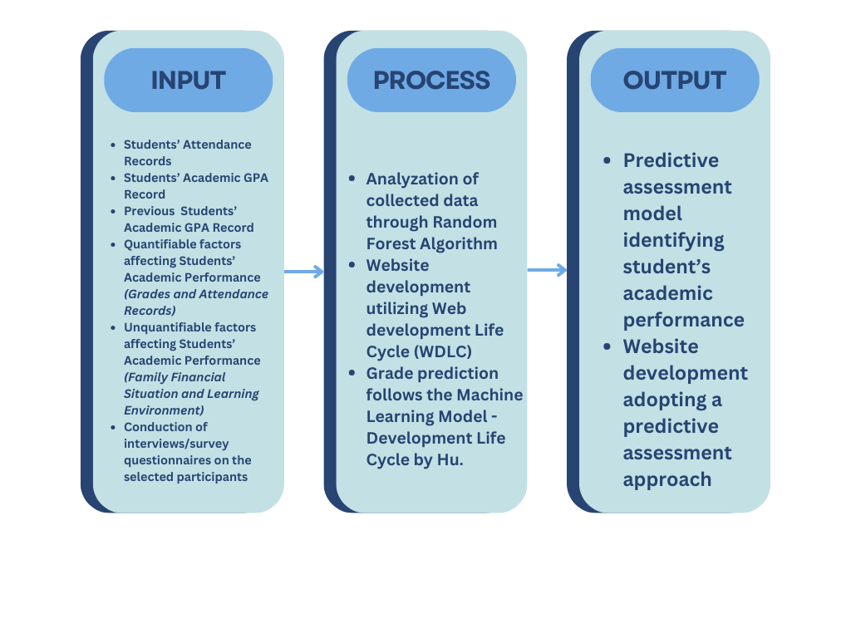

## Objectives of the Study

This study aims to develop random forest regression model for predicting students’ academic performance on a website application platform, with the aim of achieving precise and reliable predictions for individual student grades. To achieve this, the study will focus on the following:

* Gather and preprocess previous grades covering the grade point average (GPA), along with attendance records, from grade 3 of the current batch of grade 6 students.
* Develop a random forest regression model to predict students' academic performance using features including their GPA, attendance, financial situation, and learning environment.
* Evaluate the model's accuracy and efficiency by comparing its predictions with actual grades using the collected data for analysis.
* Develop a website application to facilitate the utilization of the predictive model.
* Evaluate the website application’s ability to consistently operate without errors, offers easy navigation, responds efficiently and perform its intended features, including prediction results and tasks, for its users and purpose.

## Scope of the Study

This research examined how data analytics were utilized in educational environments, primarily to predict the academic performance of graduating elementary students through the application of random forest algorithm. To pinpoint and predict the academic performance of the students, the research analyzed the effectiveness of predictive analytics methods. It delved into academic performance patterns over a quarter, focusing on seventy-six (76) graduating elementary students at San Pedro Elementary School (SPES) located in Guagua, Pampanga, to provide contextualized insights into academic difficulties and support requirements. Participants included elementary school teachers, parents/guardians of graduating elementary students, and field experts. The research focused on four (4) factors: (1) Previous Academic Performance, (2) Attendance Records, (3) Learning environment and (4) Family financial situation. These factors were gathered through quantitative survey questionnaires and interviews, along with a quantitative analysis of academic records. Attendance and previous academic records of grade 6 students for the school year 2023–2024 were obtained from the school's registrar. Additionally, field experts are provided with survey questionnaire, evaluating the website application developed by the researchers.

The gathered data from participants, specifically survey questionnaires and interviews, were interpreted using a 5-point Likert Scale(Tables 1 & 2). The model’s prediction and accuracy were evaluated through the metrics of Mean Absolute Error (MAE), Mean Squared Error (MSE), and R-squared. The evaluated data was then fed into the Random Forest Algorithm to obtain a predictive result of academic performance. The application was built on a website platform, with the system developed using Python and other programming languages. Scikit-learn was used to compute metrics and assess model performance, ensuring accurate and efficient predictions by comparing predicted academic performance with actual grades of graduating students.

The research scope was confined to the internal operations of the educational institution, excluding broader societal aspects or external data sources.

## Delimitations of the Study

This research was guided by specific delimitations to ensure the accuracy of the methodology. First, the prediction of the academic performance of graduating elementary students was the only focus of the analysis. To achieve this, the researchers utilized the GPA of the students, providing a direct and unadjusted measure of their academic performance. In accordance with this, this research offers early identification of factors that significantly affect students' academic performance, without proposing specific implementation strategies for schools, as these strategies will be determined by the schools themselves. Because targeted research was on academic performance and the four (4) identified factors, broader socio-economic issues that were not related to academic performance were not thoroughly examined.

Second, this research utilized existing institutional data, strictly adhering to ethical guidelines regarding confidentiality and privacy. This research gathered data limited with a total of 76 graduating students studying at San Pedro Elementary School, as this was the available population within the research’s locale. Due to time constraints, the research focused on the first quarter grades of Grade 6 students from S.Y. 2024-2025 to validate the prediction results. By concentrating on this initial grading period, the research aimed to provide an early assessment of the predictive model's accuracy within a limited timeframe.

## 

## Significance of the Study

The significance of this research, ‘Prediction of Academic Performance Level of Graduating Elementary Students,’ was rooted in addressing the goal of predicting the academic performance of graduating elementary students and identify early-on factors affecting students’ academic performance. This research directly aligns with the statement of the problem, presenting an early-on identification of students struggling, improving or maintaining academic performance that provide substantial benefits for both teachers and students. By employing data analytics for predicting academic grades, this research contributed to the broader societal goal of fostering a skilled and empowered educational institution.

For school administrators and teachers, the significance lies in the use of data analytics to identify early on students who might perform below expectations, improve, or maintain their performance in the classroom. As a result, they have become better equipped to customize new lesson plans, enhance teaching techniques, and address individual student needs, fostering a more diverse and adaptable learning environment for their students. Understanding the factors that influenced academic success enabled school administrators and teachers at the school to enhance educational outcomes and provide every student with the opportunity to excel.

For students, the significance lies in the potential for personalized support and assistance from teachers who benefitted from this research. The use of data analytics helped in identifying academic factors early on, allowing for targeted strategies to address individual student needs. This contributes to the overall well-being and success of students, fostering a positive educational experience.

In summary, the use of data analytics to identify students who may perform below expectations, improve, or maintain academically is crucial. This research has the potential to make school administrators and teachers aware of the students who had been struggling, improving or maintaining their performance, student support systems, maximize resource allocation, and provide information for evidence-based decision-making in educational institutions.

# 

# **Methods**

The four purposes of this chapter were to (1) describe the research methodology of the research, (2) explain the sample selection, (3) describe the procedure used in designing the instrument and collecting the data, and (4) provide an explanation of the statistical procedures used to analyze the data.

## Research Design

This research employed a quantitative approach, collecting and preprocessing academic records, and attendance data. Quantitative technique was utilized and conducted through a survey questionnaire among the parents/guardians of grade 6 students. Survey questions were designed to gain insights regarding financial situation, as Grade 6 students were not suited for survey interviews on this topic due to their limited understanding of finances and the sensitive nature of financial matters. Additionally, survey interviewing teachers offered valuable insights into the contextual factors contributing to student performance. Teachers have distinct viewpoints and have observed students firsthand in the classroom and at home, which enables a deeper understanding of the contextual distinctions surrounding student performance, especially since grade 6 students may not be capable of providing insights into factors specifically learning environment. This research aims to provide the potential academic trajectory of students nearing the completion of their elementary education. Using random forest regression, the goal is to predict the academic performance of graduating elementary students with a higher degree of accuracy. This approach leverages the collective power of various predictive factors including previous academic records, attendance, financial situation, and learning environment. Predictive capability can support student outcomes and ensure a successful transition to secondary education levels. The integration of quantitative findings allows for a comprehensive understanding of factors contributing to student performance, providing accuracy of results on the effectiveness of the random forest regression model. Throughout the research process, ethical considerations including informed consent and confidentiality are crucial, documentation and reporting guarantee accountability and transparency.

The random forest regression model had been utilized to predict grades, following a machine learning model development approach. Illustrated in Figure 2, the machine learning (ML) lifecycle outlines a series of steps. This methodology categorizes into four main sections: data ingestion, exploratory data analysis, model creation, and model operation. The first section was data ingestion where the researchers inserted the gathered data into the model, the transformed data will be fed into the data repository where the model can then explore the data and visualize plots. The second section was explanatory data analysis where the model provided visualization plots and metrics to the researchers. The third section is model creation, this is where the model was trained until the researchers determines the model’s accuracy satisfactory. The accuracy of the model was evaluated in the second step through visualization plots and metrics. In the fourth and final section, the researchers implemented the model into the website application.

**Figure 2**.

*Machine Learning Model-Development Life Cycle by Hu (2021)*

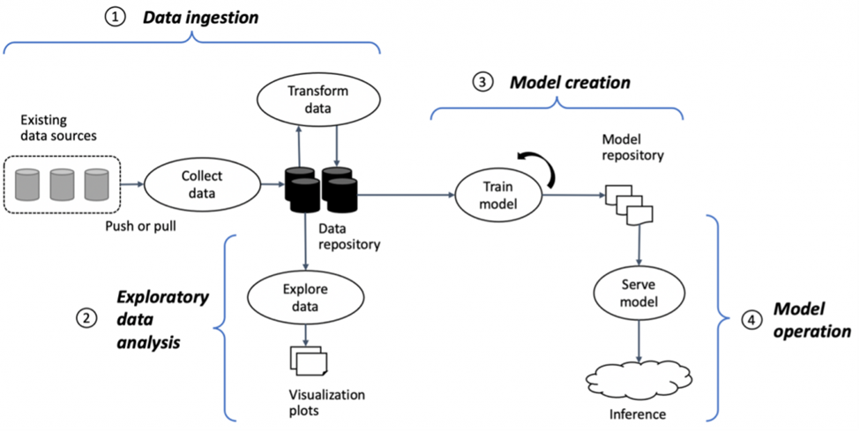

The web-based application was developed using a structured Web Development Life Cycle (WDLC). As illustrated in Figure 3, this model consists of six crucial phases: planning, analysis, design, implementation, testing, and integration. Each phase was carefully executed to ensure the smooth development and ongoing functionality of the web application which was thoroughly implemented and explained in this research paper.

**Figure 3**.

*Web Development Life Cycle (WDLC)*

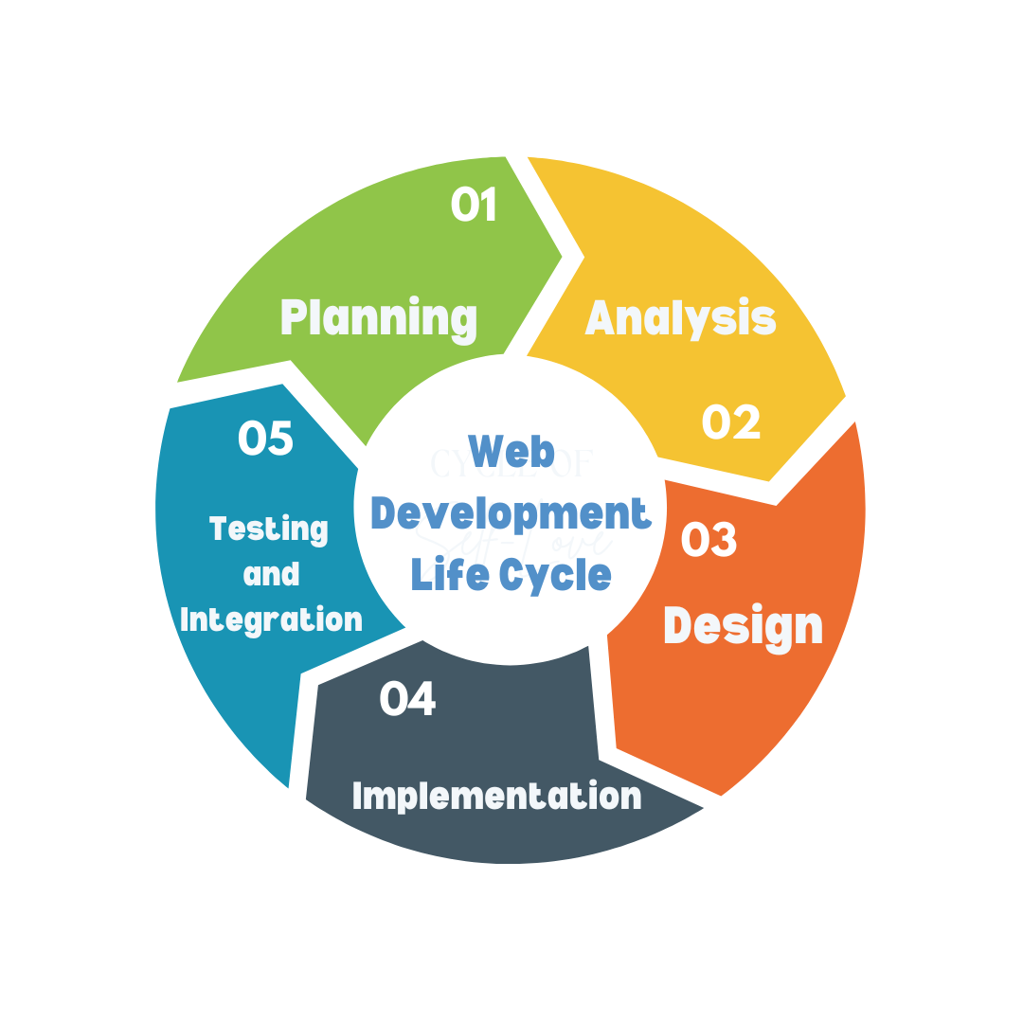

## Sources of Data

This section covers all the sources of data gathered from primary and secondary sources. Primary sources were gathered through survey questionnaires and interviews, while secondary sources were existing studies and literatures related to predictive modeling in education. These sources of data ensure accurate analysis, historical and contextual insights into the objectives of the study.

**Students' GPA and Attendance.** The researchers obtained academic records from grade 3 for the current batch of grade 6 students, including grades and attendance information. This data was acquired through collaboration with the Guidance Counselor and Student Affairs Coordinator at San Pedro Elementary School (SPES).

**Numerical Data for Financial Situation and Learning Environment**. The researchers surveyed the parents and interviewed the teachers to assess various factors such as financial situation and learning environment. The collected data was quantified, and these numeric predictors were integrated into the random forest regression model alongside GPA and attendance to predict whether a student was struggling, improving or maintaining their academic performance. Factors were interpreted on a scale of 1 to 5, with 1 being the lowest and 5 the highest score.

**Evaluation Data.** The model was extensively tested multiple times to ensure its reliability and accuracy, which included examining the predictions generated by the model. Following rigorous evaluation of the model and its predictions, the data was analyzed by comparing the model's predictions with the actual grades using the collected dataset.

**Secondary sources of data.** The researchers looked into a number of academic books and journals relating to predictive modeling in education. These sources provided theoretical frameworks as well as important approaches that were relevant to the model's development. Relevant research on the use of machine learning methods in educational settings were studied to improve prediction accuracy and design. Furthermore, research on predictive model metrics and validation techniques offered valuable data that made sure the assessment procedure followed professional best practices.

## Research Instrument

The researchers employed a quantitative approach, adopting standardized interviews to gain knowledge from individuals through verbal conversations conducted as one-on-one interviews. According to Sreekumar, D. (2024), the process of gathering and examining numerical data is known as quantitative research. It can be applied to evaluate connections between variables, identify averages and patterns, formulate predictions, and generalize findings to larger populations. Utilizing quantitative research methodologies, occurrences that impact a certain set of people the sample population are observed. Various numerical data are gathered using a variety of techniques in this kind of research, and the data are then statistically processed to aggregate, compare, or demonstrate correlations between the data. In general, experiments, organized observations, and surveys are examples of quantitative research methodologies.

This research helped the researchers gather data involving the participants related to students that had provided information regarding factors that influence the academic performance of students. Survey-style questions on interviews regarding the factors that affect their students’ academic performance were used. A quantitative survey interviews is an instrument used in measuring the opinions of individuals in a formal approach of questioning them using a response scale for each question (McGilvray D., 2021). The participants chosen for this research were those directly involved in the perspectives of the academic performance of students.

The website developed underwent quality evaluation using the FURPS model, which focuses on the functionality, usability, reliability, performance and supportability of the website through a 5-point Likert Scale (See Appendix T & U).

**Criteria for Evaluation**

A categorical scale is a scale type that groups elements into discrete categories and uses these categories to assign unique symbols, usually numbers or names, to each entity. Researchers can simplify and analyze qualitative data by using predetermined categories, such as "excellent," "good," "fair," and "poor," to classify variables. Unlike numerical scales, which focus on classifying responses into meaningful categories, categorical scales do not rank or quantify the data. By using categories instead of exact measurements, this method helps capture and analyze characteristics that are easier to understand. Researchers can examine trends and derive conclusions from qualitative data more efficiently by employing a categorical scale (Celko, J. 2010).

In a study conducted by Rajesh, et al., (2018), various attributes representing a household's perception and living situations were measured using a categorical scale. The researchers were able to more clearly analyze how different socio-economic characteristics affect household vulnerability by using this method to group these elements into discrete levels, such as low, medium, and high. The study successfully captured the variety of household perspectives on financial stability, resource access, and general well-being by using categorical measures. This approach also made it possible to compare vulnerability among the community's various socio-economic groupings. This study's use of categorical scales emphasizes how important detailed, granular data is for comprehending and resolving household vulnerability differences.

Likert scales are commonly utilized in educational research to assess and quantify perceptions, attitudes, and behaviors, such as student engagement and emotional support. They are particularly effective in evaluating the success of engagement strategies. Hart, et al. (2011) have examined the Student Engagement in Schools Questionnaire (SESQ) and identified five key factors: Affective Engagement (Liking for Learning and Liking for School), Behavioral Engagement (Effort & Persistence and Extracurricular Participation), and Cognitive Engagement. This research employed a Likert-type questionnaire specifically designed to measure various aspects of student engagement.

Likert scales categorize responses into numerical values, typically with 1 representing 'strongly agree,' 2 representing 'agree,' 3 representing 'neutral,' 4 representing 'disagree,' and 5 representing 'strongly disagree.' This scaling method, which features an odd number of response options, allows for easy quantification of responses. According to Kusmaryono (2022), 90% of research studies utilized a 5-point Likert scale as the measurement tool among 60 papers published between 2012 and 2022, demonstrating its effectiveness in producing reliable and valid coefficients. A broader review of 60 studies published between 2012 and 2021 also found that 90% of these studies favored odd-numbered Likert scales, particularly the 5-point scale, due to its reliability and validity, with the 7-point scale being especially effective in certain contexts.

## Participants

The researchers carefully selected their participants based on specific criteria to guarantee relevance and accuracy in addressing the research objectives. A total of 91 participants were included, representing the requirements and providing insights related to the purpose of this research.

**Elementary School Teachers (2).** Esteemed school advisers of section 1 and section 2 from San Pedro Elementary School who possess valuable insights into student behavior, academic performance, and classroom dynamics. The criteria for these teachers were: (1) a licensed teacher of the students studying at San Pedro Elementary School (SPES), (2) can verbally communicate well in either English, Tagalog or Kapampangan, and (3) must be 18 years old and above.

**Parents/Guardians of Grade 6 Elementary School Students (76).** Dedicated individuals responsible for the guidance of the Grade 6 student studying from San Pedro Elementary, offering invaluable perspectives on financial situation impacting academic outcomes. The criteria for these parents/guardians were: (1) A parent or guardian of a Grade 6 student attending in San Pedro Elementary School (SPES), (2) Can read and write in either in either English, Tagalog or in Kapampangan, and (3) and must be 18 years old or above.

**Field Experts (3).** Professionals with extensive experience in software development, website design, and expertise in information technology and artificial intelligence, offering valuable technical insights and contribute to evaluating system functionality, model deployment, and other essential technical components necessary for assessing the prediction of academic performance. The criteria for these experts were: (1) at least one year working experience in their field of expertise, (2) can verbally communicate well in either English or Tagalog, and (3) must be 18 years old and above.

**System Evaluators (15).** These are the ndividuals who will assess the application's effectiveness based on the study's objectives, including elementary school teachers (12) who will benefit from the website application intended for use in school institutions. Other evaluators who can identify potential improvements and suggesting modifications to enhance the performance and purpose of the application, particularly from the field experts (3).

Each participant group contributes unique insights and data crucial to the development and validation of predictive models aimed at predicting the possible grades of students and those who are struggling, improving, or maintaining their performance. Their cooperation and collaboration are deeply appreciated, as their involvement is instrumental in advancing the research objectives of this research.

## Statistical Treatment of Data

The data collection process involved obtaining the grades of grade 6 elementary students and their attendance records retrieved by the school’s registrar with informed authorization. Before proceeding with analysis, the collected data had to undergo preprocessing to ensure accuracy and consistency, including thorough checks for duplicates. Once the data was validated, it was entered into the analysis program for further processing. Initially, the algorithm has been tested using the gathered data to evaluate its effectiveness. Subsequently, the Random Forest algorithm was employed to predict the academic performance of the student.

*Testing Data*

The researchers used the following evaluation metrics to assess the model's accuracy: Mean Absolute Error (MAE), Mean Squared Error (MSE), and R-squared (R2). The formulas used for the evaluation of the model were:

***Mean Absolute Error (MAE)*** calculates the average magnitude errors of predicted values.

$$MAE = \frac{1}{n}\sum_{i=1}^{n}{}\left|Yi-\hat{Y}i\right|​$$

where $n = number of data points$

$$Yi = Actual values$$

$$\hat{Y}i = Predicted values$$

***Mean Squared Error (MSE)*** calculates the average of the squared differences of the predicted values and actual value.

where

***R-squared (R2)*** proportionate the variance between the dependent and independent variable.

$$R^{2}=1-\frac{\sum_{i=1}^{n}{} (Yi-\hat{Y}i)^{2}}{\sum_{i=1}^{n}{}(Yi-\overline{Y})^{2}}$$

where $Yi = Actual values$

$$\hat{Y}i = Predicted values$$

$$\overline{Y} i= Mean of actual values$$

*Survey Questionnaire (Website Evaluation) Data*

Website Evaluation Survey Questionnaire used a 5-point Likert Scale, applying the FURPS Model, which divided the questions into five requirements: Functionality, Usability, Reliability, Performance, and Supportability (Papa, J. F. et al., 2016). The scores were interpreted using the 5-point Likert Scale shown in Table 1. Responses obtained from the questionnaires were used for calculation.

**Table 1.**

*5-point Likert Scale Interpretation (Website Evaluation)*

|  |  |  |
| --- | --- | --- |
| **Likert Scale** | **Interval** | **Interpretation** |
| 1 | 1.00-1.80 | Not Acceptable |
| 2 | 1.81-2.60 | Fairly Acceptable |
| 3 | 2.61-3.40 | Acceptable |
| 4 | 3.41-4.20 | Very Acceptable |
| 5 | 4.21-5.00 | Highly Acceptable |

The ***Standard Deviation Formula*** measures the amount of variance in a dataset. A small variance indicates that the data points are closer to the mean, which leads to consistent data; a large standard deviation indicates that the data points are further from the mean, which leads to less consistency in the data.

$$σ = \sqrt{\frac{Σfx^{2}}{N}}$$

where $σ = Standard Deviation$

$$f = Frequency$$

$$x^{2}=Squared of difference of mid-value and mean$$

$$N=Total number of data$$

*Survey and Interview Questionnaire (Factors Affecting Academic Performance) Data*

The Survey and Interview Questionnaire used a 5-point Likert Scale (Nyutu, E., Cobern, W. W., & Pleasants, B. A., 2020) and was conducted with the selected participants of the research, particularly parents/guardians and teachers of elementary graduating students. We interpreted the scores using the 5-point Likert Scale shown in Table 2. Responses obtained from the questionnaires were used for calculation.

**Table 2.**

*5-point Likert Scale Interpretation (Factors Affecting Academic Performance)*

|  |  |  |
| --- | --- | --- |
| **Likert Scale** | **Interval** | **Interpretation** |
| 1 | 1.00-1.80 | Strongly Disagree |
| 2 | 1.81-2.60 | Disagree |
| 3 | 2.61-3.40 | Neutral |
| 4 | 3.41-4.20 | Agree |
| 5 | 4.21-5.00 | Strongly Agree |

## 

## Research Procedures

This section outlines a well-structured procedure for data collection, analysis and development, aligned by the Web Development Life Cycle (WDLC). The approach was divided into five (5) stages: (1) Planning, followed by (2) Analysis, (3) Design, (4) Implementation and (5) Testing and Integration. Each phase ensured that the research procedure was systematically planned, executed, and evaluated.

**Planning**

The researchers thoroughly reviewed the literature on the Random Forest algorithm and related studies in order to understand its advantages, disadvantages, and possible uses in academic performance prediction. This helped the researchers better understand the details of ensemble learning techniques and how they use decision trees to improve prediction accuracy. The researchers identified an important problem they researched in earlier studies: the requirement for an effective prediction model that takes into consideration the numerous variables affecting academic performance. The researchers developed theories based on information from the literature that suggests the Random Forest algorithm can produce a deeper comprehension of academic achievement when combined with demographic data, and other factors.

*Project Scheduling*

During project scheduling, we created a timeline for the project's tasks, specifying start and end dates for each task. This ensured timely completion of tasks and effective distribution of resources. The researchers were better equipped to identify dependencies, track progress, and make necessary adjustments to plans when they visualized the project flow. The schedule was composed of a Work Breakdown Structure and a Gantt Chart to provide a clear overview of tasks and their timelines (see Appendix L).

**Analysis**

*Data Collection and Preparation*

The researchers collaborated with teachers from San Pedro Elementary School (SPES) to collect student-related data. The principal signed the consent form, allowing the researchers to survey the children' parents and conduct interviews with the teachers. The survey collected information about the student's family's financial situation, which the researchers handed to the teachers, who then delivered it to the students for their parents to fill out at home. After the given deadline for the survey forms, the researchers went to the school to gather the survey forms and put them in an excel file for better clarification of data. The interviews with the teachers involved asking the advisers about their students and gathering information about the learning environment of each student. The interview process involved the researchers preparing a list of questions approved by the principal of the school and another principal from San Rafael Public School (SRPS). The advisers of the respective sections answered the questions in front of the researchers which were then put in an excel file for better data clarification. After gathering the data, the researchers then with the help of the criteria for evaluation, averaged the scores of each student and that determined their financial situation and learning environment scores. Regarding the collection of attendance, the researchers were given permission to view the class record and translate the data into digital form. The researchers were able to gather the previous GPA of the students by asking their advisers from the previous grade level. All the data gathering of the researchers followed the confidentiality agreement that included prohibition of photo taking, erasing the Learner Reference Number (LRN) of the students, and concealing the name of the students.

*Pre-processing*

The dataset the researchers gathered had various numbers of students from their previous grade level, some students were transferees, and some students left the school. The first section of the graduating elementary students has 41 students but in the previous grade level the number of students did not match. Due to this reason, the researchers were unable to gather information from those students and removed them from the model. The researchers were advised by the school principal to gather their previous GPA but keep in mind that their grades cannot be predicted as they lack other factors. In the Excel file of the attendance and the previous GPA, the researchers crossed out these students.

**Design**

*Machine Learning Model-Development Life Cycle*

To improve the model's ability to predict student academic performance using the Random Forest technique, the researchers actively employed the Machine Learning Model-Development Life Cycle. It offered an organized framework that enabled the researchers to methodically navigate the difficulties involved in developing a model. The researchers can carefully assess data, efficiently preprocess it, and choose features that are appropriate for prediction by adhering to this cycle. The life cycle also ensured the accuracy and reliability of the prediction model by guiding the researchers through the critical stages of model training, assessment, and improvement. In the end, the researchers refined their methodology by utilizing the Machine Learning Model-Development Life Cycle, which produced more accurate and perceptive predictions of student academic performance.

The machine learning model development life cycle that the researchers followed comprised four (4) key steps, each containing specific tasks crucial for the successful progression to the next phase. The first step was Data Ingestion, during which the researchers gathered, cleaned, and transformed raw data before feeding it into the model. The data collected included various factors such as grades, financial situation, learning environment, and attendance. This step also involved handling missing values, formatting the data into a compatible structure. The cleaned and transformed data was then stored in a data repository, ready for further exploration. The quality of this step was crucial, as the accuracy and performance of the model heavily relied on the quality and relevance of the ingested data. The Data Ingestion step was seen in the research as part of the planning phase, wherein data collection and preprocessing strategies were discussed and established to ensure a robust foundation for subsequent analysis.

The second step was Exploratory Data Analysis (EDA), where the researchers utilized statistical tools and visualization techniques to uncover patterns, relationships, and outliers within the dataset. During this phase, the researchers utilized Python wherein this programming language can be incorporate Pandas alongside libraries such as Matplotlib and Seaborn to create visual representations of the data. The model generated key metrics and graphical plots, scatter plots to examine relationships between variables. These visualizations enabled the researchers to gain insights into the dataset’s characteristics and informed their preprocessing strategies. The team used EDA to identify feature engineering opportunities, such as creating new features or modifying existing ones, which were critical for improving model performance. Moreover, the EDA provided a preliminary understanding of the data, helping to refine hypotheses and inform the model-building process.

The third step was Model Creation, in which the researchers built and trained the machine learning model using the processed training data. They utilized several tools from the scikit-learn library, including:

*train_test_split* for splitting the dataset into training and testing sets, ensuring that the model could learn from one portion of the data while being evaluated on another.

*GridSearchCV* for performing hyperparameter tuning, allowing the researchers to systematically explore different combinations of parameters to find the optimal settings for the model.

param_grid = {

'n_estimators': [10, 50],

'max_depth': [None, 5, 10],

'min_samples_split': [2, 4],

'min_samples_leaf': [1, 2],

'max_features': ['sqrt', 'log2'],

'bootstrap': [True],

}

*RandomForestRegressor* as the selected algorithm for building the model, known for its effectiveness in handling regression tasks and its ability to reduce overfitting through ensemble learning.

*StandardScaler* to standardize the features, ensuring that all variables contribute equally to the model's performance by scaling them to have a mean of zero and a standard deviation of one.

To evaluate the model's performance, the researchers used several key metrics, including:

Mean Absolute Error (MAE) calculates the average magnitude errors of predicted values.

$$MAE = \frac{1}{n}\sum_{i=1}^{n}{}\left|Yi-\hat{Y}i\right|​$$

where $n = number of data points$

$$Yi = Actual values$$

$$\hat{Y}i = Predicted values$$

Mean Squared Error (MSE) calculates the average of the squared differences of the predicted values and actual value.

$$MSE = \frac{1}{n}\sum_{i=1}^{n}{}(Yi-\hat{Y}i)^{2}$$

where $n = number of data points$

$$Yi = Actual values$$

$$\hat{Y}i = Predicted values$$

R-squared (R2) proportionate the variance between the dependent and independent variable.

$$R^{2}=1-\frac{\sum_{i=1}^{n}{} (Yi-\hat{Y}i)^{2}}{\sum_{i=1}^{n}{}(Yi-\overline{Y})^{2}}$$

where $Yi = Actual values$

$$\hat{Y}i = Predicted values$$

$$\overline{Y} i= Mean of actual values$$

The researchers iteratively trained the model to optimize performance, conducting multiple iterations to evaluate different model configurations and find the best balance between bias and variance. During the training process, they monitored these key performance metrics to assess the model’s effectiveness. They also validated the model using the separate validation dataset to ensure it generalizes well to new, unseen data. If the performance was unsatisfactory, adjustments were made to the model or data preprocessing steps.

In this figure, the performance metrics show the level of accuracy of the refined model in prediction.

**Figure 5**.

*Refined Model Performance Metrics*

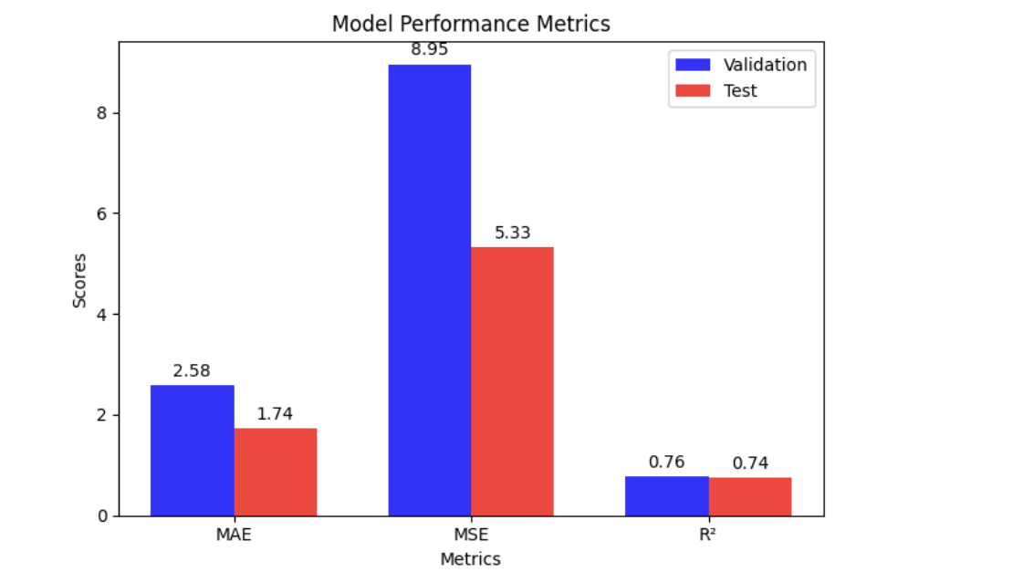

The fourth and final step was Model Deployment and Operation, where the fully trained model was integrated into a website application. In this phase, the researchers utilized several technologies to create a user-friendly interface and establish a robust back-end system, including:

*Flask* as the web framework for building the web application, allowing for easy integration of the machine learning model and handling of web requests.

*SQLAlchemy* for database interaction, providing an Object Relational Mapping (ORM) layer to facilitate database management and data retrieval.

*PostgreSQL* as the database system, ensuring reliable and scalable storage of user data and predictions.

*Render* for hosting the application, allowing for seamless deployment and scalability of the web application in the cloud.

*HTML, CSS*, and *JavaScript* for front-end development, enabling the creation of an interactive and responsive user interface that allows users to input data and view predictions easily.

This step involved packaging the model and deploying it in a scalable manner that could handle real-time or batch predictions. This phase was crucial for turning the machine learning insights into actionable outcomes for end-users.

**Implementation**

*Implementation of Random Forest Algorithm*

To develop and test the Random Forest model and take advantages of its benefits, the researchers used Python's scikit-learn element. The model's performance was improved through in-depth parameter selection and modification, resulting in accurate projections of academic results. They also prioritized efficiency and scalability, considering techniques like distributed processing to manage vast data sets well. Proper documentation was maintained during the implementation phase to guarantee accessibility and reproducibility. This created a foundation for strong validation and sharing of their results, enabling the researchers to make a significant contribution to the field of educational predictive modeling.

*Accuracy Testing*

To verify the deployed model's performance and functioning in actual situations, the researchers thoroughly tested it and took care of any possible problems or inconsistencies. The goal was to preserve the relevance and dependability of the prediction model in learning contexts by encouraging user adoption and offering users strong support tools and well-defined documentation throughout the deployment process. The researchers were advised to include additional data for extreme cases like a student dropping out or a student having zero attendance.

**Development**

*Algorithm Model*

To build a model that can predict the grades of graduating elementary students, Random Forest Regression algorithm was used. Random Forest is a learning method that operates by constructing multiple decision trees during training and outputting a prediction of the trees. The factors the researchers used were Attendance, Learning Environment, Financial Situation and Previous GPA of the students. The Random Forest model enhances accuracy, and the trained model was used to predict the grades of the students based on these factors.

*Application Development*

The researchers used Python for the development of the model, which utilized the Random Forest algorithm to predict academic performance. The researchers developed the Random Forest algorithm by utilizing Python's easy syntax and readability, which allowed the researchers to explore the complexity of predictive modeling in deeper detail. Its wide environment of frameworks and tools enabled the researchers to train models effectively, preprocess data, and assess their effectiveness in all aspects. The researchers used Python's capabilities and created an application that explains the complex relationships between the many factors that affect academic achievement.

*Development Model*

The Web Development Life Cycle model's structured methodology was used by the researchers. They were guided through every phase of the project by this systematic strategy, which guaranteed efficiency and clarity in the development process. By utilizing this model, the researchers efficiently evaluated requirements, constructed an effective system, applied the predictive model, and presented it. Using the Web Development Life Cycle model gave the researchers the ability to deliberately and accurately negotiate every aspect of their research, providing insightful knowledge on users' academic achievement as well as the model's continued effectiveness and relevance.

*Testing Plan*

The researchers paid close attention to every last detail when developing the testing strategy for the research, which used the Random Forest algorithm to predict academic performance. To ensure alignment with the research goals, the researchers first defined the objectives and variables to assess the effectiveness of the prediction model. To evaluate the model's generality and durability on a range of datasets, the researchers then developed reliable validation methodologies, such as cross-validation techniques. To find out how different variables affect the performance and stability of the model, the researchers also ran thorough sensitivity analyses. To enable consistency and review of outcomes, thorough documentation and transparency were maintained during the testing phase. Ultimately, the researcher's testing strategy was important for confirming the reliability and effectiveness of their prediction model in predicting academic performance results.

**Testing and Integration**

***First Iteration Testing***

During the first iteration model development, the baseline model that was trained was a Random Forest Regressor using default hyperparameters to predict the student’s grades. Because it was the first iteration of the model, the researchers did not conduct any hyperparameter tuning to establish a baseline performance. According to one of the experts, with only a small dataset like in the research, splitting the data into 80% training, 10% validation, and 10% testing sets. The validation set was used for training while the testing set was used for holding out which meant that the testing set was only used once the validation set had the desired accuracy and loss metrics during training. The data of the features were scaled using Standard Scaler to ensure consistent scale across variables.

*Performance Metrics*

The model gave evaluation results via Mean Absolute Error (MAE), Mean Squared Error (MSE), and R2. MAE measured the average magnitude errors of the predicted values and actual values while MSE squares the difference before averaging them. R2 is a statistical measure that tells how well the model’s prediction matches the actual data. There are three ranges for the R2: one, zero, or negative. Having the value equal to one means that the model perfectly predicts all the data, having the value equal to zero means that the model predicts the mean of the data and having a negative score means that the model is worse than just predicting the mean.

**Table 3.**

*Validation Set Baseline*

|  |  |
| --- | --- |
| Mean Absolute Error *(MAE)* | 2.131 |
| Mean Squared Error *(MSE)* | 7.717 |
| R2 | 0.796 |

**Table 4.**

*Test Set Baseline*

|  |  |
| --- | --- |
| Mean Absolute Error *(MAE)* | 1.668 |
| Mean Squared Error *(MSE)* | 5.065 |
| R2 | 0.756 |

The baseline model, with a MAE of 2.131 and a MSE of 7.717 shows that it performs well without adjustment. An R2 of 0.756 indicates that the model explains 75.6% of the variance in the data. The model appeared to function effectively even in the absence of adjustment, as shown by the test set, where the MAE increased to 1.67 and the MSE to 5.06. On unseen data, however, the marginally lower R2 of 0.76 indicates a slight drop in predicting grades on unseen data.

*Feature Importance*

The model provided insights on the importance of each feature that involves in predicting the student grades as shown in Table 5.

**Table 5.**

*Feature Importance Baseline*

|  |  |
| --- | --- |
| ***Feature*** | ***Importance*** |
| *Attendance* | 0.640 |
| *Previous GPA* | 0.163 |
| *Learning Environment* | 0.152 |
| *Financial Situation* | 0.045 |

The attendance stands out as the most influential factor, indicating its significant role in predicting student grades. While the previous GPA and learning environment follows closely, suggesting that past academic performance is also an important predictor, but the financial situation had smaller impacts to the model.

With these baseline results, the model effectively captured patterns in the data when predicting unseen test data, as indicated by the solid R² Score of 0.76. However, the slightly lower R² Score suggests there is still room for improvement in the model's generalization during the training process. The analysis also revealed that Attendance was the most influential factor in predicting student grades, followed by Previous GPA, while the Learning Environment and Financial Situation contributed less significantly.

***Second Iteration Testing***

In the second iteration testing, the researchers further improved the Random Forest Regression model based on the results of the first iteration. The goal was to optimize the model’s performance on both the validation set and test set while maintaining generalization to unseen data.

*First Hyperparameter Grid (Initial Tuning)*

The researchers started with a reasonable range of hyperparameters to get the baseline performance of the model and evaluate its ability to predict the grades of the students. The researchers used the initial hyperparameter grid:

param_grid = {

'n_estimators': [50, 100],

'max_depth': [10, 20],

'min_samples_split': [5, 10],

'min_samples_leaf': [2, 4],

'max_features': ['sqrt', 0.5],

'bootstrap': [True],

}

The results based on the initial hyperparameter are shown in Table 6.

**Table 6.**

*Validation Set Evaluation (First Hyperparameter Grid)*

|  |  |
| --- | --- |
| *Mean Absolute Error (MAE)* | 2.737 |
| *Mean Squared Error (MSE)* | 10.720 |
| *R² Score* | 0.717 |

The model provided reasonable accuracy on the validation set with the value of R2 being 0.716 which meant that 71.6% of the variance in the data set was explained by model however there was still room for improvement for the model to generalize unseen data (see Appendix K).

*Refined Hyperparameter Grid (Final Tuning)*

After analyzing the results from the first iteration and the first hyperparameter tuning, the researchers refined the hyperparameters by reducing n_estimators, max_depth, min_samples_split, and min_samples_leaf. This avoided excessive complexity, which can lead to overfitting. The results of these improvements were:

param_grid = {

'n_estimators': [10, 50],

'max_depth': [None, 5, 10],

'min_samples_split': [2, 4],

'min_samples_leaf': [1, 2],

'max_features': ['sqrt', 'log2'],

'bootstrap': [True],

}

The results of the refined hyperparameter grid are shown in Table 7.

**Table 7.**

*Validation Set Evaluation (Refined Hyperparameter Grid)*

|  |  |
| --- | --- |
| *Mean Absolute Error (MAE)* | 2.578 |
| *Mean Squared Error (MSE)* | 8.951 |
| *R² Score* | 0.764 |

When comparing the refined hyperparameter tuning to the initial tuning, the model has improved in its ability to explain variance in the validation data as R2 increased from 0.716 into 0.764 and with reductions in both the MAE and MSE. This indicated that the refined hyperparameters improved the model (See Appendix K).

*Final Model Evaluation (Test Set)*

After tuning the hyperparameters on the training and validation sets, the researchers evaluated the final model on the test set to obtain an unbiased estimate of the model's performance on unseen data. This ensured that the validation set was not overfitted and can assess the model’s generalization ability to be reliable.

**Table 8.**

*Test Set (Final Model Evaluation)*

|  |  |
| --- | --- |
| *Mean Absolute Error (MAE)* | 1.737 |
| *Mean Squared Error (MSE)* | 5.329 |
| *R² Score* | 0.743 |

With an R2 of 0.74, the model can account for 74% of the variation in the test data, indicating a reasonable degree of generalizability to unseen instances. Even though the MAE increased somewhat as expected, it remained within a tolerable range, indicating that the model's predictions and actual values were still quite similar.

**Table 9.**

*Comparison Between Iterations*

|  |  |  |  |
| --- | --- | --- | --- |
| **Metric** | **First Hyperparameter Grid (Validation)** | **Refined Hyperparameter Grid (Validation)** | **Refined Model (Test)** |
| **MAE** | 2.737 | 2.578 | 1.737 |
| **MSE** | 10.720 | 8.950 | 5.329 |
| **R² Score** | 0.717 | 0.764 | 0.743 |

The model's performance was effectively improved by tuning, as seen by increasing R2 scores and lowering errors (MAE, MSE). Strong prediction capability and generalization to new data are demonstrated by the finished model, which is crucial for real-world applications in predicting grades.

*Feature Importance*

After improving the Random Forest model, the researchers analyzed the impact of each feature in predicting student grades to understand which factor had the greatest significance on the model's prediction.

**Table 10.** *Feature Importance (Refined Model)*

|  |  |
| --- | --- |
| ***Feature*** | ***Importance*** |
| *Attendance* | 0.488 |
| *Learning Environment* | 0.253 |
| *Previous GPA* | 0.167 |
| *Financial Situation* | 0.096 |

The most significant factor for the model’s prediction of student grades was the attendance with a value of 0.488. The learning environment of the student that had a value of 0.253 and Previous GPA with a value of 0.167 both factors are relatively close to scores which the researchers analyzed as a good indicator of future performance. Financial situation has the least impact with a value of 0.096, indicating the academic performance is more closely tied to attendance. The researchers analyzed that because the locale of the research was a public school, the financial situation of the students were relatively close to each other and that in public schools, the financial situation of the students was not significant.

*Deployment*

The researchers used Render to deploy the web application, which was advised by one of the interviewed experts. This allowed the application to be hosted and accessible online. The researchers applied Flask for the backend to handle requests, process the data, and serve the predictions of the model. Flask helped the researchers integrate the web interface providing the user an easy to navigate experience, using SQLAlchemy it served as the database that handled database queries and stored data including the login credentials and previous predictions that would help the teachers to track predictions over time. In the frontend part of the application, the researchers used HTML and CSS Bootstrap for the design and after a consultation with one of the experts in web applications, the researchers came to a design that was well suited and professional user interface while also integrating cross browser compatibility and various screen sizes.

*Prediction Model Functionality*

To maximize the efficiency of device resources, the researchers chose to employ the Random Forest model to perform the calculations necessary for forecasting students' future grades. The researchers hosted the model on Render. The web application works by collecting user input such as Attendance, Learning Environment, Financial Situation, Grade Level, and Previous GPA through the use of the web interface and the data would then be sent as a query on the Flask API.

When the Flask API receives the query, it then processes the input and interacts with the model which would be the one responsible for the predictions based on the factors presented. The data is then logged into a backend database handled by SQLAlchemy.

After the computation is completed, the Flask API sends a JSON response containing the prediction which would then be processed by the web application and displayed to the user. With the use of SQLAlchemy, the results are stored in the backend database to ensure past predictions can be tracked and reviewed.

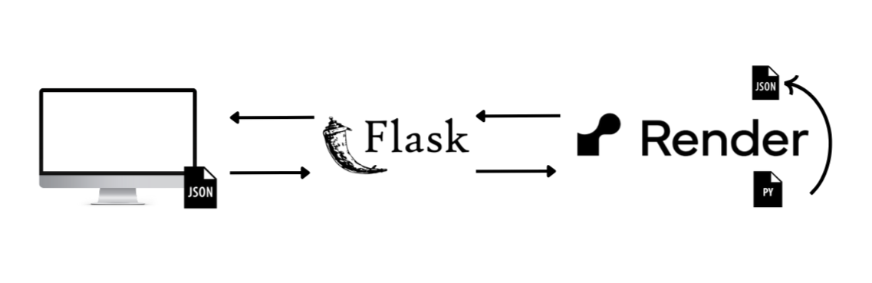

**API Testing for Grade Predictor Application**

The researchers conducted this test to validate the core functionality of the Flask-based Grade Predictor Application. The test was focused on two primary API endpoints:

1. ***/predict***: This API endpoint was used for predicting grades based on the student’s data.
2. ***/upload***: This API was used for uploading CSV files containing student data.

The researchers used two tools:

1. ***Pytest***: This tool was used for running the test cases.
2. ***Flask test client:*** This tool was used for stimulating requests and interactions with the application.

The test cases included*:*

1. Test Case 1: ***test_predict***

*test_predict* was used to test the prediction endpoint by providing JSON input for the attendance, previous GPA, financial situation, learning environment and grade level. During the testing, the researchers expected the API to return a prediction and a unique student ID. The results of this test were successful as it returned a prediction and the student ID.

1. Test Case 2: ***test_upload_file***

*test_upload_file* was used to test the upload endpoint by simulating the upload of a CSV file containing student data. The system should process the file and generate a prediction for each row. The researchers expected the API to successfully upload the file and redirect it to the home page without errors. The results of this test were successful as it uploaded the file and redirected it to the home page.

While all the test passed the results, the researchers received warnings such as*:*

1. Deprecation Warnings:
   1. ***Flask’s datatime.utcnow()*** was deprecated and was scheduled for removal in future versions.
   2. ***SQLAlchemy’s Query.get()*** method was considered legacy and had been replaced by ***Session.get()*** in SQLAlchemy 2.0.

These were warnings that did not cause problems for the functional problems but indicated that there were areas where the application needs to address in the future to maintain compatibility.

1. ***UserWarning*** from scikit-learn was the other warning the researchers received; the warning was generated regarding the use of feature names with StandardScaler. The issue was resolved by ensuring that the feature names were properly aligned.

The researchers deemed the tests as successful because the API endpoints worked as intended even with minor warnings. These warnings were about future improvements for newer versions of Flask, SQLAlchemy and scikit-learn.

## 

## Ethical Considerations

Before enrolling participants in this research, the researchers defined and applied criteria based on ethical concerns for quantitative research. Participants provided informed consent and parental consent, providing clear and intelligible research information. Researchers interviewed selected teachers from San Pedro Elementary School (SPES) about the school’s learning environment, students’ academic performance, and attendance. Following this, they had distributed survey questionnaires to Grade 6 students, covering topics related to economic conditions and other relevant issues, which had been given to their parents or guardians. The permission form has informed participants about the purpose, processes, advantages, and their rights as participants. Participants can engage voluntarily or involuntarily, and there have been no negative consequences associated with their decision. In addition, to safeguard participants' privacy and rights, their personal information and responses have been kept private and available only to the researchers.

A structured procedure is carefully followed during the survey and interview process to ensure comprehensive and accurate data collection. For the survey, researchers distributed printed questionnaires along with consent forms to the teachers at San Pedro Elementary School (SPES). These materials were then passed on to Grade 6 students, with clear instructions for their parents to complete the surveys at home, covering topics such as household economic conditions and other relevant matters. Students were instructed to return the completed forms to their teachers within a specified deadline, who would then gather and securely store them in a designated area for later collection by the researchers. Afterward, in-depth interviews were conducted with selected teachers from San Pedro Elementary School (SPES), focusing on their insights into the school's academic environment, student performance, and other relevant factors. These sessions were held in a quiet, designated space within the school, with both the researcher and the teacher present to ensure a comfortable and open discussion.

These ethical considerations assure the protection of all participants' rights and maintain research principles to conduct research in an ethically responsible way, as well as the integrity and credibility of the research process.

# 

# **Results**

***Gathered and Pre-processed Data***

After gathering the data, the researchers translated the data into digital form and from 103 students the data became 76 students because there were students were unable to provide the necessary data needed by the model for their prediction. The excluded students included transferees who the researchers were not able to gather their previous GPA. Also, students who did not pass their survey questionnaires to the teachers by the given deadline which resulted in these students having a score of zero (0) in the financial situation factor of the model.

Table 11 is a sample of the data where columns are classified as the factors (attendance, previous grades, financial situation, and learning environment) gathered from each student and last column are the existing grades of each student for the school year.

**Table 11.**

*Gathered and Pre-processed Data Sample*

|  |  |  |  |  |  |
| --- | --- | --- | --- | --- | --- |
| Student | Attendance | Previous Grades | Financial Situation | Learning Environment | Grades |
| Student 1 | 88 | 82 | 3 | 2.75 | 77 |
| Student 2 | 82 | 90 | 1.5 | 2.25 | 78 |
| Student 3 | 86 | 85 | 3 | 3 | 79 |
| Student 4 | 88 | 0 | 0 | 4.5 | 77 |
| Student 5 | 92 | 84 | 2.75 | 2.5 | 79 |
| Student 6 | 88 | 81 | 3.25 | 3 | 78 |
| Student 7 | 84 | 0 | 2.75 | 2.75 | 87 |
| Student 8 | 93 | 0 | 2.5 | 3 | 88 |
| Student 9 | 94 | 82 | 3 | 2.75 | 79 |
| Student 10 | 100 | 83 | 3.5 | 4.5 | 88 |
| Student 11 | 92 | 84 | 2.5 | 3 | 81 |
| Student 12 | 78 | 75 | 3.25 | 3 | 76 |
| Student 13 | 86 | 0 | 0 | 0 | 90 |
| Student 14 | 98 | 80 | 3.75 | 4 | 81 |
| Student 15 | 96 | 83 | 3 | 4 | 82 |
| Student 16 | 100 | 77 | 4 | 5 | 86 |
| Student 17 | 98 | 85 | 3.25 | 4.25 | 87 |
| Student 18 | 75 | 96 | 1.25 | 1.5 | 82 |
| Student 19 | 86 | 93 | 0 | 0 | 86 |
| Student 20 | 92 | 85 | 3.5 | 3.25 | 83 |
| Student 21 | 97 | 92 | 2.25 | 3.5 | 90 |
| Student 22 | 83 | 75 | 3 | 1.75 | 75 |
| Student 23 | 84 | 88 | 0 | 0 | 94 |
| Student 24 | 95 | 83 | 2.75 | 3 | 84 |
| Student 25 | 87 | 85 | 2.25 | 2.5 | 80 |
| Student 26 | 93 | 82 | 3 | 3.25 | 81 |
| Student 27 | 94 | 85 | 4.5 | 3.75 | 86 |
| Student 28 | 97 | 77 | 0 | 4.5 | 79 |
| Student 29 | 98 | 88 | 0 | 2.75 | 94 |
| Student 30 | 86 | 88 | 4.5 | 2.75 | 86 |
| Student 31 | 97 | 82 | 3 | 4.25 | 84 |
| Student 32 | 100 | 80 | 4.25 | 5 | 80 |
| Student 33 | 83 | 84 | 0 | 3.25 | 88 |
| Student 34 | 20 | 65 | 1.25 | 1.5 | 60 |
| Student 35 | 88 | 76 | 2.5 | 3.75 | 79 |
| Student 36 | 89 | 75 | 3 | 2.5 | 78 |
| Student 37 | 81 | 83 | 2.25 | 2.25 | 76 |
| Student 38 | 79 | 89 | 2 | 1.25 | 79 |
| Student 39 | 92 | 88 | 0 | 0 | 0 |
| Student 40 | 100 | 77 | 3.25 | 3.75 | 83 |
| Student 41 | 80 | 91 | 1.75 | 1.5 | 80 |
| Student 42 | 77 | 93 | 2.5 | 2 | 81 |
| Student 43 | 88 | 0 | 3 | 3.75 | 90 |
| Student 44 | 98 | 88 | 2.75 | 4 | 90 |
| Student 45 | 100 | 82 | 4.75 | 5 | 91 |
| Student 46 | 96 | 80 | 3 | 3.75 | 82 |
| Student 47 | 83 | 94 | 2.75 | 2.25 | 85 |
| Student 48 | 89 | 87 | 2.75 | 3.5 | 82 |
| Student 49 | 92 | 82 | 3 | 2.75 | 80 |
| Student 50 | 82 | 78 | 3 | 3 | 77 |
| Student 51 | 84 | 0 | 2.5 | 3.5 | 83 |
| Student 52 | 86 | 80 | 3.25 | 3 | 80 |
| Student 53 | 75 | 97 | 1.25 | 1 | 78 |
| Student 54 | 93 | 0 | 2.5 | 4 | 88 |
| Student 55 | 83 | 84 | 2.25 | 2.5 | 79 |
| Student 56 | 92 | 78 | 3.5 | 3.75 | 81 |
| Student 57 | 84 | 79 | 3.5 | 2.75 | 77 |
| Student 58 | 90 | 90 | 0 | 3.5 | 96 |
| Student 59 | 87 | 80 | 3 | 4 | 81 |
| Student 60 | 85 | 80 | 2.25 | 3.25 | 76 |
| Student 61 | 96 | 88 | 0 | 3.5 | 91 |
| Student 62 | 92 | 0 | 3.75 | 4.5 | 88 |
| Student 63 | 86 | 81 | 3.25 | 3 | 82 |
| Student 64 | 78 | 95 | 2 | 1.75 | 80 |
| Student 65 | 89 | 85 | 3.25 | 4 | 87 |
| Student 66 | 92 | 85 | 3.75 | 3.75 | 86 |
| Student 67 | 90 | 84 | 0 | 0 | 89 |
| Student 68 | 77 | 96 | 2.5 | 1.75 | 82 |
| Student 69 | 93 | 92 | 3.75 | 4 | 90 |
| Student 70 | 87 | 88 | 3 | 2.75 | 84 |
| Student 71 | 84 | 79 | 3.5 | 4.25 | 82 |
| Student 72 | 90 | 80 | 3 | 3 | 80 |
| Student 73 | 93 | 78 | 3 | 4 | 82 |
| Student 74 | 94 | 0 | 2.25 | 3.25 | 84 |
| Student 75 | 93 | 0 | 3 | 3.5 | 81 |
| Student 76 | 97 | 84 | 3.5 | 4.5 | 90 |
| Student 77 | 81 | 78 | 3 | 3 | 76 |
| Student 78 | 83 | 0 | 0 | 4 | 97 |
| Student 79 | 88 | 0 | 0 | 0 | 86 |
| Student 80 | 77 | 80 | 3 | 2.75 | 78 |
| Student 81 | 84 | 79 | 3 | 3.75 | 82 |
| Student 82 | 100 | 83 | 2.75 | 4.5 | 90 |
| Student 83 | 94 | 0 | 3 | 4 | 79 |
| Student 84 | 94 | 0 | 0 | 3.75 | 83 |
| Student 85 | 89 | 0 | 3.25 | 2.75 | 92 |
| Student 86 | 87 | 78 | 2.5 | 4 | 82 |
| Student 87 | 72 | 91 | 3 | 2 | 79 |
| Student 88 | 85 | 83 | 3 | 3.75 | 84 |
| Student 89 | 87 | 87 | 3.25 | 4.27 | 89 |
| Student 90 | 90 | 93 | 3 | 4 | 90 |
| Student 91 | 100 | 84 | 3.5 | 4.5 | 91 |
| Student 92 | 97 | 83 | 0 | 2.5 | 85 |
| Student 93 | 94 | 84 | 3 | 5 | 90 |
| Student 94 | 99 | 84 | 4 | 4.25 | 91 |
| Student 95 | 93 | 83 | 3.25 | 4.25 | 85 |
| Student 96 | 88 | 82 | 3 | 3 | 83 |
| Student 97 | 86 | 81 | 2.5 | 3.75 | 83 |
| Student 98 | 90 | 78 | 3 | 4 | 84 |
| Student 99 | 92 | 83 | 2.75 | 3.5 | 80 |
| Student 100 | 87 | 77 | 3.25 | 4 | 81 |
| Student 101 | 92 | 86 | 3.25 | 4.5 | 90 |
| Student 102 | 88 | 0 | 2.5 | 3.5 | 92 |
| Student 103 | 88 | 82 | 0 | 0 | 85 |

***Prediction from Actual Grades***

The researchers gathered the actual first quarter grades of the current grade 6 students and compared these grades to the predicted grades of the model (see Appendix Q). Out of 76 students, the average of the actual grades was 83.8211, the average of the predicted grades was 81.7734.

**Table 12.**

*Tabulated Comparison Between Predicted and Actual Grades*

|  |  |  |  |
| --- | --- | --- | --- |
| **Metric** | **Actual Grades** | **Predicted Grades** | **Refined Model (Test)** |
| **Average** | 83.8211 | 81.7734 |  |
| **MAE** | 2.148 |  | 1.737 |
| **MSE** | 4.619 |  | 5.329 |

**Figure 5.**

*Illustrated Comparison Between Predicted and Actual Grades*

This shows the average results for predicted grades compared to the first-quarter actual grades (S.Y 2024-2025) of the graduating elementary students.

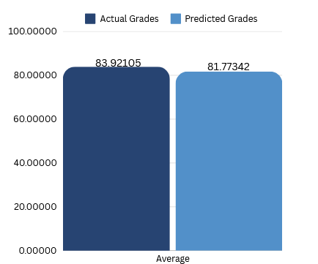

Following that, this shows the MAE and MSE results of the actual grades of the graduating elementary students in comparison to the acquired MAE and MSE results on the refined model testing.

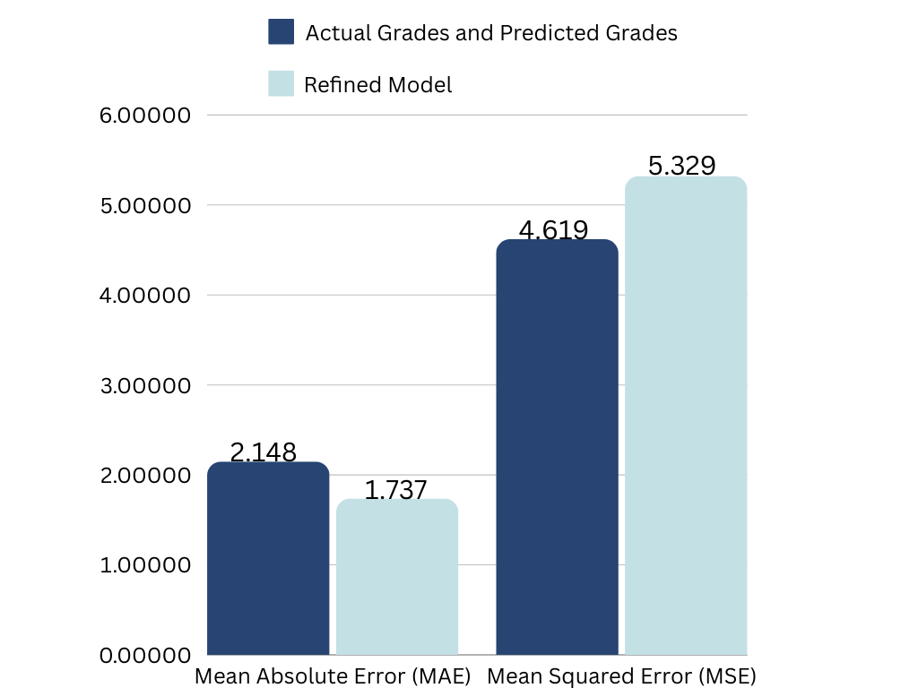

***Summary of Findings (Between Predicted and Actual Grades)***

Following this, the researchers calculated the Mean Absolute Error (MAE) of the averages, which was 2.148, compared this to the MAE of the model, which was 1.737, this meant that the model’s ability to predict the unseen data had a higher error rate than expected. After the MAE, the researchers calculated the Mean Squared Error (MSE) of the averages and the result was 4.619 compared to the MSE of the model, which was 5.329, this meant that the model performed better when generalizing unseen data. The researchers highlighted that the model was not memorizing the data and was making accurate predictions, and these results proved that the model was not overfitted.

***Website Evaluation***

The Website Evaluation utilized a Website Evaluation Questionnaire divided into five (5) requirements of website evaluation: Functionality (F), Usability (U), Reliability (R), Performance (P) & Supportability (S). The questionnaire gathered responses from a total of 15 research participants in using the application. The following are the results from the questionnaire:

**Elementary School Teachers**

***Summary of Findings (by Requirements)***

From the responses of twelve (12) Elementary School Teachers who were part of the research, they answered the survey about the website the researchers have deployed. The teachers were asked about how well defined the website about its functionality and the researchers asked if the website was easy to learn. The researchers asked more questions about how the website appeals to the teachers because they would be the ones using it and the researchers wanted the teachers to be comfortable with the resources needed to run the website. The researchers told the teachers that the accuracy of the model would have a Mean Absolute Error (MAE) of 1.737 meaning that the results of the prediction can miss by 1.737 for the accuracy portion of their evaluation.

**Table 13.**

*FURPS Website Evaluation Tabulated Results by Requirements (Elementary School Teachers)*

|  |  |  |  |  |  |  |  |
| --- | --- | --- | --- | --- | --- | --- | --- |
| **Teacher** | **F** | **U** | **R** | **P** | **S** | **Overall Average** | **Interpretation** |
| 1 | 4.50 | 3.67 | 4.00 | 4.50 | 4.50 | 4.23 | Highly Acceptable |
| 2 | 5.00 | 5.00 | 5.00 | 5.00 | 5.00 | 5.00 | Highly Acceptable |
| 3 | 5.00 | 4.67 | 5.00 | 5.00 | 5.00 | 4.93 | Highly Acceptable |
| 4 | 5.00 | 4.67 | 4.00 | 4.00 | 4.00 | 4.33 | Highly Acceptable |
| 5 | 4.00 | 5.00 | 4.33 | 4.25 | 4.00 | 4.32 | Highly Acceptable |
| 6 | 5.00 | 5.00 | 5.00 | 5.00 | 5.00 | 5.00 | Highly Acceptable |
| 7 | 5.00 | 5.00 | 5.00 | 5.00 | 5.00 | 5.00 | Highly Acceptable |
| 8 | 5.00 | 5.00 | 5.00 | 5.00 | 5.00 | 5.00 | Highly Acceptable |
| 9 | 5.00 | 5.00 | 5.00 | 5.00 | 5.00 | 5.00 | Highly Acceptable |
| 10 | 5.00 | 4.67 | 5.00 | 5.00 | 5.00 | 4.93 | Highly Acceptable |
| 11 | 5.00 | 5.00 | 5.00 | 5.00 | 5.00 | 5.00 | Highly Acceptable |
| 12 | 3.50 | 4.33 | 4.00 | 4.00 | 4.00 | 3.97 | Very Acceptable |

**Figure 6**. *FURPS Website Evaluation Illustrated Results by Requirements (Elementary School Teachers)*

Figure 6 presents the results for each five (5) requirements and corresponding evaluation scores from the elementary school teachers, starting with Functionality. This figure highlights the overall feedback on the website application’s functionality, focusing on its compliance and suitability.

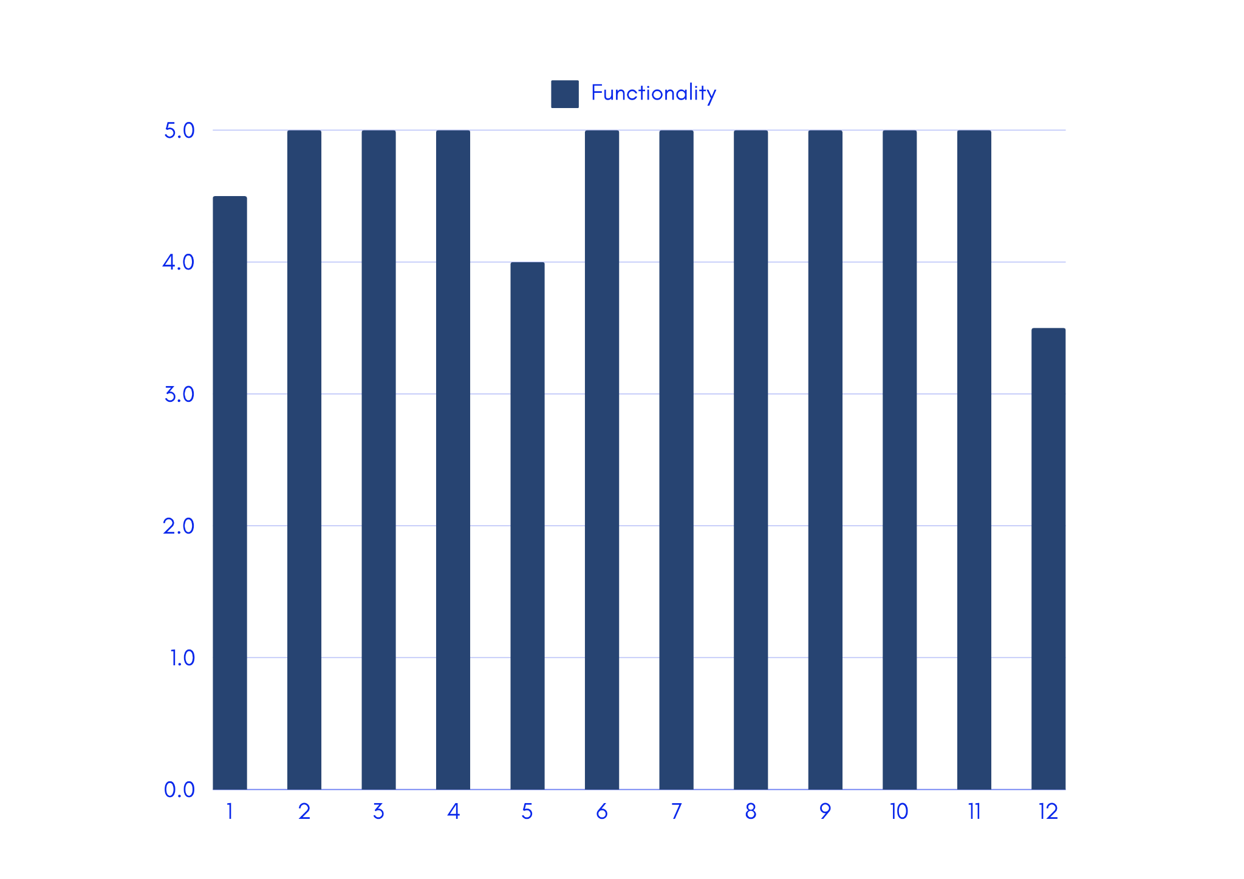

This highlights the overall feedback on the website application’s usability, focusing on its ease of use, overall interface design and consistency.

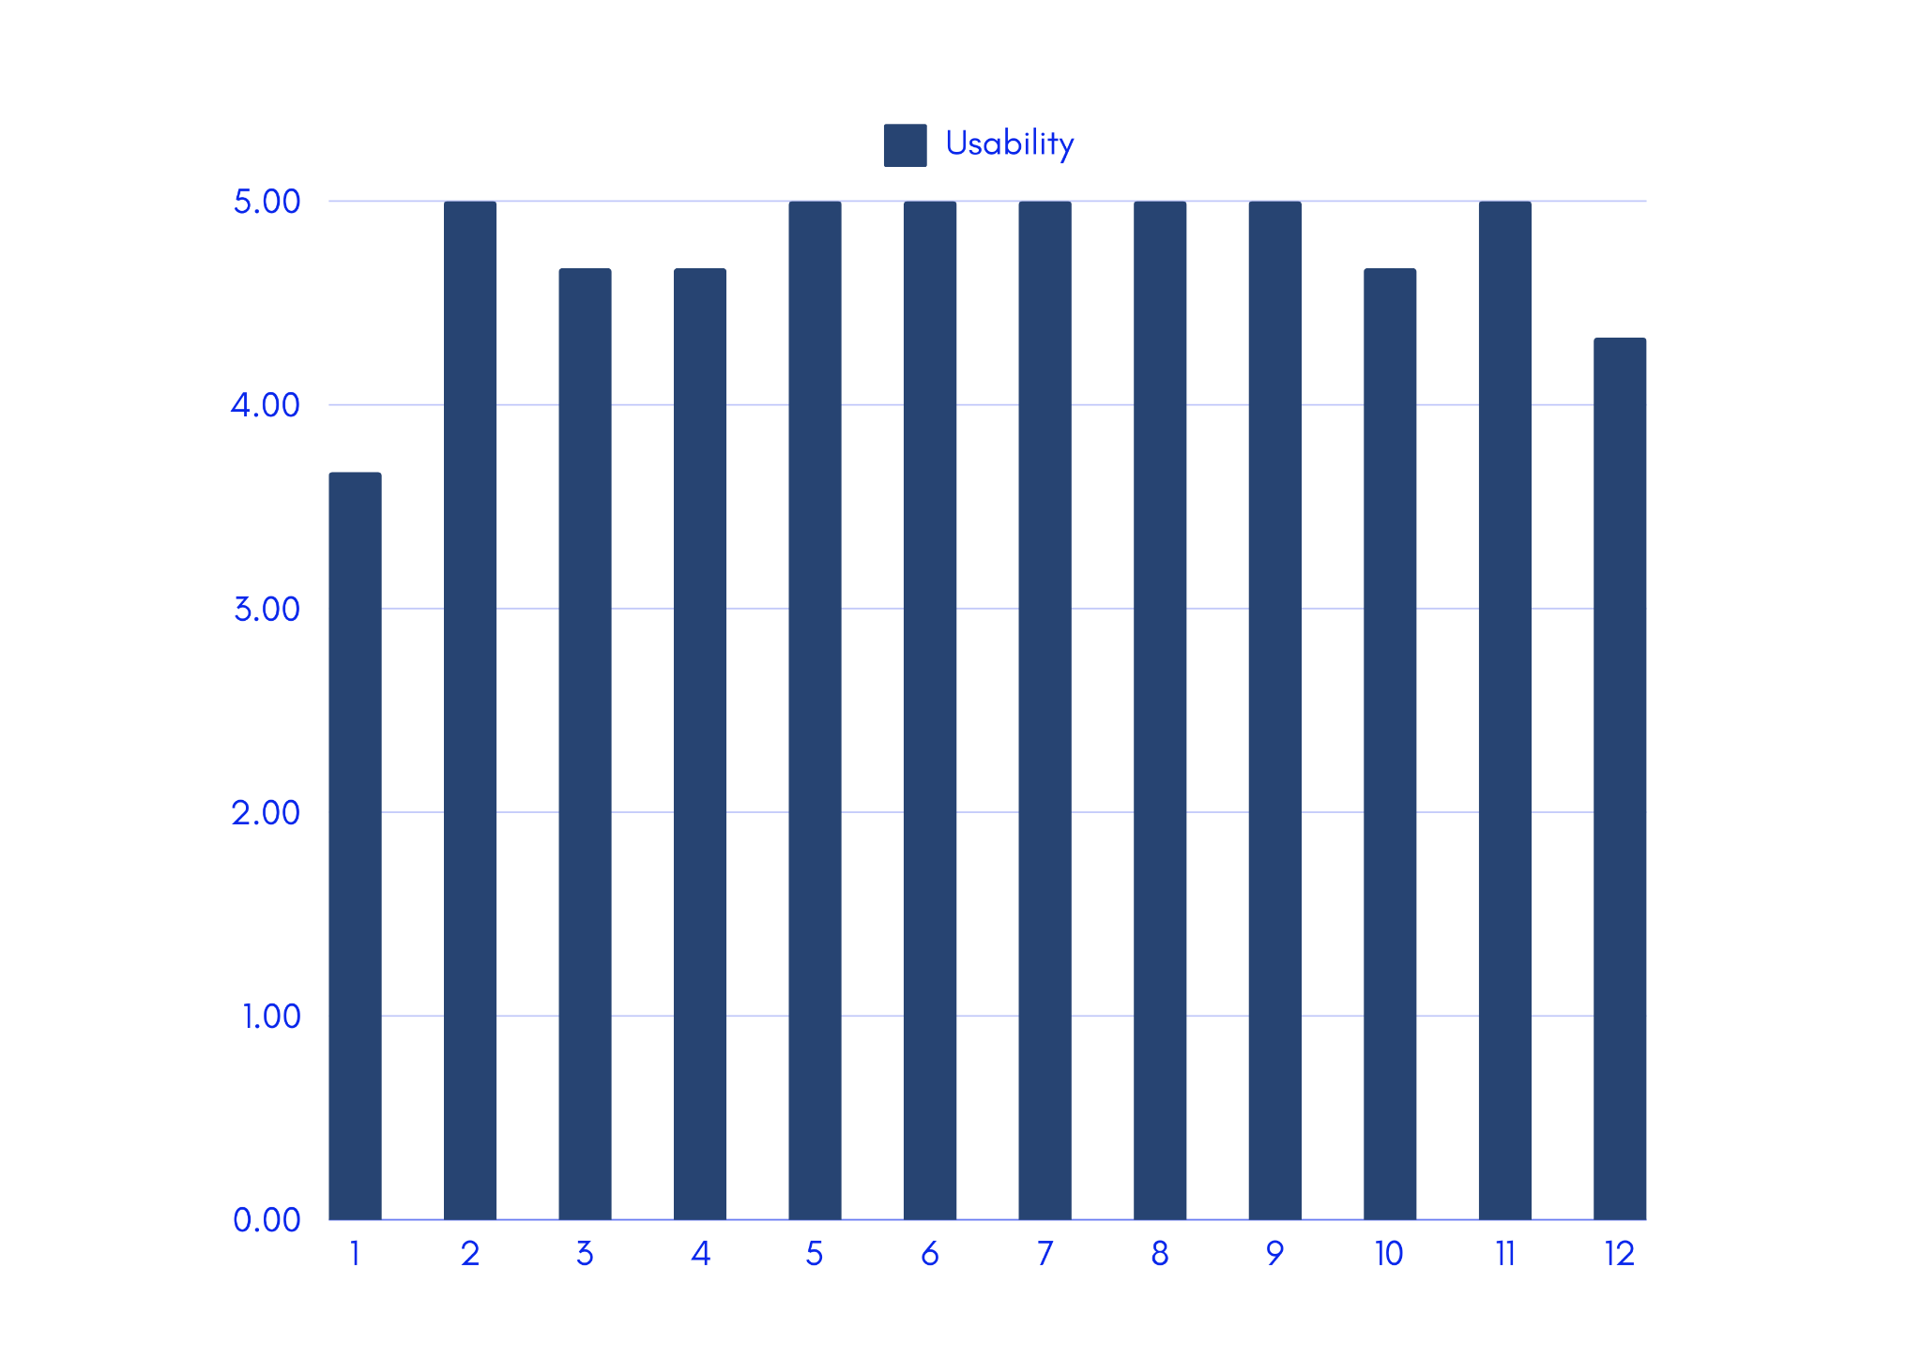

This highlights the overall feedback on the website application’s reliability, focusing on its accuracy, fault tolerance, and predictability.

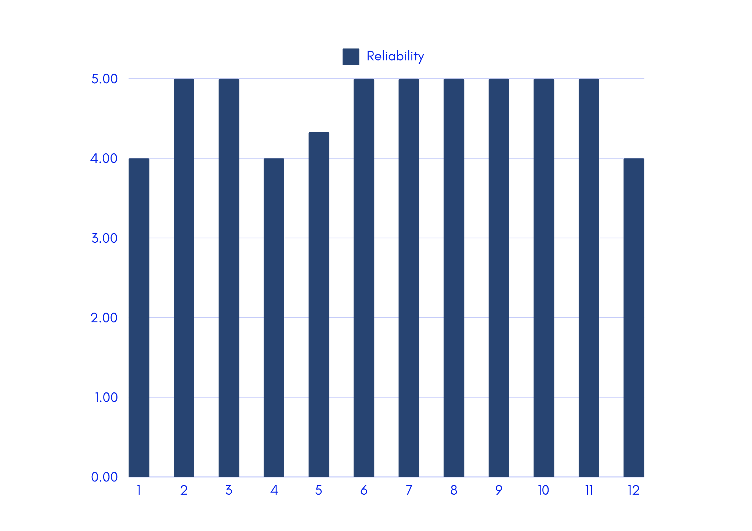

This highlights the overall feedback on the website application’s performance, focusing on its response time, resource consumption and through put.

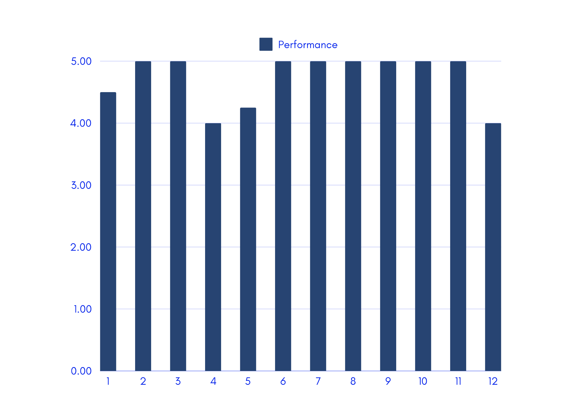

This highlights the overall feedback on the website application’s supportability, focusing on its adaptability.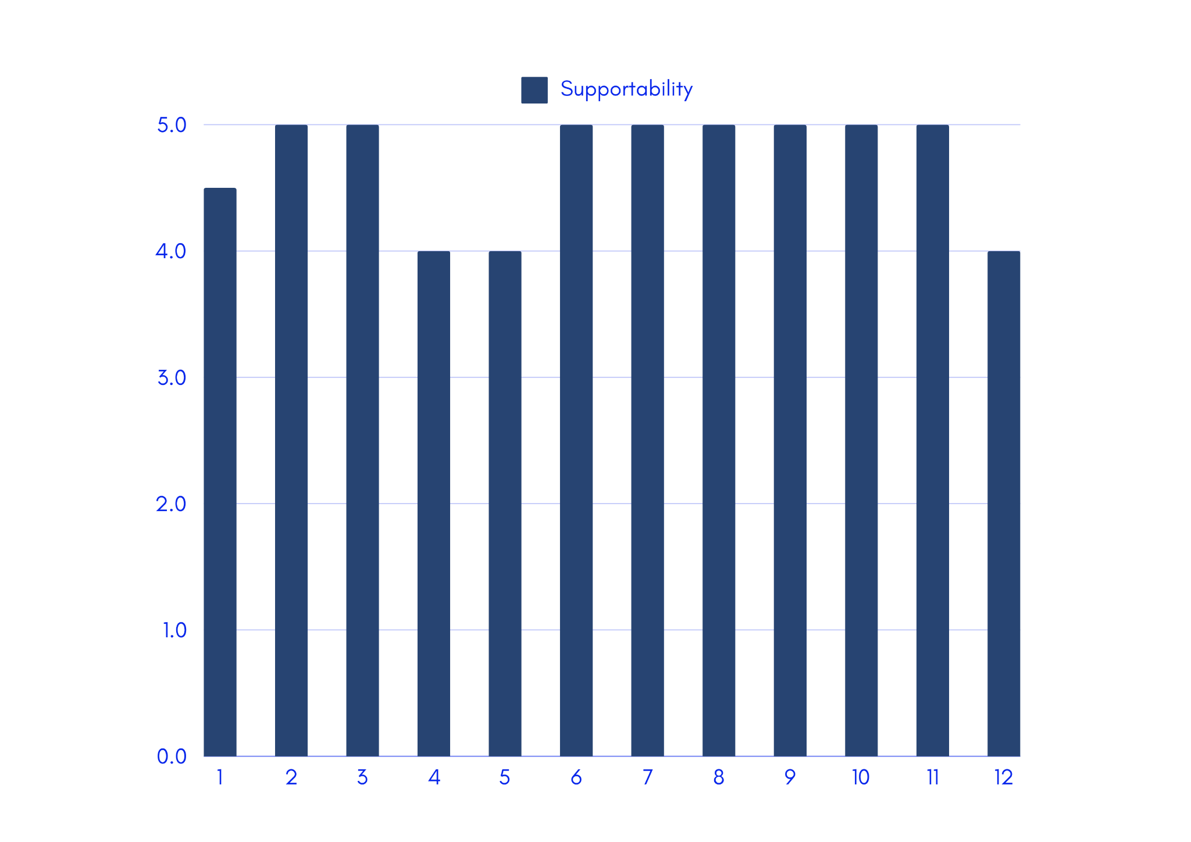

***Summary of Findings (by Item in the Questionnaire)***

The summary of findings gathered from the elementary school teachers - per item in the questionnaire, particularly questions that outlines Functionality, Usability, Reliability, Performance and Supportability, is shown in Table 14. The average of all scores, in which the website application’s functionality got an overall average score of 4.72, which corresponds to a *highly acceptable* user experience and satisfaction *(see Figure 6)* and standard deviation ranging from 0.28 to 0.62, indicating a relative pattern from low to moderate variability (see Figure 7).

**Table 14.**

*FURPS Website Evaluation Tabulated Results by Item (Elementary School Teachers)*

|  |  |  |  |  |  |  |  |  |  |
| --- | --- | --- | --- | --- | --- | --- | --- | --- | --- |
|  | **Question** | **1** | **2** | **3** | **4** | **5** | **Ave. Score** | **Int** | **Σ** |
| **Functionality** | | | | | | | | | |
| 1. | The website includes all necessary features for grade prediction (e.g., data input, records of data). | 0 | 0 | 1 | 1 | 10 |  | Highly Acceptable | 0.60 |
| 2. | The website aligns with the objectives of predicting students' academic performance. | 0 | 0 | 1 | 2 | 9 | 4.67 | Highly Acceptable | 0.62 |
| **Usability** | |  |  |  |  |  |  |  |  |
| 3. | Website user-friendly and easy to navigate. | 0 | 0 | 1 | 2 | 9 | 4.67 | Highly Acceptable | 0.62 |
| 4. | Overall appearance of the website. (Font, color, style, etc.). | 0 | 0 | 0 | 1 | 11 | 4.92 | Highly Acceptable | 0.28 |
| 5. | The website's layout is consistent and structured, making it easy to explore and use. | 0 | 0 | 0 | 3 | 9 | 4.75 | Highly Acceptable | 0.43 |
| **Reliability** | |  |  |  |  |  |  |  |  |
| 6. | The website provides an accurate result expected output. | 0 | 0 | 0 | 4 | 8 | 4.67 | Highly Acceptable | 0.47 |
| 7. | The website function consistently without crashing  or technical issues. | 0 | 0 | 0 | 4 | 8 | 4.67 | Highly Acceptable | 0.47 |
| 8. | Predictions generated by the website free from errors or inaccuracies. | 0 | 0 | 1 | 2 | 9 | 4.67 | Highly Acceptable | 0.62 |
| **Performance** | |  |  |  |  |  |  |  |  |
| 9. | The website load and process data quickly, without significant delays. | 0 | 0 | 0 | 3 | 9 | 4.75 | Highly Acceptable | 0.43 |
| 10. | The website run smoothly without overloading system resources (e.g., memory, CPU). | 0 | 0 | 0 | 4 | 8 | 4.67 | Highly Acceptable | 0.47 |
| 11. | It has acceptable response and throughput time. | 0 | 0 | 0 | 3 | 9 | 4.75 | Highly Acceptable | 0.43 |
| **Supportability** | |  |  |  |  |  |  |  |  |
| 12. | The website be adapted to different educational contexts (e.g., different grade levels). | 0 | 0 | 0 | 4 | 8 | 4.67 | Highly Acceptable | 0.47 |
|  | Overall | 0 | 0 | 4 | 33 | 107 | 4.72 | Highly Acceptable | 5.94 |

**Figure 7.**  *FURPS Website Evaluation Illustrated Average Scores (Elementary School Teachers)*

Figure 7 displays the average scores derived from the overall responses of the elementary school teachers, showing that the overall feedback on the website application is *highly acceptable*.

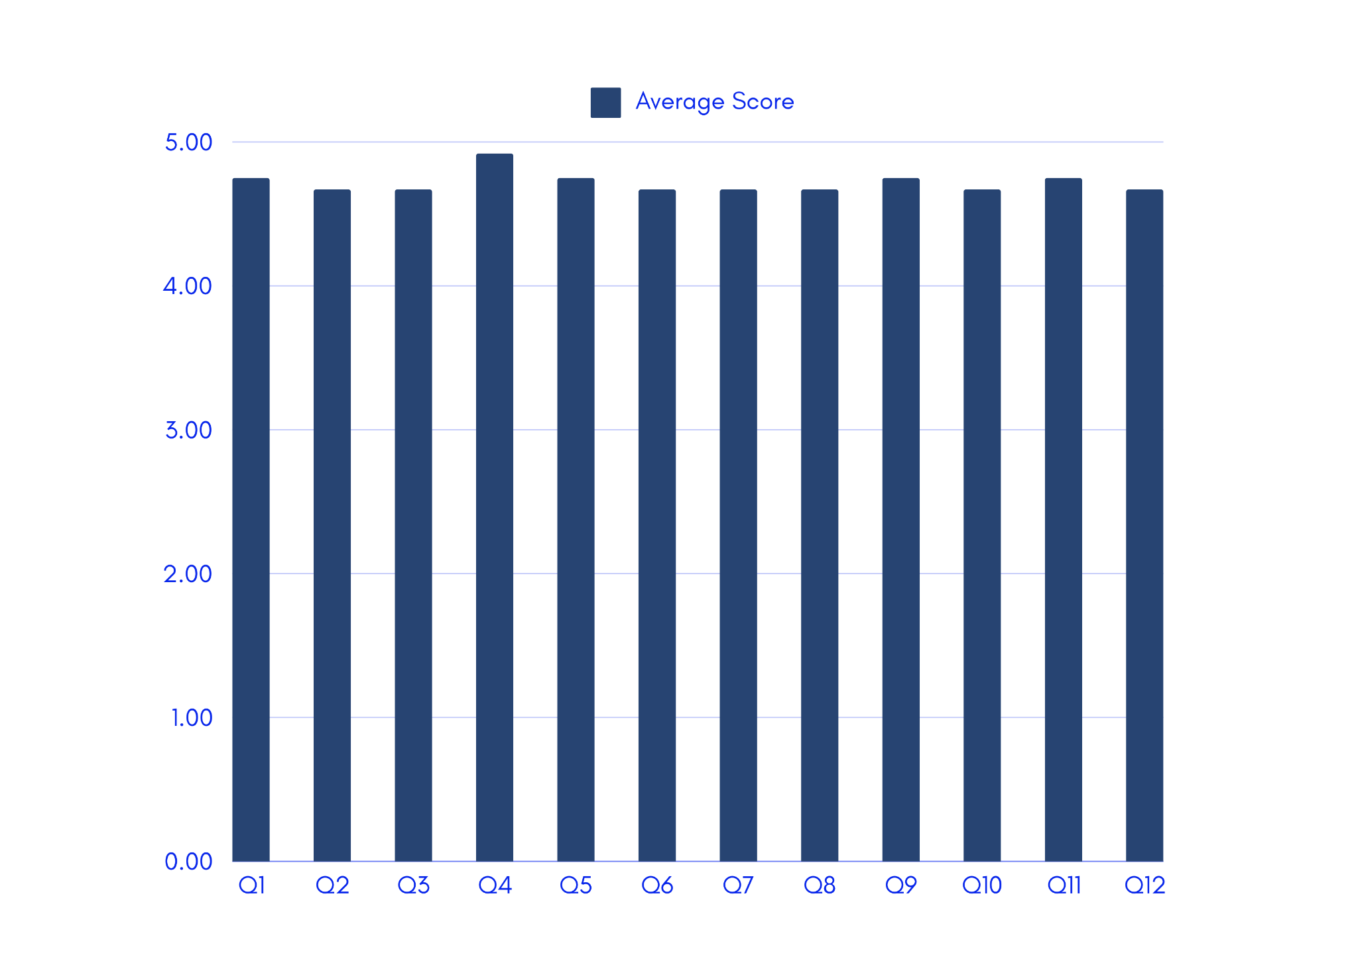

**Figure 8.** *FURPS Website Evaluation Illustrated Standard Deviation (Elementary School Teachers)*

Figure 8 displays the standard deviation derived from the overall responses of the elementary school teachers, showing that the overall feedback on the website application indicates relative consistency among the data points for each question.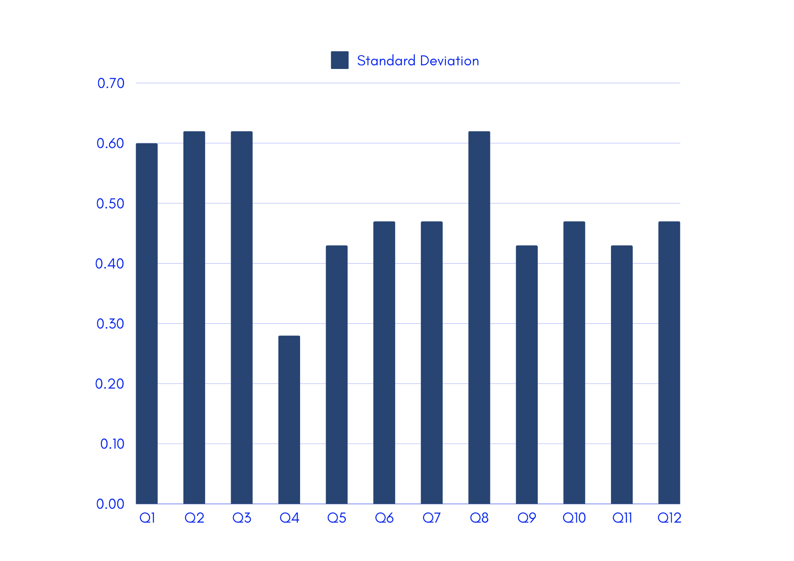

**Field Experts**

***Summary of Findings (by Requirements)***

From the responses of three (3) Field Experts who were part of the research, they have answered the survey questions about the website application the researchers deployed. The experts were asked to give their suggestions on how to improve the website application at the last part of the survey. The researchers wanted an in-depth analysis about the usability portion of the website which is why the researchers required the suggestion box.

**Table 15.**

*FURPS Website Evaluation Tabulated Results by Requirements (Field Experts)*

|  |  |  |  |  |  |  |  |
| --- | --- | --- | --- | --- | --- | --- | --- |
| **Experts** | **F** | **U** | **R** | **P** | **S** | **Overall Average** | **Interpretation** |
| 1 | 4 | 4 | 4 | 3.75 | 4 | 3.95 | Very Acceptable |
| 2 | 3 | 2 | 3 | 3 | 2 | 2.6 | Fairly Acceptable |
| 3 | 4.5 | 4 | 4.33 | 4 | 4 | 4.17 | Very Acceptable |

**Figure 9.**

*FURPS Website Evaluation Illustrated Results by Requirements (Field Experts)*

Figure 9 presents the results for each five requirements and corresponding evaluation scores from the field experts, starting with Functionality. This figure highlights the overall feedback on the website application’s functionality, focusing on its compliance and suitability.

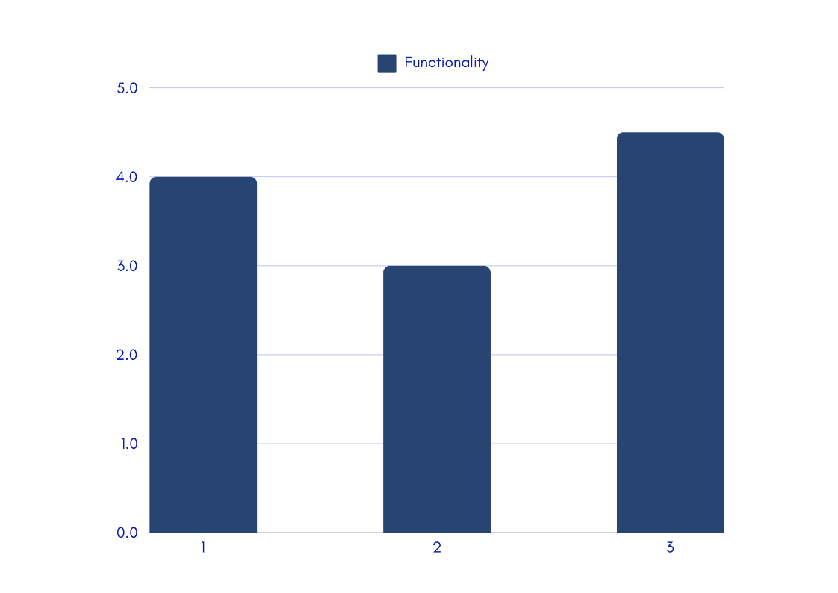

This highlights the overall feedback on the website application’s usability, focusing on human factors, overall aesthetics, and consistency.

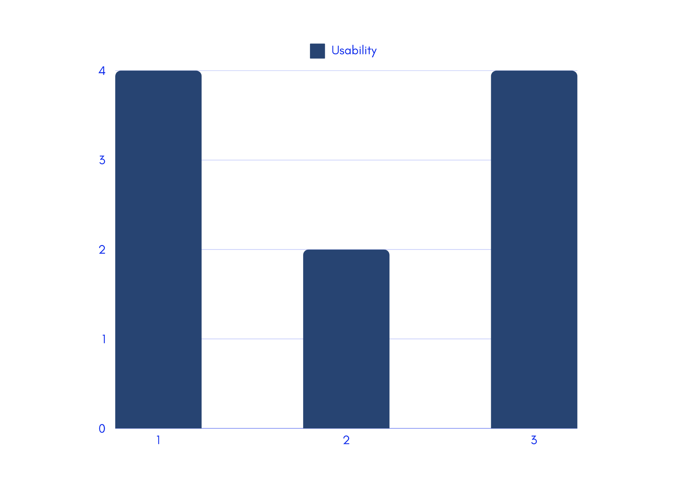

This highlights the overall feedback on the website application’s reliability, focusing on its accuracy, fault tolerance, and predictability.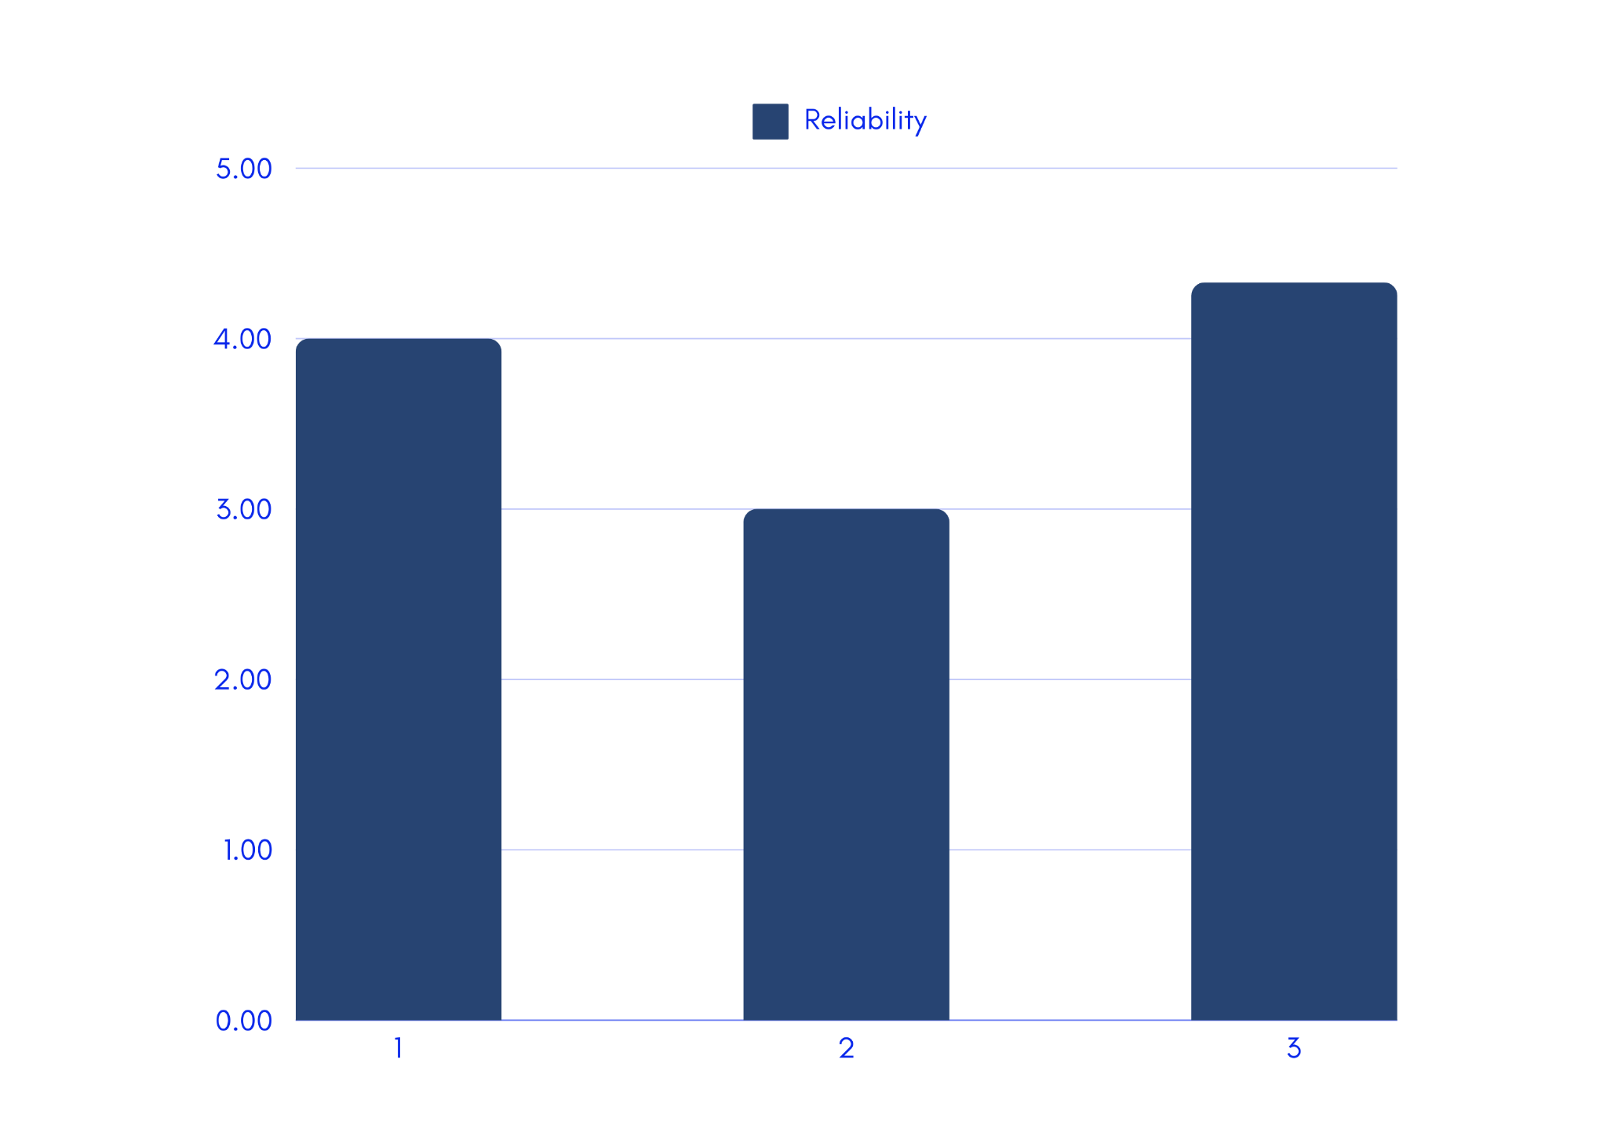

This highlights the overall feedback on the website application’s performance, focusing on its speed of processing, resource consumption, throughput and efficiency.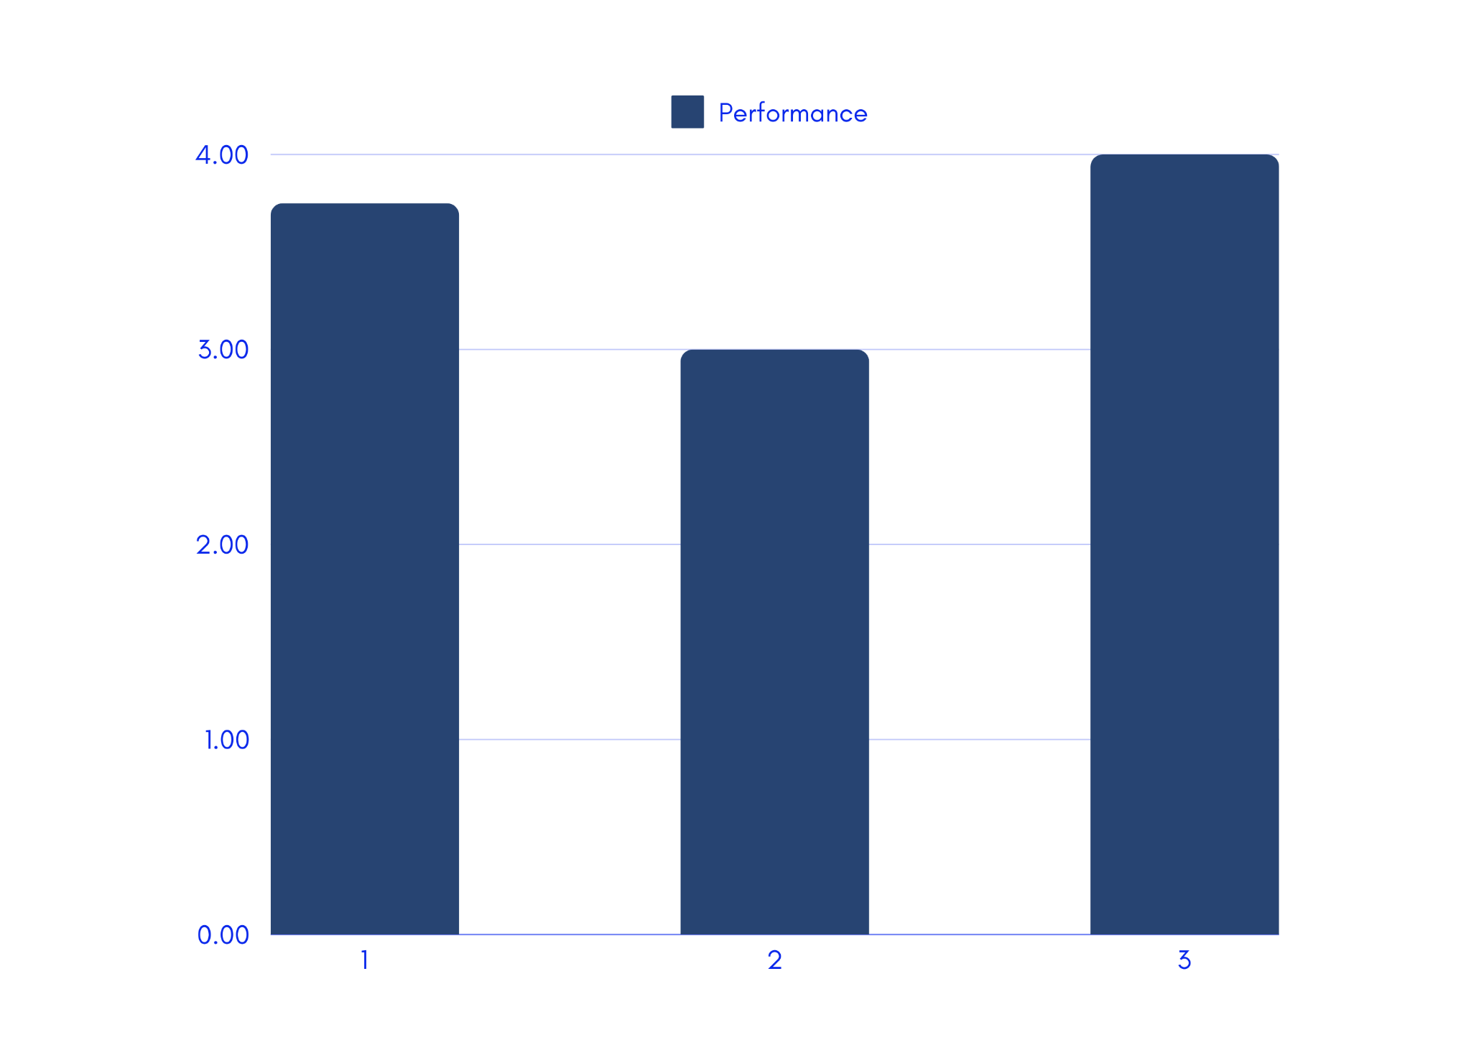

This highlights the overall feedback on the website application’s supportability, focusing adaptability and configuration.

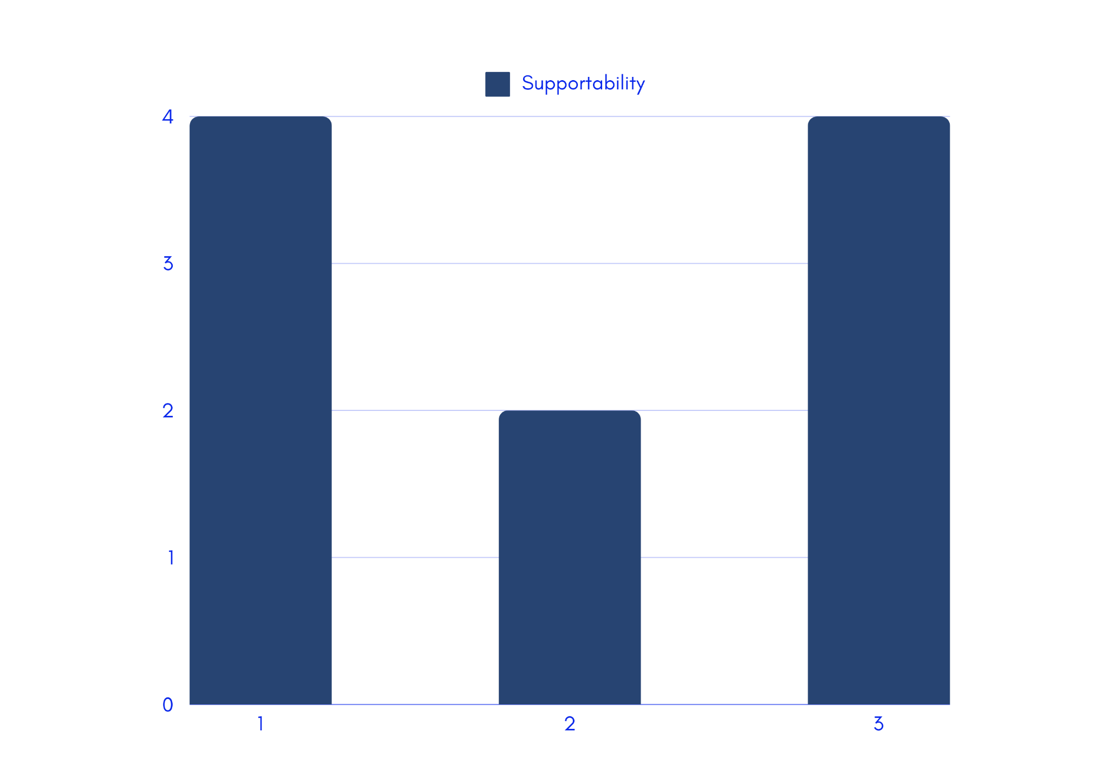

***Summary of Findings (by Item in the Questionnaire)***

The summary of findings gathered from the expert-participants per item in the questionnaire, particularly Functionality, Usability, Reliability, Performance and Supportability, is shown in Table 16. The average of all scores then reveals an overall average score of 3.57 (see Figure 9), which corresponds to a *very acceptable* user experience and satisfaction and a standard deviation ranging from 0.00 to 0.94, indicating a mixed pattern of consistency and variability.

**Table 16.**

*FURPS Website Evaluation Tabulated Summary by Item (Field Experts)*

|  |  |  |  |  |  |  |  |  |  |
| --- | --- | --- | --- | --- | --- | --- | --- | --- | --- |
|  | **Item** | **1** | **2** | **3** | **4** | **5** | **Ave. Score** | **Int** | **σ** |
| **Functionality** | |  |  |  |  |  |  |  |  |
| 1. | The website addresses the defined set of features needed (manual input/file upload, user login, data set, user index, and prediction results). | 0 | 0 | 1 | 2 | 0 | 3.67 | Very Acceptable | 0.47 |
| 2. | The website has completed the necessary set of features following its primary objectives. | 0 | 0 | 1 | 1 | 1 | 4.00 | Very Acceptable | 0.82 |
| **Usability** | |  |  |  |  |  |  |  |  |
| 3. | Easy for the user to learn and operate its application. | 0 | 1 | 0 | 2 | 0 | 3.33 | Acceptable | 0.94 |
| 4. | Overall appearance of the website. (Font, color, style, etc.) | 0 | 1 | 0 | 2 | 0 | 3.33 | Acceptable | 0.94 |
| 5. | Website design is applicable and it conforms to the standard. (Design is not mixed up) | 0 | 1 | 0 | 2 | 0 | 3.33 | Acceptable | 0.94 |
| **Reliability** | |  |  |  |  |  |  |  |  |
| 6. | The website provides an accurate result expected output. | 0 | 0 | 1 | 1 | 1 | 4.00 | Very Acceptable | 0.82 |
| 7. | It has the ability to a specified level of performance in case of failure. | 0 | 1 | 0 | 2 | 0 | 3.33 | Acceptable | 0.94 |
| 8. | The website operates in a consistent and expected manner, regardless of different inputs. | 0 | 0 | 0 | 3 | 0 | 4.00 | Very Acceptable | 0.00 |
| **Performance** | |  |  |  |  |  |  |  |  |
| 9. | Processing speed is equivalent to the user's expectations or standards. | 0 | 0 | 2 | 1 | 0 | 3.33 | Acceptable | 0.47 |
| 10. | The website makes efficient use of system resources to carry out its activities/functions. | 0 | 0 | 1 | 2 | 0 | 3.67 | Very Acceptable | 0.47 |
| 11. | It has acceptable response and throughput time. | 0 | 0 | 1 | 2 | 0 | 3.67 | Very Acceptable | 0.47 |
| 12. | The website is competent, well-organized, and effective. | 0 | 0 | 1 | 2 | 0 | 3.67 | Very Acceptable | 0.47 |
| **Supportability** | |  |  |  |  |  |  |  |  |
| 13 | It could adapt to different environments without applying other functions to it. | 0 | 1 | 0 | 2 | 0 | 3.33 | Acceptable | 0.94 |
| 14. | It is maintainable and is easy to modify the website and remove faults. | 0 | 1 | 0 | 2 | 0 | 3.33 | Acceptable | 0.94 |
|  | Overall | 0 | 6 | 8 | 26 | 2 | 3.57 | Very Acceptable | 0.69 |

**Figure 10.** *FURPS Website Evaluation Illustrated Average Scores (Field Experts)*

Figure 10 displays the average scores derived from the overall responses of the field experts, showing that the overall feedback on the website application ranges from *acceptable* to *highly acceptable*.

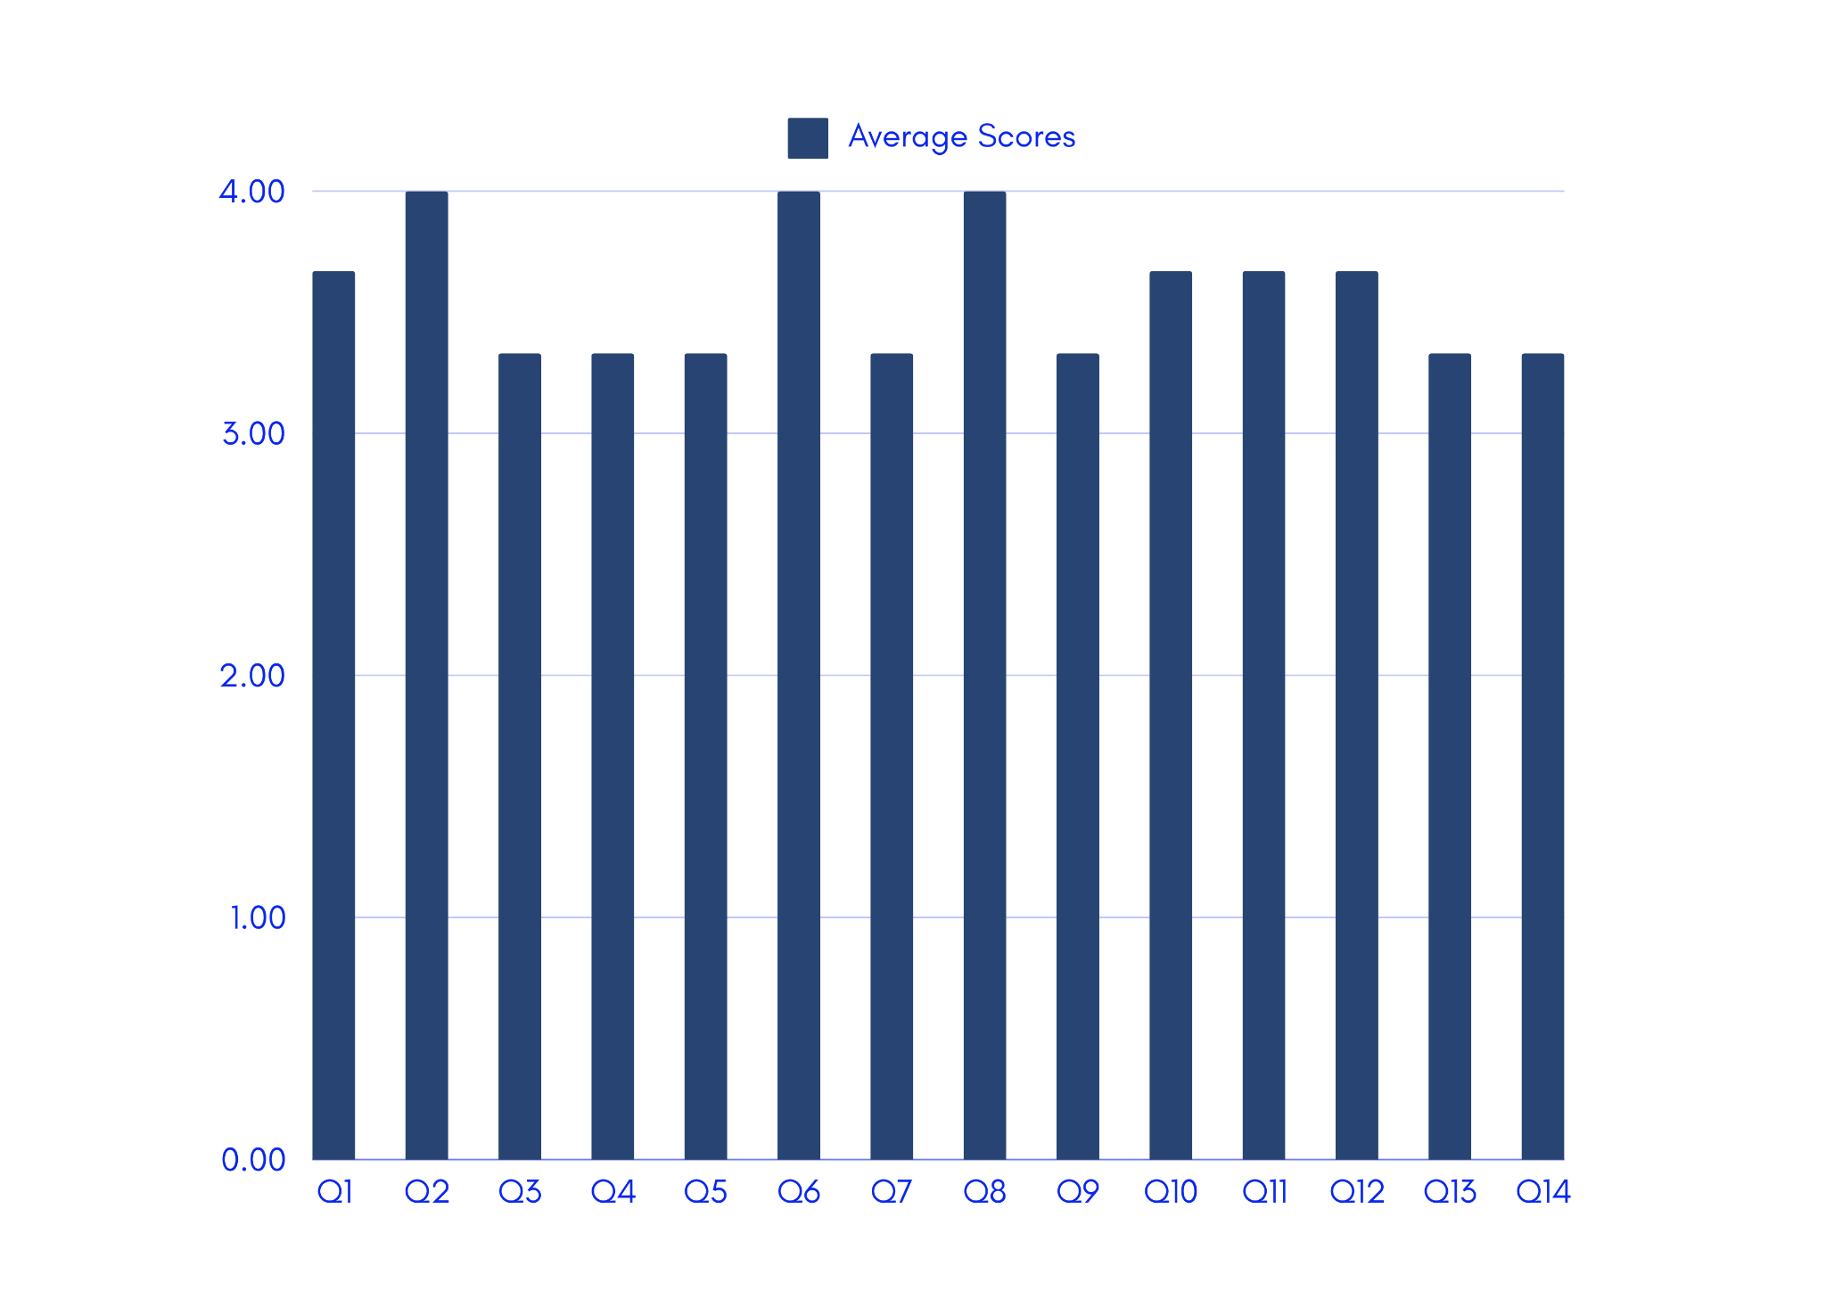

**Figure 11.** *FURPS Website Evaluation Illustrated Standard Deviation (Field Experts)*

Figure 11 displays the standard deviation derived from the overall responses of the filed experts, showing that the overall feedback on the website application indicates varying levels of consistency and variability among the data points for each question.

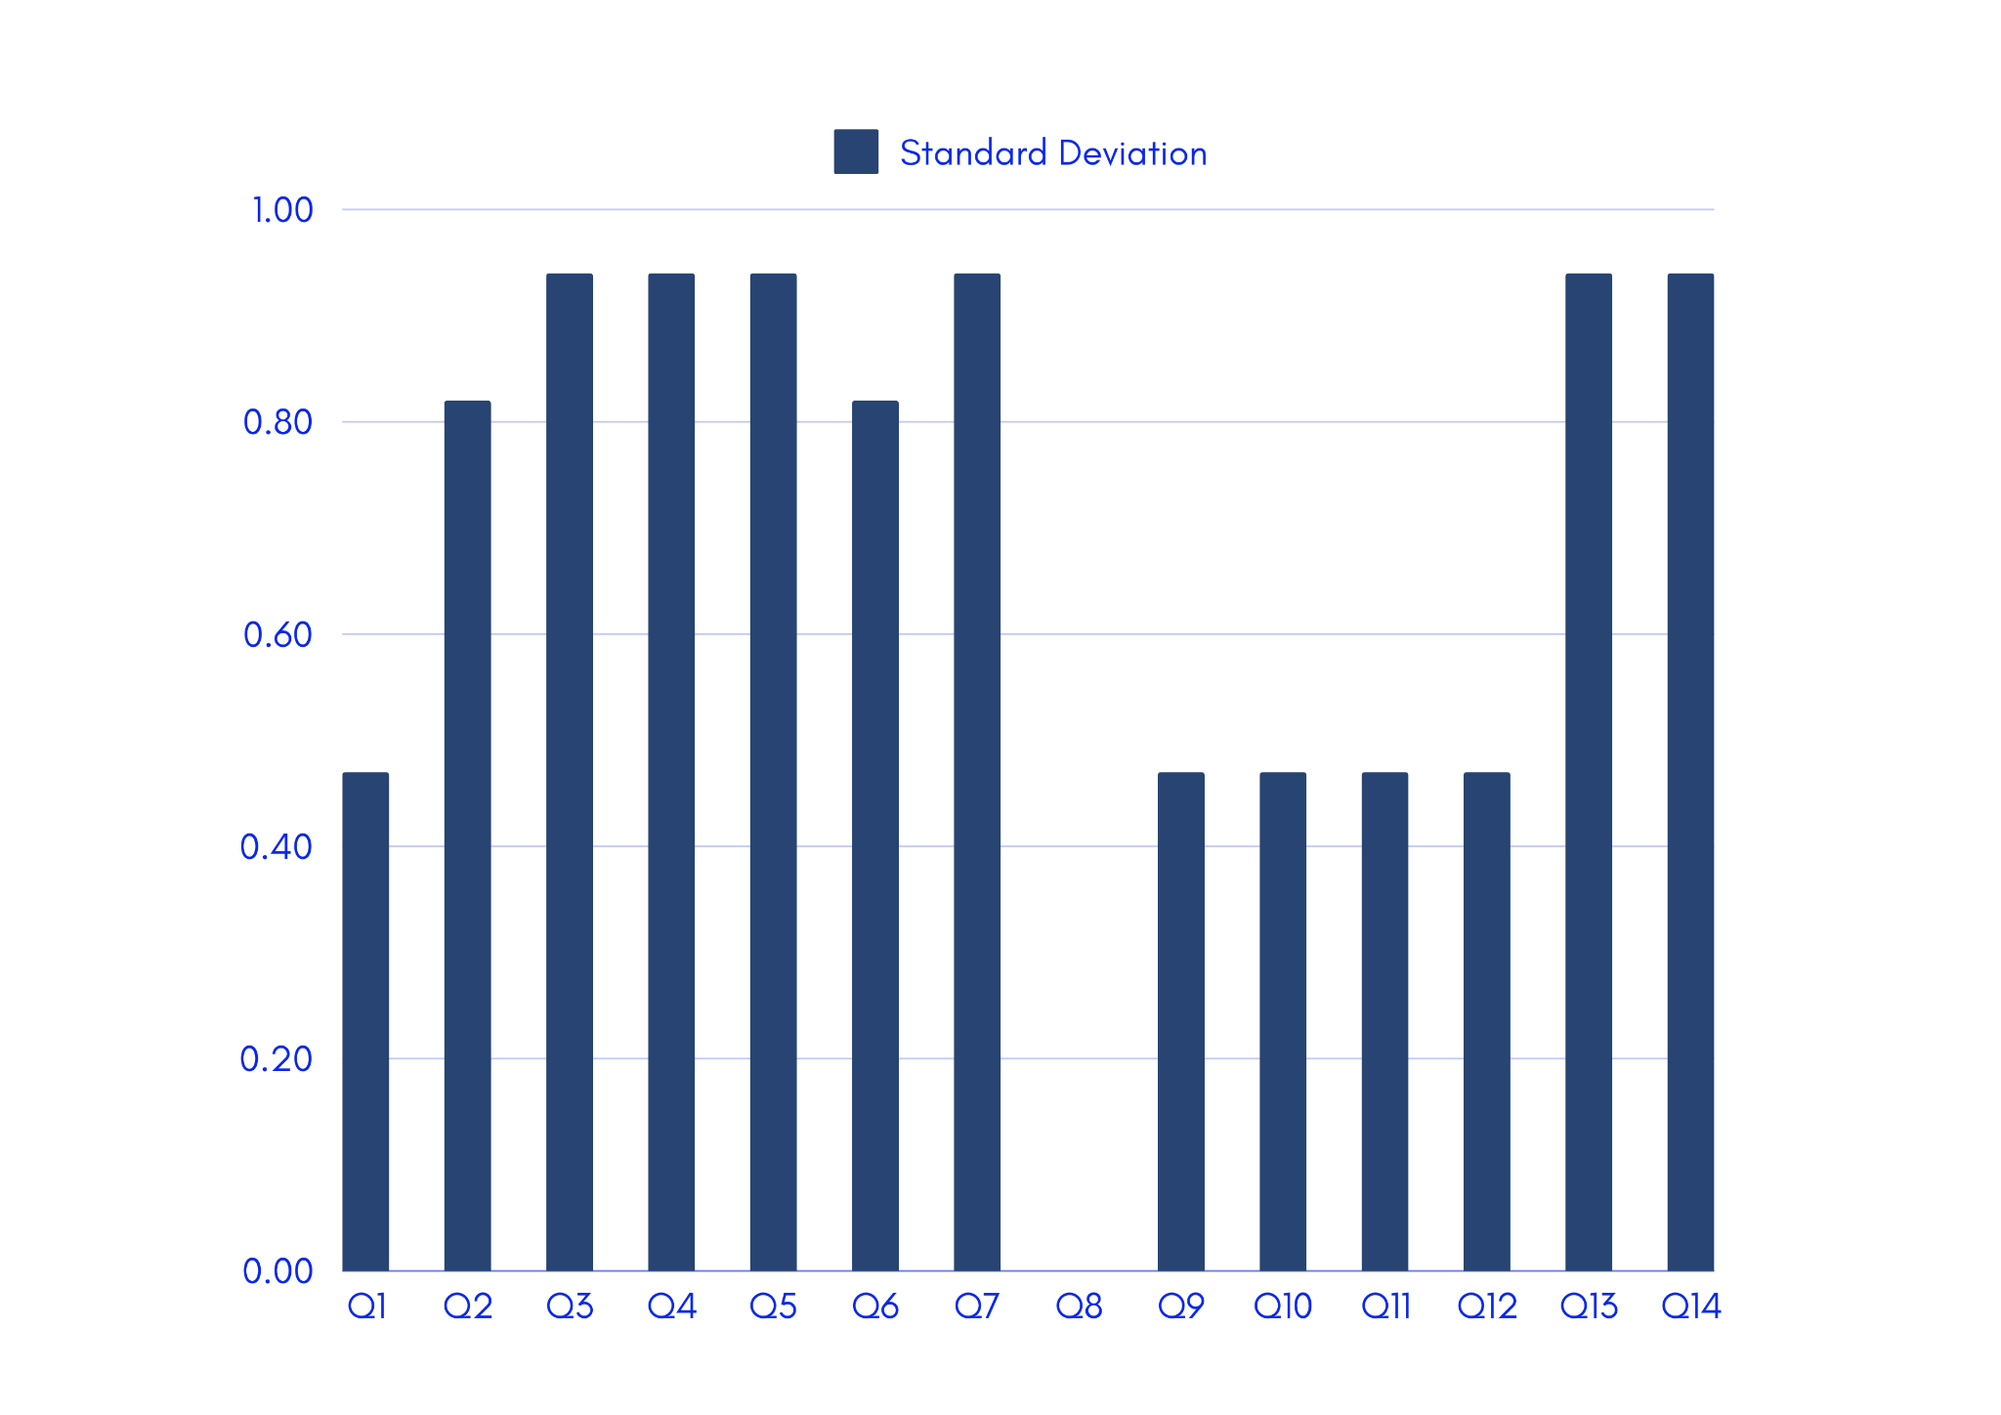

# **Discussion**

A structured and iterative approach was used incorporating both the web development cycle and machine learning life cycle to ensure the effectiveness of both the machine learning model and web application. The researchers first collected 76 data sets, each containing features such as attendance, previous GPA, financial situation, and learning environment. Random Forest Regressor was trained by splitting the dataset into 80% training, 10% validation, and 10% testing. The validation datasets were used to improve the performance of the model, while the datasets used for training dataset recognizes the patterns and relationship within the data and the testing dataset used to test the performance of the model of unseen data. This ensured that the model was not only trained but also validated and tested on separate portions of the data, allowing to effectively evaluate its generalization.

Iterations involved hyperparameter tuning with decision trees set at 50 and 100. On the other hand, the researchers discovered that the parameter, the number of decision trees in the model was bigger than what was necessary given the comparatively small number of our dataset. This led to model overfitting, where the model performed well on training data but poorly on unseen data. To address this, we made the model simpler by reducing the number of decision trees to 10 and 50 in the hyperparameter which will reduce the variance and allow the model to generalize better.

After tuning the model, the researchers used different metrics to gauge how well it performed. The training set showed some good results, however, the validation set showed a Mean Absolute Error (MAE) of 2.578, a Mean Squared (MSE) of 8.950, and an R2 Score of 0.764. The test set review witnessed a MAE of 1.737, MSE of 5.330, R2 of 0.743. These metrics demonstrated the model’s capability while also revealing areas for further improvement. The evaluation emphasized the importance of balancing model complexity with the available data.

While developing the machine learning model, the researchers worked on implementing the web application called the “Grade Predictor App”, together using Flask as the backend. SQLAlchemy was chosen as the database management system to handle user inputs and store predictions. The web application was deployed in Render, which provided a reliable and scalable environment with minimal setup effort, making it ideal for the web application. The website was tested using data that was input manually and also using file uploads. To ensure the data that was submitted is correctly given back across the backend and with the trained random forest model. During this phase, the researchers found a key drawback of the model that most of the time, the model was predicting grades in the range of 80 to 85, regardless of the input features provided. This problem can be attributed to the small size of our dataset, the model found it difficult to learn patterns and relationships that are between its input features.

The researchers were able to gather the actual grades for the first quarter of the current grade 6 students, with these gathered data, the researchers compared the prediction of the model to the actual data. The findings the researchers highlighted were about the MAE and MSE of the model and the results of both the actual and predicted data. The model had a lower MAE which meant that the model had a higher error rate than expected, however with a lower MSE it meant that the model was better at generalizing unseen data than the researchers expected. With these highlights in mind, the researchers concluded that the model was predicting rather than just memorizing the data, which meant that the model was not overfitted and was a success.

The researchers surveyed the three (3) field experts and twelve (12) elementary school teachers. After the researchers surveyed the respondents and processed the data, the highlights that were seen were the differences between the experts and the teachers, the teachers mostly answered acceptable and higher while the experts gave their evaluation from barely acceptable to highly acceptable.

The data gathered about the website application from the teachers gave similar results with the highest result being the overall appearance of the application. In contrast to the experts, who had different results and only came to an agreement that the website operated in a very acceptable manner and that the website had acceptable processing speed. Another highlight that can be seen is that one expert gave the website barely acceptable design, the researchers took this advice and modified the website. After taking these insights, the researchers interpreted these results and concluded that for the teachers, the website was very acceptable and appealing to them while for the experts there were nuances that should be fixed.

## Conclusion

Education plays an important role in our lives and continues to enhance students' learning abilities. Students' performance is reflected in the level of achievement they accomplish throughout their academic school year. Beginning their education journey at a young age, these primary students steadily progress until they graduate, marking the start of a new chapter as young teenagers, where they will develop new skills and further expand their intellectual capacity. Graduation is the reward of completion among students who worked hard until the end, demonstrating their tenacity and resilience at a young age. Their performances are calculated based on their general point average (GPA) that measures the academic performance of a student, indicating that the student has either passed, failed or maintained his/her performance. Considering that various factors can cause inconsistencies in students' performance, such as a student whose grade dropped from high to low, this research focused on four (4) factors that affect the academic performances of students: (1) previous GPA records, (2) attendance records, (3) learning environment, and (4) family financial situation.

The researchers were able to achieve the objectives of the studies which involved the gathering of data, developing random forest algorithm for prediction of academic performance, evaluating the accuracy and efficiency of the model, utilize the predictive model on a website application, and evaluation of the website application’s capabilities. These objectives were as follows:

**Gather and preprocess previous grades covering the grade point average (GPA), along with attendance records, from grade 3 of the current batch of grade 6 students. *Gathered and Pre-processed Data.*** The researchers gathered these data via a survey questionnaire to gather their family’s financial situation and an interview was conducted with their advisers to get their learning environment. After that, the researchers excluded students who did not pass the questionnaires by the given deadline to their advisers resulting in these students getting a financial score of 0.

**Develop a random forest regression model to predict students’ academic performance using features including their GPA, attendance, financial situation, and learning environment.** The researchers developed the model implementing random forest regression that was able to predict students' future academic performance using the features GPA, attendance, financial situation, and learning environment as the predictors for the model. The researchers trained the model with assistance from the AI expert validation and after following his advice, the model was tuned to the satisfaction of the researchers with an MAE of 1.737, MSE of 5.329 and a R2 of 0.796. One of the most useful tools in data science is the random forest algorithm. With the use of an effective machine-learning algorithm, it allows us to evaluate complicated datasets and generate accurate predictions. Multiple decision trees are combined into one model using the Random Forest technique. Every tree in the forest develops its own unique prediction based on an individual part of the data. The weighted average of all the predictions made by each individual tree serves as the basis for the final input prediction (AnalytixLabs, 2023).

**Evaluate the model's accuracy and efficiency by comparing its predictions with actual grades using the collected data for analysis.** The researchers gathered the actual first quarter grades of the current grade 6 students and compared these grades to the predicted grades of the model (see Appendix Q). Out of 76 students, the average of the actual grades was 83.8211, the average of the predicted grades was 81.7734.

**Develop a website application to facilitate the utilization of the predictive model.** The researchers developed a website application named as “Grade Predictor App”, that requires the users to log in and the researchers utilized a database for the authorization of the users. The website contains a CSV file template that can be downloaded and uploaded by the users for batch prediction of the students. The CSV file contains the school days present, number of school days, financial situation, learning environment, and previous GPA of the student. The website application also supports manual input of these features for a single prediction output. The website application utilized a database that stores these features including the predicted output for the user interface.

**Evaluate the website application’s ability to consistently operate without errors, offers easy navigation, responds efficiently and perform its intended features, including prediction results and tasks, for its users and purpose.** The website was evaluated based on the evaluation tool, a 5-point Likert Scale, to evaluate the website answered by the system evaluators, composing elementary school teachers and field experts. The evaluation gathered from the elementary school teachers resulted to highly acceptable and from field experts resulted in very acceptable. This explains their overall user experience and satisfaction upon using the website application. The website underwent two design changes which were advised by the Website Application expert and with his validation, the website application was deemed satisfactory for this research.

The aim of this research was to use machine learning to develop a grade prediction app with a multi-level classification in a web application. This research identified attendance as the significant factor affecting academic performance amongst the graduating elementary students. With a rate of 5.329 MSE (see Table 9), indicating that the refined model showed greater results compared to the baseline model from predicting the unseen data.In some way, the evaluations and tests demonstrated that the application effectively integrated all of the components and complied with all specified requirements. These components included a database of students’ data, prediction with multi-level classification, login page, single input analysis and CSV file input analysis.

This research has developed a tool that not only achieves its goals but also benefits the academic system by effectively creating a grade prediction model. Elementary teachers can use the web application as an administrative hub to evaluate students' academic performance early on and modify their lesson plans, visual aids, and other instructional resources.

## 

## Recommendations

In this section, the following actions are recommended for future related projects/research based on the findings and results of this research:

* **More dataset.** Feeding additional data into the Random Forest Algorithm might result in improved accuracy and more precise prediction results. Due to constraints such as time and data confidentiality issues, the current dataset utilized in this research is restricted to what the researchers were able to gather. Future studies may resolve the dataset's shortcomings, resulting in more trustworthy and accurate results.
* **User Access Level.** Improving the accessibility and security on school administrators, such as the Principal and Head Teachers, allowing them to monitor the data inputted on the database and users who logs in and out of the website. Also, this allows school administrators to easily identify whose students are improving or those who need improvement.
* **Broader scope of locale.** Broader scope of locale. This research’s locale focused on graduating elementary students studying at San Pedro Elementary School (SPES), offering quality education to children from kindergarten through grade 6. While this research specifically targets elementary students, it can serve as a reference for future researchers performing research on the academic performance of graduating high school students. Expanding the scope enables future studies to explore factors affecting older students and obtain a better understanding of the learning experience across different educational stages.
* **More predictors.** This research focused on quantifiable factors, such as attendance, learning environment, financial situation, and previous GPA, having more predictors can make the prediction of grades in the model find better compatibility. With more predictors, the model can generate complex relationships that can aid the future researchers look into what predictors affect students the most.
* **Cultivate academic support.** Schools can produce action plans that would integrate approaches for supporting or improving their students’ academic performance. Identifying students who appear to experience struggling, enhancing or maintaining their academic performance can be valuable for future research aiming to implement effective academic support systems. The Grade Predictor App can be used to identify students who may need additional support or intervention.
* **Comparison to Private School.** Considering that this research focused on a public school, future researchers can use this research as a foundation to compare the findings those from a private school. By analyzing comparative results, future researchers can reveal what significant factor/s affects academic performance and what similarities occurs in terms of different educational sectors.

# **References**

Abdullah, N. A., & Mirza, M. S. (2019). Predicting Academic Performance in Undergraduate Online Degree Programs from Previous Academic Achievement in Pakistan. *Pakistan Journal of Distance & Online Learning*, *5*(2), 209-222.

Alboaneen D, Almelihi M, Alsubaie R, Alghamdi R, Alshehri L, Alharthi R. Development of a Web-Based Prediction System for Students’ Academic Performance. *Data*. 2022; 7(2):21. https://doi.org/10.3390/data7020021

Alshanqiti, A., & Namoun, A. (2020). Predicting student performance and its influential factors using hybrid regression and multi-label classification. *IEEE Access*, *8*, 203827-203844. <https://doi.org/10.1109/access.2020.3036572>

Al-Tameemi, R., Johnson, C., Gitay, R., Abdel-Salam, A. G., Hazaa, K., BenSaid, A., & Romanowski, M. H. (2023). Determinants of poor academic performance among undergraduate students—A systematic literature review. *International Journal of Educational Research Open*, *4*, 100232. <https://doi.org/10.1016/j.ijedro.2023.100232>

AnalytixLabs. (2023, December 26). Random Forest Regression — How it Helps in Predictive Analytics? *Medium*. https://medium.com/@byanalytixlabs/random-forest-regression-how-it-helps-in-predictive-analytics-01c31897c1d4

*August 5, 2021 DO 029, S. 2021 – School calendar and activities for school year 2021-2022. (2021, August 5).* Department of Education. https://www.deped.gov.ph/2021/08/05/august-5-2021-do-029-s-2021-school-calendar-and-activities-for-school-year-2021-2022/

Bhat, A. (2023, October 31). Quantitative survey questions: Definition, types and examples. QuestionPro. https://www.questionpro.com/blog/quantitative-survey-questions/

Bosano, R. (2024, June 28). A month of teaching days lost due to extreme heat, other calamities: study. *ABS-CBN News*. https://news.abs-cbn.com/news/2024/6/28/a-month-of-teaching-days-lost-due-to-extreme-heat-other-calamities-study-1752

Camera, L. (2022, October 24). *Pandemic Prompts Historic Decline in Student Achievement on Nation’s Report Card*. U.S News. <https://www.usnews.com/news/education-news/articles/2022-10-24/pandemic-prompts-historic-decline-in-student-achievement-on-nations-report-card?fbclid=IwZXh0bgNhZW0CMTEAAR1mGHvUDYxhaVZA4u-VwBCN1yor5Oz4tyPdtYLJd2skmJIkUuiBsNckY7U_aem_xjTbGCD420-o-UFbjpeLBw>

Cattan, S., Kamhöfer, D. A., Karlsson, M., & Nilsson, T. (2022). The Long-Term Effects of Student Absence: Evidence from Sweden. The Economic Journal, 133(650), 888–903. https://doi.org/10.1093/ej/ueac078

Celko, J. (2010). Scales. In *Elsevier eBooks* (pp. 71–94). https://doi.org/10.1016/b978-0-12-374722-8.00004-9

*DepEd Data Bits: Learning Delivery Modalities (SY 2021-2022). (2022, July).* Department of Education. https://www.deped.gov.ph/alternative-learning-system/resources/facts-and-figures/datasets/?fbclid=IwZXh0bgNhZW0CMTEAAR0RwKeyzAZfBAws_vcaFM2Y5cEy2hc7yDVg3VWfe2f5A3jrvzDKl9J2slM_aem_sQpqC60uLkhw1QowqGaQpg

*DepEd prepares self-learning modules for education’s new normal. (2020, July 2).* Department of Education. https://www.deped.gov.ph/2020/07/02/deped-prepares-self-learning-modules-for-educations-new-normal/

DM 014, S. 2021 – Interim guidelines on the preparation, submission and checking of school forms for the SY 2020-2021. (2021, March 26). Department of Education. https://www.deped.gov.ph/2021/03/26/march-26-2021-dm-014-s-2021-interim-guidelines-on-the-preparation-submission-and-checking-of-school-forms-for-the-sy-2020-2021/

DO 012, S. 2020 – Adoption of the basic education learning continuity plan for school year 2020-2021 in the light of the COVID-19 public health emergency. (2020, June 19). Department of Education. https://www.deped.gov.ph/2020/06/19/june-19-2020-do-012-2020-adoption-of-the-basic-education-learning-continuity-plan-for-school-year-2020-2021-in-the-light-of-the-covid-19-public-health-emergency/

Gafarov, F., Rudneva, Y., Sharifov, U., Trofimova, A., & Bormotov, P. (2020). Analysis of students’ academic performance by using machine learning tools. *Proceedings of the International Scientific Conference “Digitalization of Education: History, Trends and Prospects” (DETP 2020)*. https://doi.org/10.2991/assehr.k.200509.104

Garcia, A. S., & De Guzman, M. R. T. (2020). The meanings and ways of parental involvement among low-income Filipinos. *Early Childhood Research Quarterly*, *53*, 343–354. https://doi.org/10.1016/j.ecresq.2020.05.013

GMA Integrated News. (2024, May 5). DepEd wants End of School Year rites indoors, in covered courts. *GMA News Online*. https://www.gmanetwork.com/news/topstories/nation/905797/deped-wants-end-of-school-year-rites-indoors-in-covered-courts/story/

Hart, S. R., Stewart, K., & Jimerson, S. R. (2011). The student engagement in schools questionnaire (SESQ) and the teacher engagement report form-new (TERF-N): Examining the preliminary evidence. Contemporary School Psychology, 15(1), 67-79. https://doi.org/10.1007/bf03340964

Hewinson, P. (2021, December 9). Building a web app to save teachers time and help students learn. *Medium*. https://philhewinson.medium.com/building-a-web-app-to-save-teachers-time-and-help-students-learn-3118dce9994f

Hossain, M.K., Mahfuz, T., Latif, S. and Hossain, M.E. (2023), "Determinants of financial stress among university students and its impact on their performance", *Journal of Applied Research in Higher Education*, Vol. 15 No. 1, pp. 226-237. https://doi.org/10.1108/JARHE-02-2021-0082

Hu, R. (2021). *Machine learning model-development lifecycle | office of the CTO blog*. vmware. https://octo.vmware.com/machine-learning-model-development-lifecycle/

Husaini, Y. A., & Shukor, N. A. (2023). Factors affecting the academic performance of students. Journal of Education and Practice. https://doi.org/10.7176/jep/14-15-04

Hussaini, M. A., & Hussain, T. (2023). Impact of environmental factors on student’s educational background and their future performance. International Journal of Scientific Multidisciplinary Research, 1(6), 607-616. https://doi.org/10.55927/ijsmr.v1i6.5021

Kusmaryono, I., Wijayanti, D., & Maharani, H. R. (2022). Number of response options, reliability, validity, and potential bias in the use of the Likert scale education and social science research: A literature review. International Journal of Educational Methodology, 8(4), 625-637. https://doi.org/10.12973/ijem.8.4.625

Llego, M. A. (2022, June 23). *DepEd K to 12 grading system steps for computing grades*. TeacherPH. <https://www.teacherph.com/deped-grading-system/#google_vignette>

MacCann, C., Jiang, Y., Brown, L. E. R., Double, K. S., Bucich, M., & Minbashian, A. (2020). Emotional intelligence predicts academic performance: A meta-analysis. *Psychological Bulletin, 146*(2), 150–186. https://doi.org/10.1037/bul0000219

Masereka, Biitikoro ; Muhammad, Tukur & Rahim, Abdul (2023). Influence of Family Income Level on Academic Performance Among Secondary School Students of Kitswamba and Rugendabara-Kikongo Town Councils, Kasese District, Uganda. Iaa Journal of Education 9 (2):117-128.

McGilvray, D. (2021). Chapter 6 - Other Techniques and Tools. Executing Data Quality Projects (Second Edition), 269-304. https://doi.org/10.1016/B978-0-12-818015-0.00003-7

Mu, X., & Chen, S. (2022). Family-size effect on intergenerational income mobility under China’s family planning policy: Testing the quantity–quality trade-off. *Sustainability*, *14*(19), 12559. <https://doi.org/10.3390/su141912559>

Nabil, A., Seyam, M., & Abou-Elfetouh, A. (2021). Prediction of students’ academic performance based on courses’ grades using deep neural networks. *IEEE Access*, *9*, 140731-140746. <https://doi.org/10.1109/access.2021.3119596>

Norazlan, N., Yusuf, S., & Mohamed Hamoud Al-Majdhoub, F. (2020). The financial problems and academic performance among public university students in Malaysia. *The Asian Journal of Professional & Business Studies*, *1*(2). <https://doi.org/10.61688/ajpbs.v1i2.52>

Nyutu, E., Cobern, W. W., & Pleasants, B. A. (2020). Correlational study of student perceptions of their undergraduate laboratory environment with respect to gender and major. International Journal of Education in Mathematics, Science and Technology, 9(1), 83-102. https://doi.org/10.46328/ijemst.1182

Ofori, F., Maina, E., & Gitonga, R. (2020). Using machine learning algorithms to predict students’ performance and improve learning outcome: A literature based review. *Journal of Information and Technology*, *4*(1), 33-55.

Ojajuni, O., Ayeni, F., Akodu, O., Ekanoye, F., Adewole, S., Ayo, T., ... & Mbarika, V. (2021). Predicting student academic performance using machine learning. In *Computational Science and Its Applications–ICCSA 2021: 21st International Conference, Cagliari, Italy, September 13–16, 2021, Proceedings, Part IX 21* (pp. 481-491). Springer International Publishing.

Onyinyechi Omodero, C. (2020). Factors associated with under-performance of accounting students: Evidence from a Nigerian public University. *International Journal of Education and Practice*, *8*(3), 432-440. <https://doi.org/10.18488/journal.61.2020.83.432.440>

Ozcan, M. (2021). Factors affecting students’ academic achievement according to the teachers’ opinion. Education Reform Journal, 6(1), 1-18. https://doi.org/10.22596/erj2021.06.01.1.18

Papa, J. F. (2016). *Development of a centralized Human resource information system of Cavite State University*. https://www.semanticscholar.org/paper/Development-of-a-Centralized-Human-Resource-System-Papa/4d19eb74926d3cd0d60befa3d5fce0cf79444ba7

Papadogiannis, I., Poulopoulos, V., Platis, N., Vassilakis, C., Lepouras, G., & Wallace, M. (2023). First grade GPA as a predictor of later academic performance in high school. https://doi.org/10.20944/preprints202307.1112.v1

Papadogiannis, I., Poulopoulos, V., Platis, N., Vassilakis, C., Lepouras, G., & Wallace, M. (2023). First grade GPA as a predictor of later academic performance in high school. https://doi.org/10.20944/preprints202307.1112.v1

PBEd. (n.d.). *State of Philippine Education Report 2023*. PBEd. https://pbed.ph/blogs/47/PBEd/State%20of%20Philippine%20Education%20Report%202023?fbclid=IwZXh0bgNhZW0CMTEAAR0sJRElgEuvSL2SLrz8LEGzcE3aG_4WWrIkuC0dmsDOfZ2Q3FmMFcFshEk_aem_9QhflcET54isCwLF4_Z65w

Predicting student performance and its influential factors using hybrid Regression and Multi-Label Classification. (2020). IEEE Journals & Magazine | IEEE Xplore. https://ieeexplore.ieee.org/abstract/document/9250366

Prediction of students’ academic performance based on courses’ grades using deep neural networks. (2021). IEEE Journals & Magazine | IEEE Xplore. https://ieeexplore.ieee.org/abstract/document/9568875

Qasserras, L., Qasserras, M., Asmae, M., & Anasse, K. (2023). The effects of grades on the motivation and academic performance of moroccan high school students. *International Journal For Multidisciplinary Research*, *5*(2). <https://doi.org/10.36948/ijfmr.2023.v05i02.2341>

Rajesh, S., Jain, S., & Sharma, P. (2018b). Inherent vulnerability assessment of rural households based on socio-economic indicators using categorical principal component analysis: A case study of Kimsar region, Uttarakhand. *Ecological Indicators*, *85*, 93–104. <https://doi.org/10.1016/j.ecolind.2017.10.014>

*Random forests: Embracing random forests for effective predictive modeling*. (2024, June 5). FasterCapital. <https://fastercapital.com/content/Random-forests--Embracing-Random-Forests-for-Effective-Predictive-Modeling.html>

Saini, R., Dubey, S., & Rana, A. (2011). ANALYTICAL STUDY OF MAINTAINABILITY MODELS FOR QUALITY EVALUATION. *Indian Journal of Computer Science and Engineering, 2*.

Sandra, L., Lumbangaol, F., & Matsuo, T. (2021). Machine learning algorithm to predict student’s performance: A systematic literature review. *TEM Journal*, 1919-1927. https://doi.org/10.18421/tem104-56

Sekeroglu, B., Abiyev, R., Ilhan, A., Arslan, M., & Idoko, J. B. (2021). Systematic literature review on machine learning and student performance prediction: Critical gaps and possible remedies. *Applied Sciences*, 11(22), 10907. https://doi.org/10.3390/app112210907

Sekiwu, D., Ssempala, F., & Frances, N. (2020). Investigating the relationship between school attendance and academic performance in universal primary education: The case of Uganda. *African Educational Research Journal*, *8*(2), 152-160. <https://doi.org/10.30918/aerj.82.20.017>

Shah, S. O., & Hussain, M. (2021). PARENTAL OCCUPATION AND ITS EFFECT ON THE ACADEMIC PERFORMANCE OF CHILDREN. *ResearchGate*. https://www.researchgate.net/publication/356460362_PARENTAL_OCCUPATION_AND_ITS_EFFECT_ON_THE_ACADEMIC_PERFORMANCE_OF_CHILDREN?fbclid=IwZXh0bgNhZW0CMTEAAR15NdZ8Sb54RBI1K2__9UjjbZUkCPzRbrvcdGPsH1idnEvO_m6IyRSG2ds_aem_gzyi1V9tC5YinBlEM98n4Q

Sreekumar, D. (2024, July 14). *What is Quantitative Research? Definition, Methods, Types, and Examples | Researcher.Life*. https://researcher.life/blog/article/what-is-quantitative-research-types-and-examples/

Student physical health and wellness. (2024). California School Boards Association. https://www.csba.org/GovernanceAndPolicyResources/ConditionsOfChildren/StudentPhysicalHealthWellness?fbclid=IwAR0lHfukG_eEfz6V2wqeBLHRN3pT8xb_Nab1UZosDMJsoz9OtIBD7t7jNHE#gsc.tab=0

Tentama, F., & Abdillah, M. (2019). Student employability examined from academic achievement and self-concept. *International Journal of Evaluation and Research in Education (IJERE) 8(2):243*. https://doi.org/10.11591/ijere.v8i2.18128

Wankasi, H. I. (2022). Environmental Factors That Affect Academic Performance of Public Secondary School Students: A Cross Sectional Study. Journal of Medical and Dental Science Research, 9(5), 18-30. www.questjournals.org

Yadav, S., & Kishan, B. (2020). Analysis and assessment of existing software quality models to predict the reliability of component-based software. *International Journal of Emerging Trends in Engineering Research, 8(6)*, 2824-2840. https://doi.org/10.30534/ijeter/2020/96862020

Yağcı, M. (2022). Educational data mining: prediction of students’ academic performance using machine learning algorithms. Smart Learning Environments, 9(1). https://doi.org/10.1186/s40561-022-00192-z

**Appendix A**

**Cover Letter**



**Appendix B**

**Interview Questions**

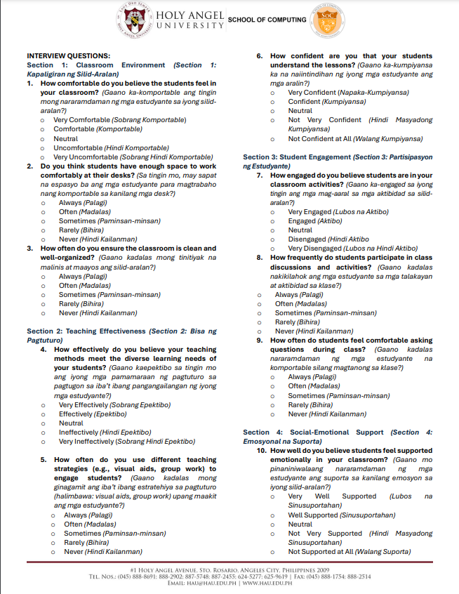

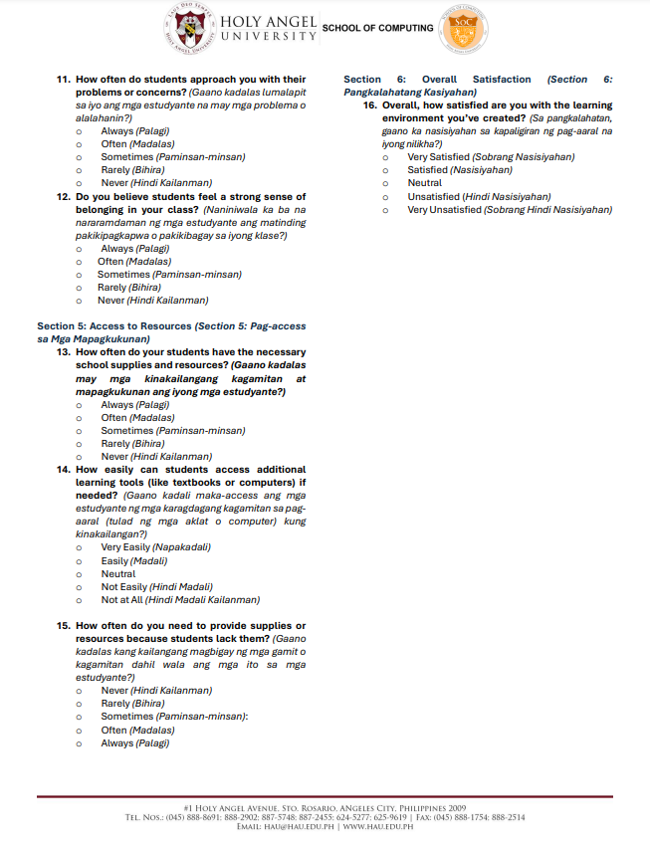

**Appendix C**

**Interview Transcript with Artificial Intelligence (AI) Professional**

Name of Interviewee: Arian Yambao

Name of Interviewer 1: Gabriel Paolo I. Baltazar

Name of Interviewer 2: Carl Gabriel S. Yap

Location of Interview: Messenger Video Call

Date of Interview: July 30, 2024

**[Start of Transcript]**

**Interviewer 2**: Ok lang po ba if i-record ang interview and transcribe po namin?

**Interviewee**: Sure.

**Interviewer 1**: Hello, rinig po ba?

**Interviewee**: Hello, nawala ata ako.

**Interviewer 1**: Ay sorry sir naka mute pala po ako.

**Interviewer 1**: So gumamit po kami ng algo ng Random Forest Regression, so may questions lang po kami sa inyo, if ok lang po sa inyo.

**Interviewee**: Sure.

**Interviewer 1**: For the record, state your name.

**Interviewee**: Arian Yambao, director of AI. Experience is around 5 to 6 years.

**Interviewer 1**: Ok po so, yung question po namin sir is ano po yung pre-processing step na crucial na for preparing data for?

**Interviewee**: Ok so yung multi variants naman, I don’t exactly see.

**Interviewer 1**: We have 5 columns, Attendance, Financial Situation.

**Interviewee**: How did you measure those columns?

**Interviewer 1**: Umm sa ngayon po sir cino-construct po namin yung mga questions po para ma measure yung mga factors.

**Interviewee**: I was really wondering how would you measure those, especially Financial Situations.

**Interviewee**: How many students will you get?

**Interviewer 1**: Around 80 – 100.

**Interviewee**: 100 is ok to start the thesis lower than that is not acceptable, If I read this title I’m making account all the students in the Philippines.

**Interviewee**: The problem might be the data itself, lower the case into one school or one city. Does the problem apply itself dito sa Pampanga?

**Interviewer 1**: Sa inyo po sir paano niyo po ma e-evaluate mga features sa pag predict po ng grades?

**Interviewee**: There is a metric on how to evaluate, in predicting. Accuracy is not always reliable, needs more specific and recoil, sabihin natin 90 out of 100 ilan don yung hinula lang niya or ilan doon yung ginawa talaga. Classification checks those.

**Interviewer 1**: So classification po no sir?

**Interviewer 1**: Yung output po kase Sir is yung grades po kase.

**Interviewee**: Pass or fail ba?

**Interviewer 1**: Meron po kaming, wait lang po sir.

**Interviewer 1**: Sir yung pong performance po kanita meron po kaming Outstanding, Very Satisfactory, Satisfactory, Fairly satisfactory, Did not meet expectations, meron din pong naka-kabit na remarks if pass or fail.

**Interviewee**: Pili ka lang kung gusto mo yung binary or multiclass classification, if gusto niyong mas challenging piliin mo yung multiclass, where 4 are positive and did not meet is yung negative, if mas madali naman yung pass or fail lang.

**Interviewer 1**: How do you interpret and improve the model performance if the initial results are not satisfactory?

**Interviewee**: Hyperparameter tuning.

**Interviewer 1**: So yung hyperparameter tuning sir iyon po ba yung parang train ng model po diba iyon po ba iyon?

**Interviewee**: Yes basically if you are not adept to Random Forest, if I remember correctly you have like number of trees or number of estimation you also have max depth, sample splits, the best thing to do is to research what type of hyperparameter for specific set of data. It’s gonna make Decisions Tree so if you are familiar with familiar trees parang pababa siya. If maliit lang dataset nyo it might be better to use less than 200 it looks like decision trees. And also if gusto niyo industry if failed siya ang sasabihin namin talaga is to try it on another model, but it’s not possible sa thesis kasi passed na ata ito so since wala ka namang magagawa you cannot switch models anymore. Put this in mind the final output of thesis doesn’t have the model perfect, pwede nga mag fail si model as long as you produce a research kasi that’s the whole purpose of research, but in the case of the model of your thesis, is failing yung performance you can then conclude that the findings of this research or thesis is failed yung model na to so we recommend not using it. Do that when it is not in existent yet, you might fail kapag sinabi nyong fail siya pero may nagsabi ng iba na research study cases na nag fail siya kasi it meant that you did not do sufficient research when you reference with other work that means you did not read the recent papers kase nangyari na iyon before wherein so the used this model and the said na it’s parang pangit yung model nato or wag gamitin itong model na to but they did not know it was already written 5 years ago so they failed their thesis pero yun lang in case kase baka mamaya kabahan kayo hala hala di siya gumagana or pangit nitong model kapag discuss then that’s a good research kasi you’ve proven na it failed. But you have to make sure that you tried it with different and you tried it with the hope of success.

**Interviewer 1**: Last question nalang po sir. Paano po mag deploy ng machine learning program model gamit po yung web? May mga suggestion po ba kayo paano po mag deploy?

**Interviewee**: Marami, pero do you have the PC specs ba, does it have GPU, pero if Random Forest pwede naman sa CPU.

**Interviewee**: Ok if that’s the case, try niyo yung TryRender sign up lang kayo don Render.com and or mas madali just run a StreamLit app, it’s just free may GUI narin iyon aralin niyo nalang you can run your model there, it’s just gonna be a background process just connect your GitHub its gonna run there free, you no longer need to run a Hiroku or whatever, pero if you want a hard route then of course make a Fast API and then deploy that then make your GUI. Ayun, so if you use your StreamLit, click niyo lang yung deploy co-connect niyo lang yung GitHub. Pero if gusto niyo na mag practice deployment talaga then. Oh nawala siya, ok si Carl nalang naririnig pa ba niya ako.

**Interviewer 2**: Opo sir opo, opo naririnig po.

**Interviewee**: Ok so I will just continue with you, but if you use StreamLit di niyo na need mag deploy ng render. But if gusto niyo ng render free rin naman iyon pero you need to separate it.

**Interviewer 2**: Sige po sir, yung pong render and StreamLit ano po mga iyon?

**Interviewee**: So si StreamLit is more of a framework, pinadaling framework so pwede na iyon para sa thesis, si render naman it can actually be use in the industry, si render kase super hybrid siya na free na deploy you can make your server there for free may CIDT integrations narin sila so good siya, so any changes you do on your github repository kunyare may update kayo just do GitPush and you no have to redeploy it it will already redeploy on it’s own.

**Interviewer 2**: Sige po sir, i-research po naming dalawa.

**Interviewee**: Yeah go study it kasi it will also be used in the industry kaya try it.

**Interviewer 1**: Ok po sir nawala lang po ako kanina pero naka record naman po

**Interviewee**: Ok, anything else?

**Interviewer 1**: Sa ngayon po sir iyon muna po sir thank you po.

**[End of Transcript]**

**Appendix D**

**Interview Transcripts with Website Development Professional**

Name of Interviewee: Joshua Edwin B. Dela Rosa

Name of Interviewer 1: Gabriel Paolo I. Baltazar

Name of Interviewer 2: Carl Gabriel S. Yap

*1st Interview*

Location of Interview: Messenger Video Call

Date of Interview: July 30, 2024

**[Start of Transcript]**

**Interviewer 2**: Hello po sir pwede po bang record and transcribe?

**Interviewee**: Sure.

**Interviewer 1**: For the record po sir, ask ko lang po full name niyo po?

**Interviewee**: Joshua Edwin B. Dela Rosa.

**Interviewer 1**: Current field of position po in Web Development?

**Interviewee**: Current Office manager but have been a project manager for almost slide on to development for 8 years.

**Interviewer 1**: How many years of experience po?

**Interviewee**: I’ve been in the company ever since, so around 9 years.

**Interviewer 1**: Ok po nice.

**Interviewer 1**: Mag a-ask lang po kami about sa thesis po naming about po sa aming web app.

**Interviewee**: Sure

**Interviewer 1**: Yung web po naming ay nag prepredict po ng grades gamit po ang Random Forest and gusto lang po naming makarinig ng suggestion po and……

**Interviewee**: Can you repeat the main topic of your research?

**Interviewer 1**: Prediction of grades po and academic performance po so gumamit po kami ng Random Forest sir share ko po iyong nagawa kong web app which hindi pa po final.

**Interviewee**: Ok.

**Interviewer 1**: Kita po ba sir?

**Interviewee**: Yes.

**Interviewer 1**: First question sir pano po namin ma-improve yung overall user experience para po sa web app namin.

**Interviewee**: Is this the only screen or meron paba?

**Interviewer 1**: Ito lang po sir.

**Interviewee**: Ok.

**Interviewee**: Bali ang use case nito is to input details on the left side and then malalagay yung prediction sa right side this is a single use entity where every time na kailangan nila input for every student they need to place it individually. Can you input some details? Let's say that is student A. Then click mo yung predict. Wala naba yan in terms of hindi mo na ba gagamitin yung data na currently inputted?

**Interviewer 1**: Gagamitin po sir.

**Interviewee**: Pero currently walang sort of database kung saan masasave yung grades right?

**Interviewer 1**: Wala pa po sir, kung baga parang testing palang po sir.

**Interviewee**: Pero magiging part din iyon no?

**Interviewee**: Kasi sa visual part, more likely iyon yung requirement para makita mo dapat yung per student ba or para connected yung values, kase currently parang online calculator yung dating.

**Interviewer 1**: Opo opo ok po.

**Interviewer 1**: May experience po ba kayo sir when developing a machine learning web app po sir ganun po?

**Interviewee**: Uhh let me think, I don’t think it’s use for most business na nagpapagawa ng website, so usually ginagawa naming ay scope ng kailangan. So for example meron silang product calculator or kung ano man yung need nila regarding commerce. Kung may use man ang machine learning it’s mostly for SEO stuff and how to better yung website para maging siyang top ng search results, so I don’t think it applies on my end.

**Interviewer 1**: Ok po sir.

**Interviewer 1**: Kapag po sa mga ano sir ano po suggestion niyo po sa hosting services or platform na suitable po dito?

**Interviewee**: Hosting services pag ganon yung kailangan niyong I check is yung locale, sino ba gagamit as much as possible yung hosting platform na gagamiting niyo dapat kung saan malapit yung gagamit, if doon located mas mabilis yung input niya and output or kapag mag geget for API lets say API data, overall speed. Usually iyon yung kailangan niyong i-check usually sa paid platforms ikaw mamimili kung saan data server mo ilalagay. Ano pa kasi yung isa?

**Interviewer 1**: or Platforms po kasi what are some hosting services?

**Interviewee**: Platforms you mean what CMS or backend gagamitin mo, for simple things like this one I guess kahit minimal lang WORDPRESS would do pwede naman customize for what is needed, if gusto niyo rin ng combinations of platform and hosting VPN generator wordpress engine which also provides great speed mura lang ang cost. Since custom ang code niyo, it doesn’t really matter yung platform service it only depends when you need to input a lot of information on the backend, let’s say na editable yung fields na ito tas kailangan mong gumawa ng 10 pages of this one wherein you need to edit each page or each title, kailangan i-translate into multiple languages, I think that’s only where it’s going to make sense otherwise where it’s like an online pero thing wherein you input lahat walang masyadong backend input lahat iyon generated na not much need for complicated services or complicated solutions.

**Interviewer 1**: When it comes po ba sa pag dedeploy ng ganitong web app ano po ba yung principles niyo po para mas or may ma-rerecomend po ba kayong techniques or tools?

**Interviewee:** On my end it is crucial when it comes to deployment is testing, bago siya mapunta sa let’s say you when you are going to put it live, you need to make sure na nagkaroon kayo a way of testing like naka iterations ba kayo or naka waterfall or kung ano man ginamit niyong method, you need to make sure na yung scope ng software needs to run, iyon yung pinaka-una niyong kailangan gawin scoping is important because it makes the box of what you need to do. So let’s say itong app na to para san ba siya is it just for browser or pati mobile dapat accessible? If ever man accessible sa mobile which versions IOS lang ba siya or fit din sa Android? If fit siya sa android, which versions? Tapos I che-check niyo rin considered din ba ang tablet size or may iba pang specific sizes na isusuport? So things like those they get very intricate as you go along na dapat kailangan naka check lahat atleast if sinabi ninyo na browser lang ito tapos dapat full screen that blocks everything up para hindi na kayo mapupunan o bakit hindi gumagana sa mobile kase sinabi naming desktop lang does that make sense.

**Interviewer 1**: Opo sir, so parang kapag pagdating po doon dapat na aadjust po yung gumagamit.

**Interviewee**: Kung saan gagamitin so for example, wala kayong ini scope na area if for desktop lang siya or for mobile kase baka I check nila ito for mobile tas hindi siya responsive edi extra fixes sa end niyo.

**Interviewer 1**: Ok po sir.

**Interviewer 1**: When it comes to design sir kailangan po ba sir ok lang po ba yung simple lang po ba?

**Interviewee**: Yup, simple lang I think it just needs to serve its purpose when it regards to this one. Parang nasa online calculator look pa kasi kaya ang laki ng title niya diba. Pero I think you need a proper UI once you start let’s say may kailangan na siyang part na you can save student info, pero I don’t think it makes sense to have the title so big, so need niyo na magkaroon na ng menu or some sort of way para atleast lets say magkakaroon ba ng login per teacher, let’s say a teacher is going to use this can they create a login wherein lahat ng students nila they can keep track of what’s happening or is it a one time session.

**Interviewer 1**: Yung balak po naming sir is one time session lang po, pero ano po mas prefer ninyo if nasa case niyo po kame?

**Interviewee**: If I am in your hands, of course I would reach for what is available pero I think yung pinaka best use case nito is yung masasave yung info nila that way may database sila or history of what’s happening kaso that’s going to be a lot of work, so if gagawin man siyang online calculator I think you need to ay one time session only then dapat informative rin siya I guess so what you could do is to keep it this way and then add some documentation below, of how it’s calculated and some notes or inputs that might help paano naprepredict yung grades based of what I’ve input. Parang nakapag try naba kayo ng online calculators like tax calculator or SSS online?

**Interviewer 1**: Opo sir.

**Interviewee**: Diba mapapansin niyo yung mga websites na yon usually they try to teach you how to use it at the same time kasi nga one time use lang siya or one session use, as a user, they need to know how to use it, tsaka what’s it use for in one page hindi siya yung tool that a teacher uses everytime need niya mag log in para ma save yung info parang ganon.

**Interviewer 1**: Ok po sir, sa ngayon po sir yun lang po mga questions po namin and kapag meron pa po kaming further questions po sir mag chat nalang po kami.

**Interviewee**: Yep, sure mag ping nalang kayo sa messenger.

**Interviewer 1**: Thank you po sir.

**Interviewer 2**: Thank you po sir.

**Interviewee**: Yeah thank you.

**[End of Transcript]**

*2nd Interview*

Location of Interview: Google Meet

Date of Interview: September 22, 2024

**[Start of Transcript]**

**Interviewer 1**: Sir rinig po ba?

**Interviewee**: Yes rinig.

**Interviewer 1**: Doon po kami may problem sir, doon po sa may pag predict so sa tingin ko po sir kaya po siya ganon dahil po sa model namin, kasi po tinatry po naming mag work doon po sa nakuha po naming data which is 154 lang po.

**Interviewee**: Hindi ba magiging issue iyon mismo if panel na magtatanong sa inyo kasi main topic ng thesis niyo is predictive study and if may problema sa prediction results you guys are going to get grilled. Kailangan niyo siguro kasi kahit 150 lang yung data actually that’s simpler ideal is you play around and start with 0 then go with 5, gaya noong sabi ko before first thing na kailangan is to add tool tips or kahit guide man lang kasi currently nakakalito yung app sa first view, tapos if I could request palitan niyo yung color ng accordion kasi they are all blue and yung dating is parang parepareho sila or they all drop into a single drop of table whereas yung input or yung initial or kung yun yung current data, tapos yung sa ilalim change it into green or something else lalo na yung predicted grade. In regards naman to the actual info since i-cocontest nila yung prediction for sure that’s 100% na yung magagawa niyo is to cover the extremes muna since predictive ito you have to know when it is going to predict when something happen. For example, let’s say a student 80 yung grade niya binaba niyo lahat yung stats niya syempre kahit walang predictive app, ikaw ako masasagot natin yan magfafail siya masasagot natin yun. Magfafail siya yun yung magiging prediction hindi na kailangan I predict yon. Pero currently dahil I think there is something wrong with how it is being evaluated parang expect niya is passado parin siya kaya feel ko its mostly relying on GPA so parang nag minus lang siya ng certain numbers para hindi malayo yung predictive grade niya sa previous grade. So I think it would be a good thing to make sure if someone places in extremes kasi sa business kapag meron ganyan you always test the extremes to make sure it doesn’t break iyon yung quality assurance or quality control and I think iyon yung pinaka kailangan niyo dito. Check niyo muna sa extremes what happens if high grading student bigla siyang binagsak ng sobra bumaba yung financial pumangit learning environment niya tapos hindi siya pumasok weird din kasi na hindi ako makapag input ng 0, I think it’s showing as wala akong nilagay whereas that is technically possible diba for someone to enroll then never showup then yung weird din kahit di na siya pumasok dapat heavily reliant din siya doon sa attendance which is currently hindi nag shoshowup, so I think yun yung pinaka minimum na step at least for now to improve yung app kahit confusing yung inbetween kailangan niyong ma-cover yung extremes kasi kahit anong grade mo nung umpisa if bababa lahat ng stats mo you don’t need a predictive app to say na you are gonna fail, everyone is going to assume that already since it is a predictive app, I think it’s going to play around doon nga sa middle ground yun yung papakita sa inbetween, let's say this guy has great financial situation kaso pangit yung learning environment niya, does it affect it, currently wala akong makitang ganon numbers dito mostly the same yung numbers na lumalabas.

**Interviewer 1**: Opo sir, soo.

**Interviewee**: Iyon yung sinasabi kong need niyong ground and ceiling yun yung mga extremes para kapag tinanong kayo ng panel ninyo masasabi niyo na ito yung 0 what happens and 100 what happens meron na kayong start and finish tapos pwede kayo mag plot ng info inbetween since predictive ito unlimited naman yung pag submit ng info try niyong I plot yung lahat ng data makukuha niyo per situation from 0 to 100 para makita niyo yung range of what happens duon sa input kahit bawasan niyo muna non yung mga values niyo para atleast makita niyo lang kung ano yung nagiging main factor or ano dapat yung main factor.

**Interviewer 1**: Ok po sir. So yung sa web app naman po sir, yung mga kailangan ko lang po palitan is palitan ko po yung kulay.

**Interviewee**: Oo para hindi sila parapareho para clear na itong part na ito is yung student and predicted tapos yung first is yung input tas mas I showcase yung predicted grade kasi parang nangyari is bonus lang siya sa dulo. Tapos kahit konting guide lang kahit paalam niyo lang na yung 1 is yung lowest or something kasi by first look you’d know kung ano yung nangyayari. Kasi, kagaya duon sa attendance, kahit hindi ko kayo tanungin kaya kong i-input ng sarili ko yung values, kasi alam ko na yung isang column ay pang school days yung kabila is yung present whereas duon sa financial situation, for example radio slider lang siya or slider lang siya pero walang kahit anong input in between lalo na mahirap I explain ano difference ng 1.34 sa 1.35 saan niyo galing yung number na iyon, so change this into a drop down na may cinocover na range, otherwise you might need to defend sa panelist san galing yung value what makes a student 3.29 financial situation for example, also the same for the learning environment. Wag niyo rin pahirapan masyado sarili, kase baka kapag naka mood mga panelist niyo mahihirapan kayong sumagot.

**Interviewer 1**: Ok po sir, yung ano po kasi namin talaga sir is yung model po namin nung in-implement na po namin sa web app tapos ginamit na po yung trained model, yung nakikita po namin kapag nagprepredict na po kami halos 80 to 85 lang po.

**Interviewee**: Gawin niyo sa ganon try niyong kumausap ng teachers with existing data input niyo yung same data ng previous year doon sa current year, kasi both are available and then if yung predictor niyo is almost same doon sa ino-output duon sa existing data duon sa teacher is close at least meron na kayong parang ok its very close kasi ngayon wala kayong basis pati mga numbers na lumalabas they don’t make too much sense.

**Interviewer 1**: Ok po sir so yung kailangan ko muna pong ayusin ngayon sir is yung pag predict po talaga.

**Interviewee**: Yeah kase iyon yung title thesis niyo, sigurado yung panelist niyo doon sila mag fo-focus. You need to be able to defend kung ano man yung itanong nila na possible scenario or question and kailangan dapat meron kayong pagsagot. I get it it’s a predictive study or a predictive app, but since it’s a predictive app then you need to explain why it behaved this way. So kunware duon sa sample ko, let’s say nag thesis defense kayo and Ok paano itong student na ito, 90 yung grade niya last time kaso never na siyang pumasok, yung financial niya bumaba and learning environment niya bumaba, mahirap I explain na and hindi niyo pwede sabihin sa panelist na mahirap talaga siyang I explain, sa middle ground they won’t accept that you will need something concrete that is possibly based on facts, meron kayong mahuhugutan na reference similar to your documents, diba kumukha kayo ng reference para I prove yung point ng thesis niyo. Similar lang yan sa presentation niyo kailangan meron kayong explanation with regards to whatever is showing up in regards to the app.

**Interviewer 1**: So ngayon po sir try po naming ayusin po.

**Interviewee**: So let’s say gagamitin na talaga yung app, yung use case niya is matutulungan niya yung student na mag iba yung path based doon sa nakalagay dito. I think iyon yung kailangan niyong malagay na scenario, kasi yung student lets say 90 yung grade niya out of 150 days, 1 day lang siya pumasok tapos bumaba lahat ng stats niya tapos satisfactory paren yung grade niya, then I think something is wrong.

**Interviewer 1**: Ok po sir, thank you po sa time niyo sir and advice niyo po.

**Interviewee**: Advice ko pa sa inyo is paliitin yung scope niyo without ruining the title of your thesis, kase kapag lumiit masyado scope niyo papapalit title niyo or di-disqualify kayo kasi malayo na yung goal niyo sa title niyo. Yeah parang ganon.

**Interviewer 1**: Ok po sir salamat po.

**Interviewer 2**: Thank you po sa advice sir.

**[End of Transcript]**

**Appendix E**

**Interview Transcript on Factors affecting Academic Performance**

Name of Interviewee: Reachie Calalang

Name of Interviewer: Carl Gabriel S. Yap

Location of Interview: San Pedro Elementary School (SPES)

**[Start of Transcript]**

**Interviewer:** Hi maam, pwede kobang irecord para po ma transcript? Tagalog nalang po mode of language natin.

**Interviewee:** Ok sige.

**Interviewee:** Chineck ko yung mga rrl mo and nakita ko yung mga sinasabi mong factors kung bakit may chance na mag underperform ang student, sa public school mas maganda tignan mo ang learning environment o kung paano ka komportable ang estudyante sa school. Dahil public school kami, alam naman namin ang mga estudyante na isa lang cellphone para gamitin sa pagaaral tapos wala pa silang internet kaya mag papa load pa sila, may mga effects din kasi iyon. Meron nga tatlo silang magkakapatid grade 3, grade 2, grade 1 sila tapos hindi man sila binibigyan ng baon ng parents nila kaya kapag nasa room na sila nanahimik sila pero as a teacher kung makikita mo naman yon hindi mo kakayanin na hindi sila bigyan ng pagkain. Maganda rin sana sa factors niyo dahil meron kaming feeding program mga nutrition levels nila pero parang hindi niyo na scope yon dahil graduating or grade 6 students nalang kayo.

**Interviewer:** Opo maam, meron din po kaming health and mental factors na nakuha sa rrl na pwede maging factor.

**Interviewee:** Ang health, physical and mental hindi mo naman makukuha sa mga elementary students, ang mga factors nayan nag affect naman lahat ng tao pero mahirap siyang i-measure and mahirap din i-prove na ganon nga ang health niya kaya kase di ako sure sa research niyo kung kailangan niyo talaga iyon. Meron pa palang factor na nakita ko sa research niyo kaso mostly college students yung topic yung ngang financial factor. Dito sa DepEd, merong survey na ginagawa yung DepEd na tinatanong yung income ng parents nila.

**Interviewer:** Pwede po ba naming makita yung survey maam.

**Interviewee:** Kaso dahil DepEd research iyon, results lang pwede makita kasi hindi siya kamukha ng mga grades na kami yung gumagawa kaya kahit DepEd files sila dahil kami nag fill-up pwede naming i-share.

**Interviewer:** Ay kamalasan naman pala.

**Interviewee:** Ganyan talaga tsaka wala na yung mga paper na iyon kasi agad pinapass yon. Pero yung survey nila tungkol doon tinanong yung income tsaka parang overall satisfaction kung stable yaba o ali. Tagalugan munemu keng transcript.

**Interviewer:** Syempre maam.

**Interviewee:** So para matapos na, ang magandang kunin niyong data dito sa school na may informed consent ay yung learning environment pati financial. Yung grades and attendance dalhin mo nalang laptop mo para mabilis pero sesend ko rin files para may proof ka basta alam mo na kung paano i-confidential iyon.

**Interviewer:** Sige ma’am thank you, send ko nalang thesis after ma approve na lahat-lahat.

**Interviewee:** Oh sige galingan mu.

**[End of Transcript]**

**Appendix F**

**Survey Questionnaire**



**Appendix G**

**Informed Consent**

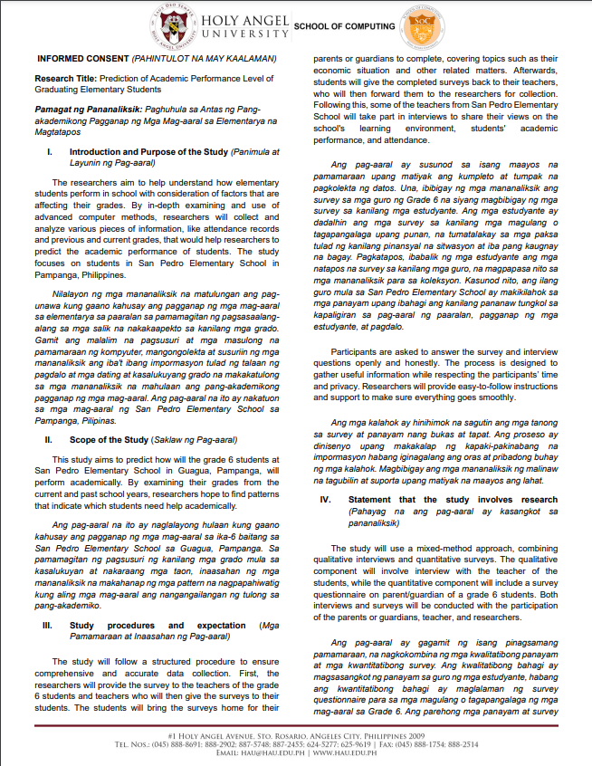

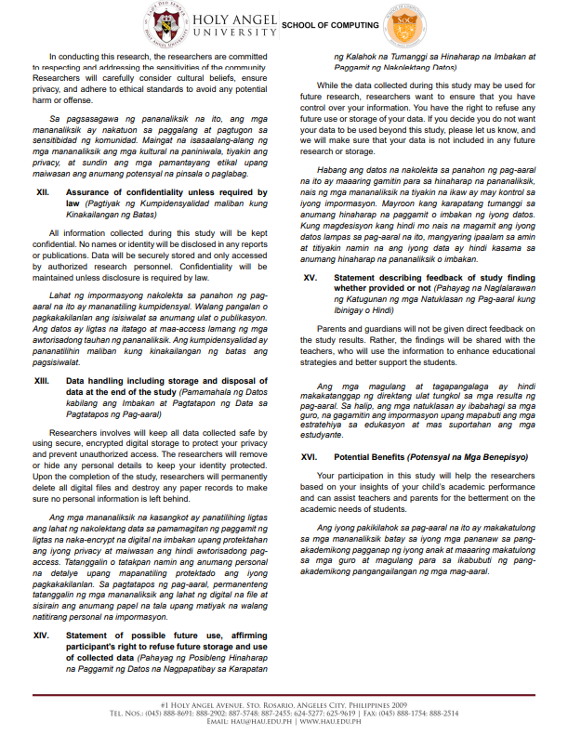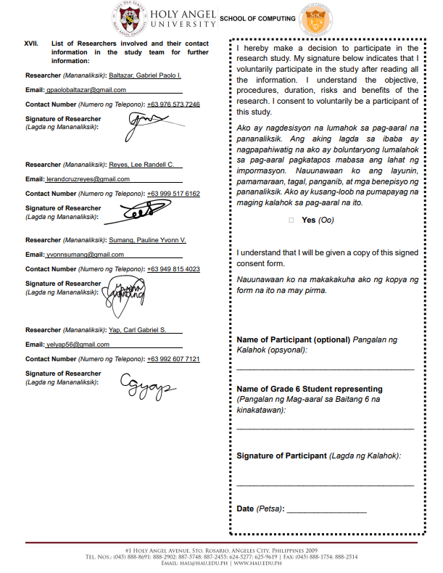

**Appendix H**

**Website Evaluation Questionnaire (Teachers)**

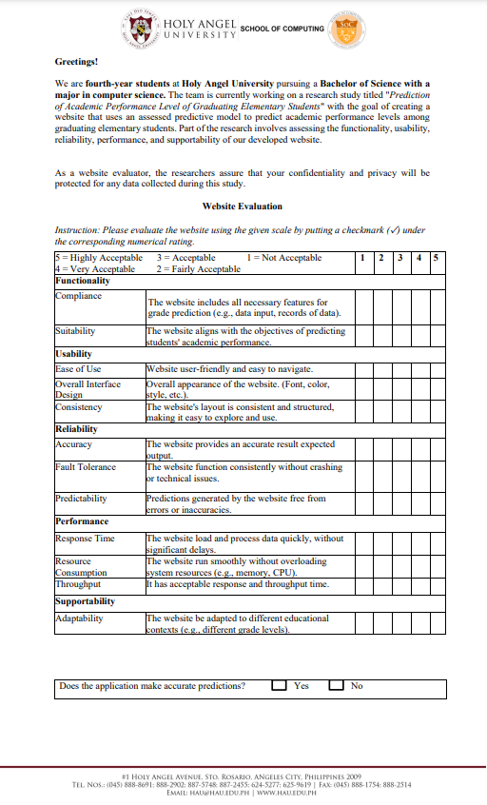

*Documentation*

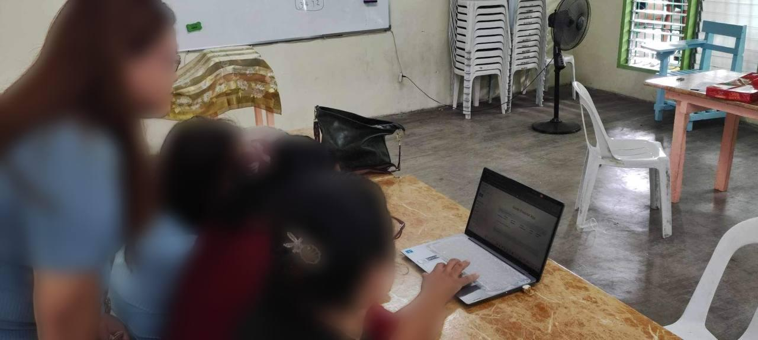

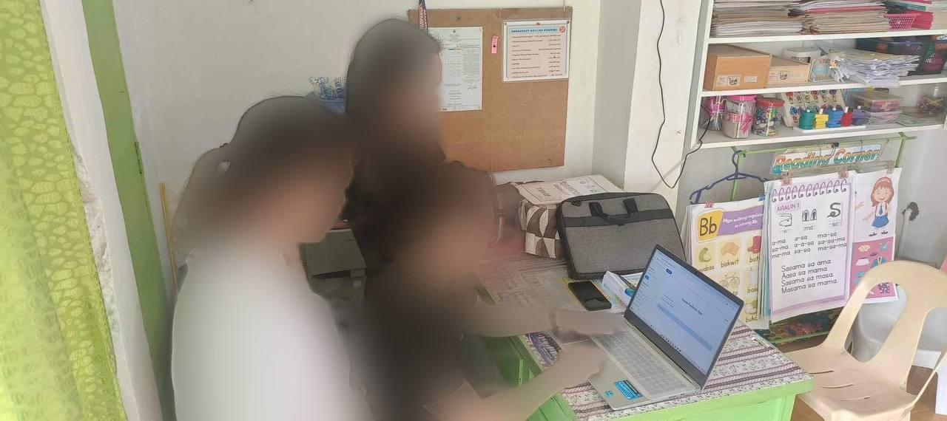

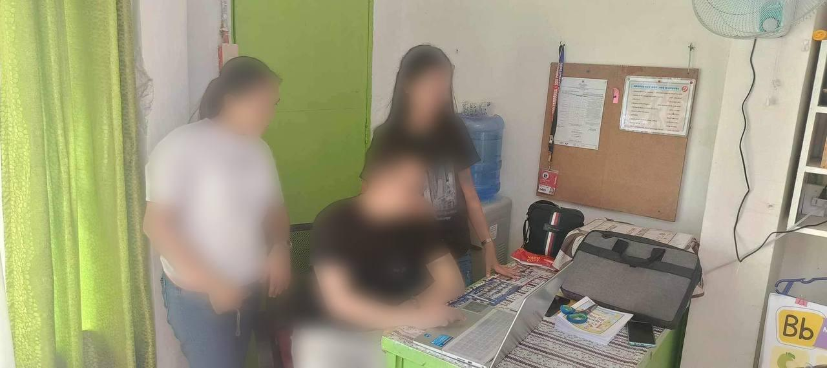

**Appendix I**

**Website Evaluation Questionnaire (Experts)**



**Appendix J**

**Project Description**

|  |  |
| --- | --- |
| **Project title** | Prediction for Academic Performance Level of Graduating Elementary Students. |
| **Purpose** | The purpose of this Grade Predictor App is to predict the academic performance of grade 6 students using a multi-level classification system. Moreover, the aim of this is to provide an administrative hub for teachers to early determine students’ academic performance and to adjust teaching methods, visual aids, and other learning materials. |
| **Target users** | The intended users of this Grade Predictor App are grade 6 teachers in general. |
| **Scope** | The aim of this Grade Predictor App is to predict the academic performance of grade 6 students using a multi-level classification system. This is achieved by creating a database of Grade 6 students from San Pedro Elementary School (SPES) for the school year 2024-2025, which includes data family financial situation, learning environment, their current and historical grades, and their class attendance that had been inputted into the system. |

**Appendix K**

**Software and Hardware Specifications**

*Development Requirements for the Website Application*

|  |  |
| --- | --- |
| *Hardware Requirements* | |
| ***Hardware Type*** | ***Specification*** |
| Computer / Laptop | |
| *Processor* | Minimum: Intel Core i5 (8th Generation) or AMD Ryzen 5 equivalent. |
| *Ram* | Minimum: 8 GB. |
| *Storage* | Minimum: 256 GB SSD. |
| *Graphics* | Minimum: Nvidia GTX 1650 |
| *Internet Connection* | Minimum Speed: 10 Mbps download / 5 Mbps upload. |

|  |  |
| --- | --- |
| *Software Requirements* | |
| ***Software Type*** | ***Specification*** |
|  | |
| *Operating System* | Windows 10/11, macOS Catalina or higher, or Linux (Ubuntu 20.04 or higher) |
| *Languages* | Python 3.x, JavaScript (ES6 or higher), HTML5, CSS3, and SQL |
| *Libraries*  *Services* | Bootstrap, Flask  Render |
| *Asset Provided / Editor* | Figma |
| *IDE* | Microsoft Visual Studio Code |

*Implementation Requirements for the Website Application*

|  |  |
| --- | --- |
| *Hardware Requirements* | |
| ***Hardware Type*** | ***Specification*** |
| Computer / Laptop | |
| *Ram* | Minimum: 8 GB. |
| *Storage* | Minimum: 256 GB SSD. |
| *Internet Connection* | Minimum Speed: 10 Mbps download / 5 Mbps upload. |

|  |  |
| --- | --- |
| *Software Requirements* | |
| ***Software Type*** | ***Specification*** |
| *Operating System* | Windows 10/11, macOS Catalina or higher, or Linux (Ubuntu 20.04 or higher) |

**Appendix L**

**Entity Relationship Diagram**

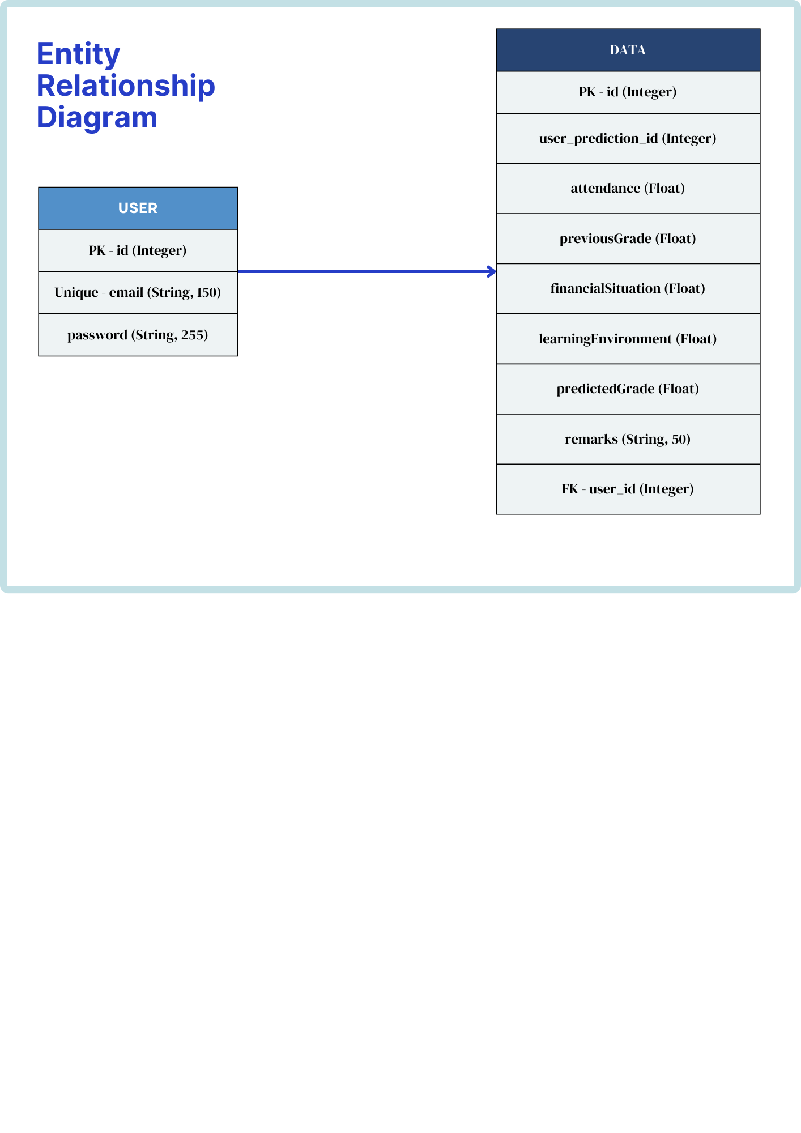

**Appendix M**

**JSON Schema**

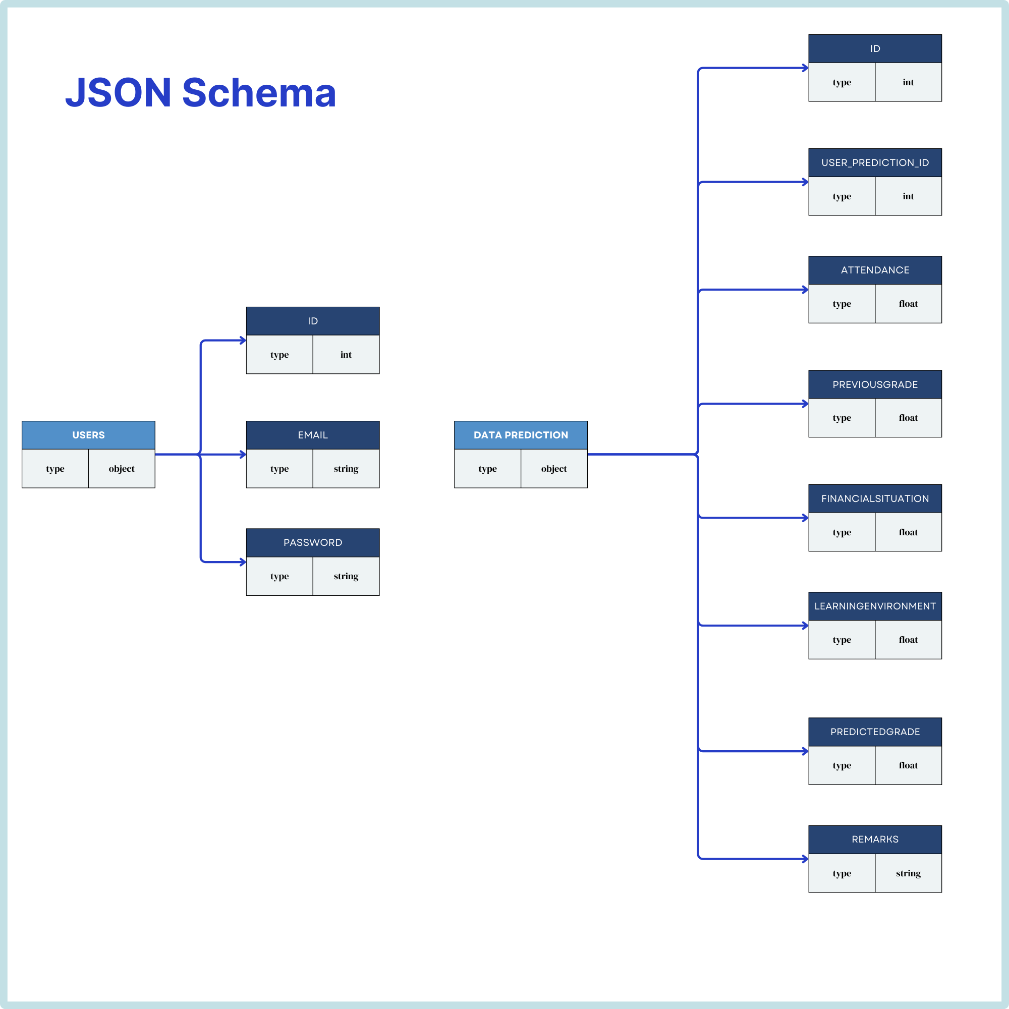

**Appendix N**

**Pseudocode**

**Website Application**

***Sidebar Toggle Functionality***

1. Initialize the buttons ‘toggleBtn’ and ‘toggleBtnCollapsed’ initialize ‘sidebar’ and ‘mainContent’ elements.

2. Add event listener for ‘toggleBtn’ click:

a. Collapse sidebar by adding ‘collapsed’ class.

b. Hide ‘toggleBtn’ and show ‘toggleBtnCollapsed’.

3. Add event listener for ‘toggleBtnCollapsed’ click:

a. Expand sidebar by removing the ‘collapsed’ class.

b. Hide ‘toggleBtnCollapsed’ and show ‘toggleBtn’.

***Slider Value Function***

1. Define function ‘updateSliderValue’ with ‘sliderId’ and ‘valueId’ parameters.

2. Retrieve the elements using IDs.

3. Add event listener for slider ‘input’ event:

a. Update ‘valueDisplay’ text content with the slider’s value.

***Initialize Sliders***

1. Call ‘updateSliderValue’ for each slider: ‘financialSituation’ and ‘learningEnvironment’.

***Form Submission and Prediction Handling***

1. Add event listener for form submission:

a. Prevent default form submission.

b. Retrieve values from factors.

c. Validate all required fields and display alerts if values are missed.

d. Calculate the percentage of the attendance by dividing ‘daysPresent’ by ‘schoolDays’

e. Create a data object with the form values.

f. Send the data to the Server via a POST request to ‘/predict’.

g. If there is an error, display error message.

h. If successful, update the first accordion with inputs and the predicted grades.

i. Update the second accordion with the student ID and predicted grades.

j. Display the predicted grades in the ‘prediction-result’ element.

***Styling: Sidebar and Main Content Layout***

1. Define styles for sidebar and main content.

2. Handle sidebar transition for collapsing and expanding.

3. Apply media queries for mobile view to adjust layout and handle sidebar.

Flask Login Handling

1. User submits the login form:

a. Retrieve ‘email’ and ‘password’:

b. Check if the user exists in the database.

i. If the user exists and the password is correct, the user is logged in.

ii. If the user does not exist or password is incorrect, display an error message.

2. Logout function

a. Log the user out and redirect to the login page.

***Flask Route for Prediction***

1. When ‘/predict’ is accessed:

a. Ensure user is authenticated, otherwise display an error message.

b. Parse and validate input data.

c. Use the pre-trained model to predict the grade based on input features.

d. Store the results in the database with a user-specific prediction ID.

e. Return the results and student ID as a response.

***File Upload and CSV Processing***

1. Handle file upload via the ‘/upload’ route:

a. Check if a file is provided and if its filename is valid.

b. Save the file in the ‘uploads’ directory.

c. Parse the CSV file and check if required columns are present.

d. For each row in the CSV:

i. Extract the features.

ii. Use the model to predict the grades.

iii. Store the prediction in the database with a user-specific ID.

e. Commit all new entries to the database and redirect to the home page.

**Appendix O**

**Flowcharts**

*Flowchart for the Web Application*

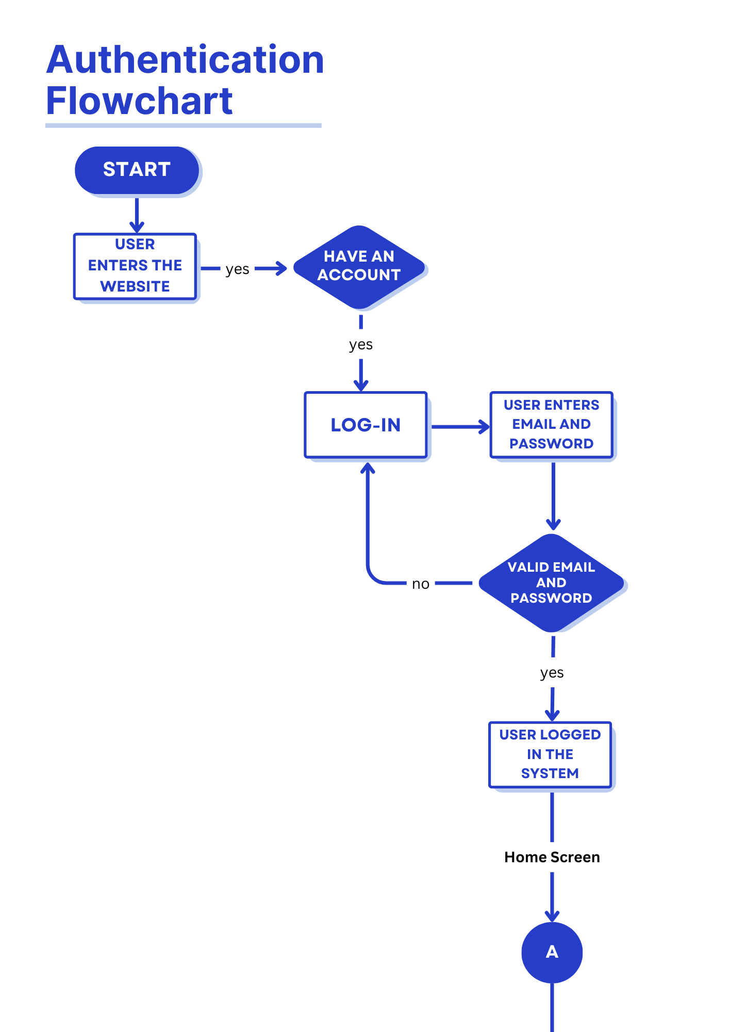

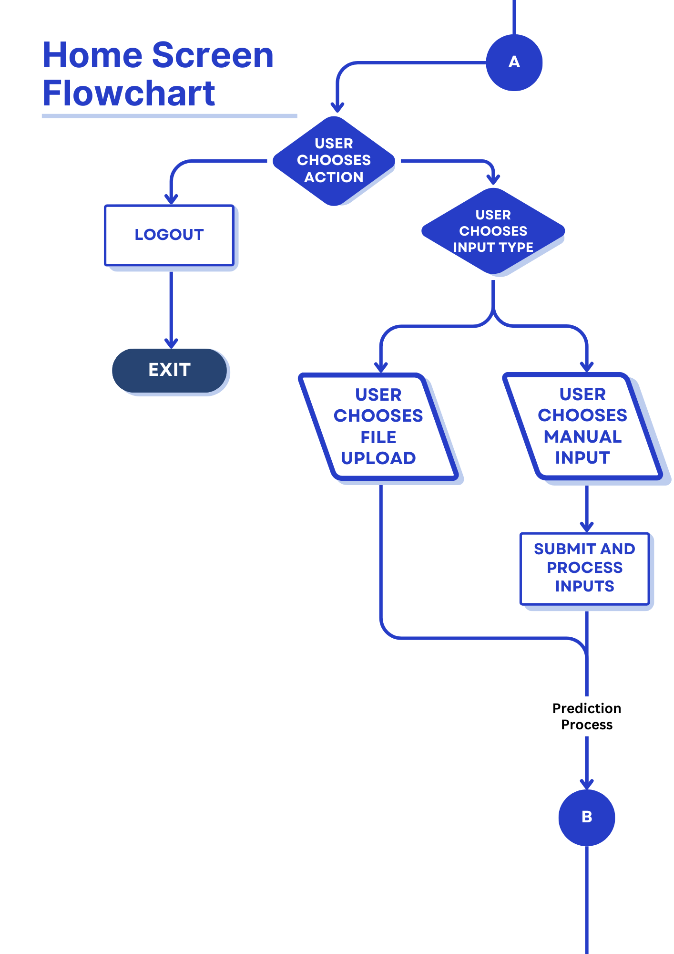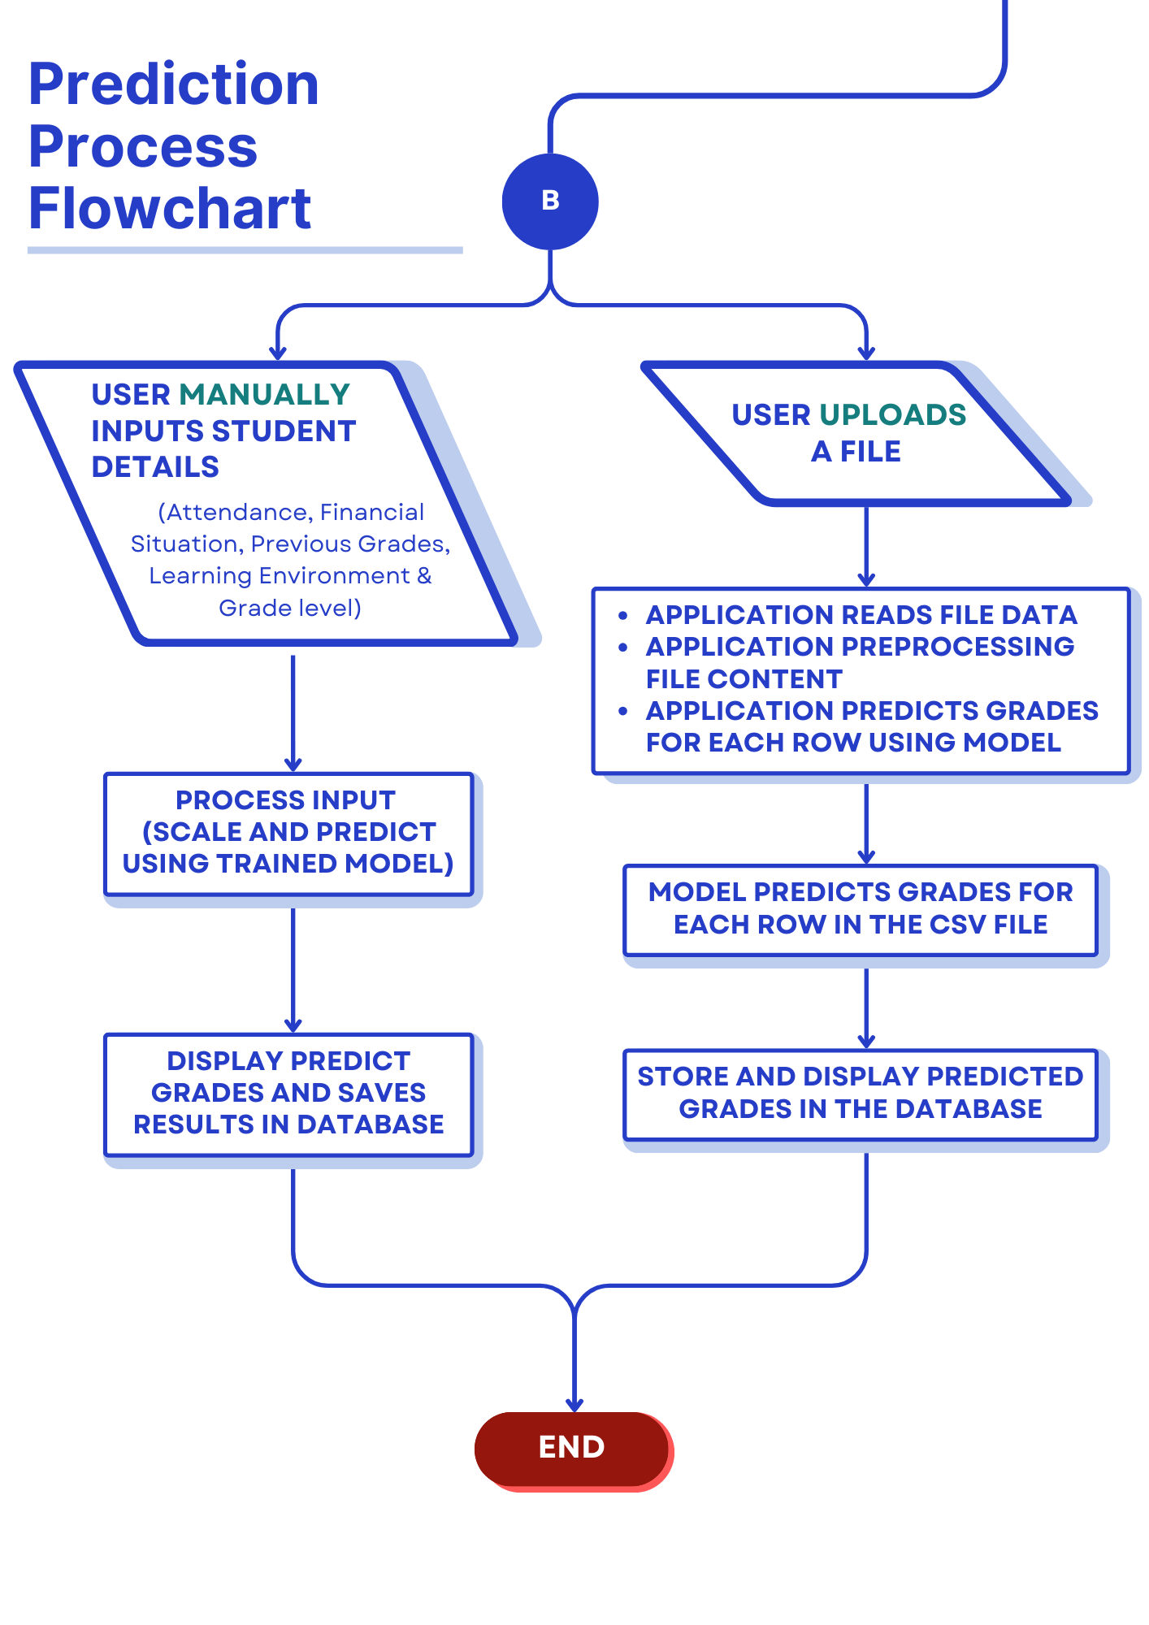

*Flowchart for the Algorithm*

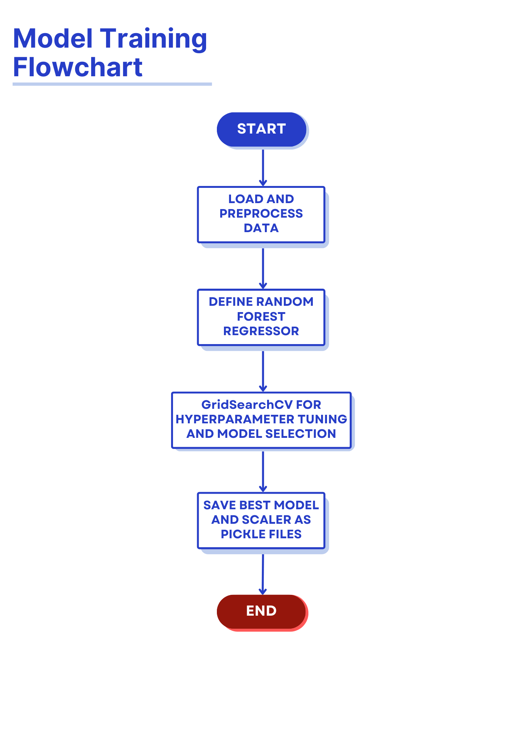

**Appendix P**

**Data Flow and Use Case Diagrams**

**Data Flow Diagram**

*Data Flow Diagram (Level 0 DFD)*

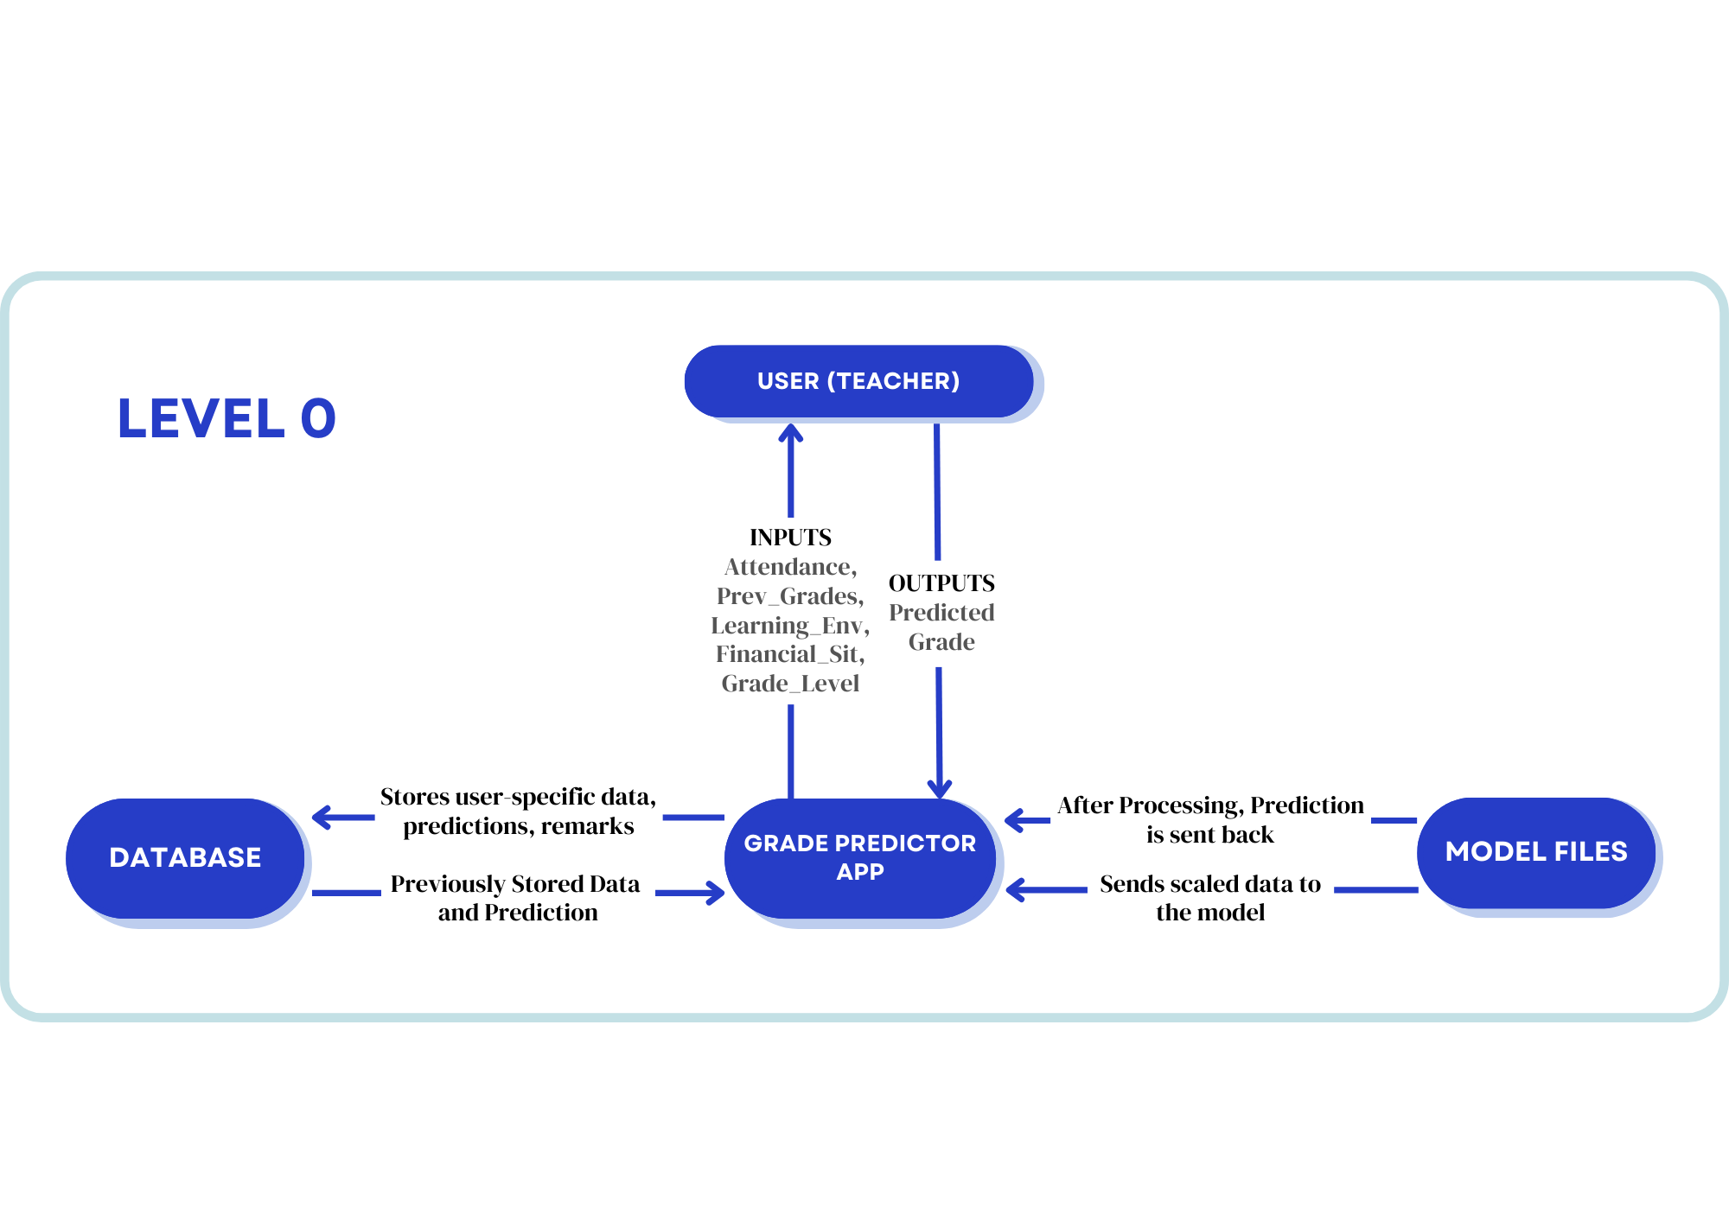

*Data Flow Diagram (Level 1 DFD)*

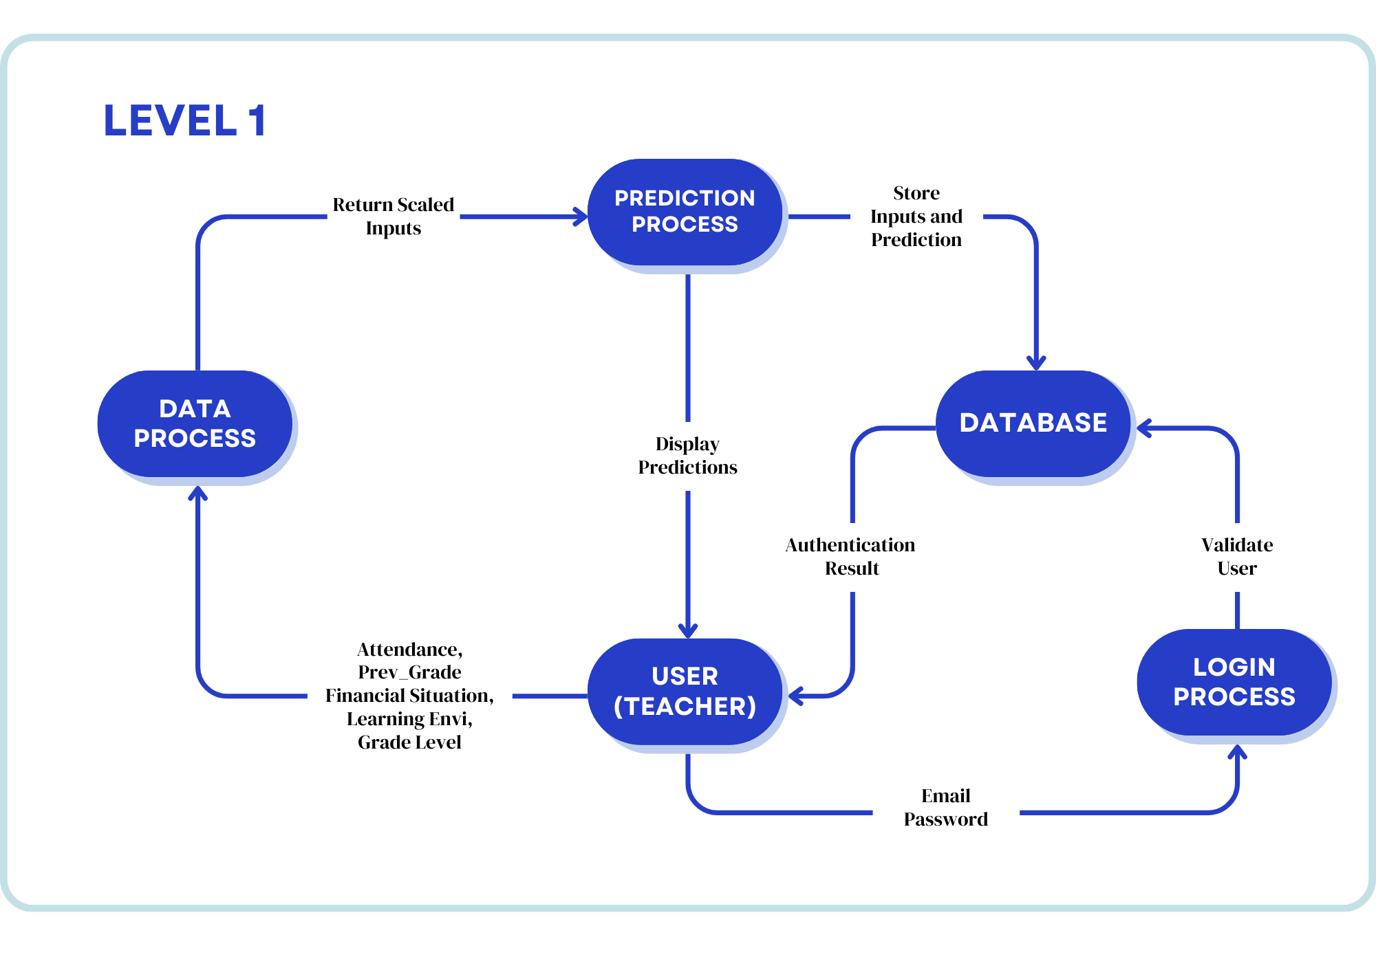

*Data Flow Diagram (Level 2 DFD)*

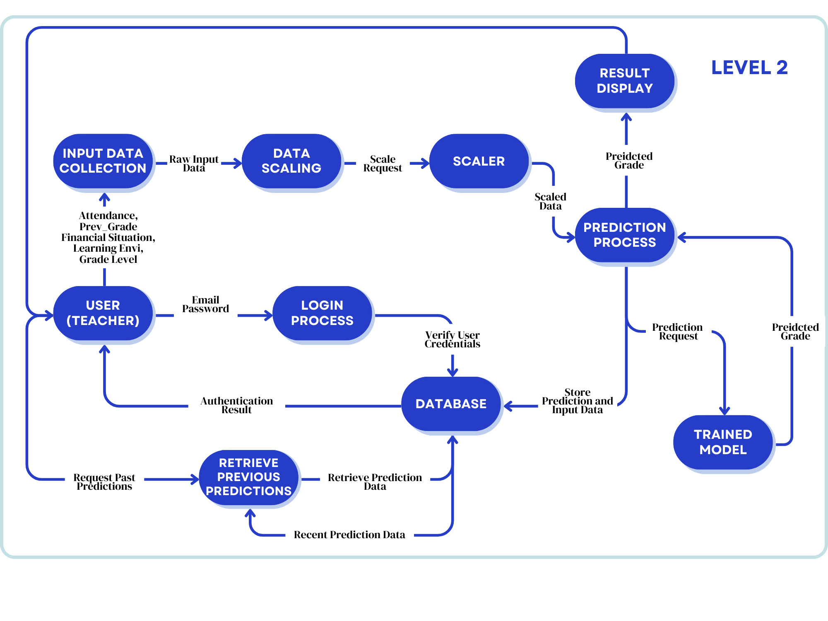

**Use Case Diagram**

*Use Case Diagram (Grade Prediction App)*

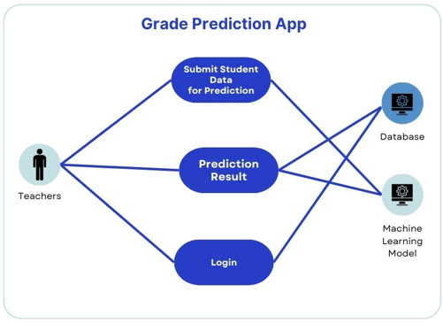

*Use Case Diagram (View Results Prediction)*

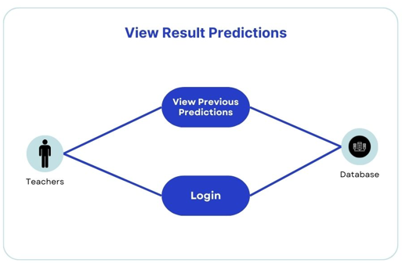

*Use Case Scenario 1 (Submit Student Information for Prediction)*

|  |  |
| --- | --- |
| **Use Case Name:** Submit Student Information for Prediction | **ID:** UC - 1 |
| **Actor/s:** Teachers, Database & Model | |
| **Description:**  The teacher submits the student information on their own choice which would be either manually or CSV upload for the system to process and return a prediction. The data is validated, scaled, and passed to the model for prediction. After these actions, the results would be stored in the database and displayed back to the teacher. | |
| **Trigger/s:** The teacher submits the data either manually or uploads a CSV file. | |
| **Precondition:**   1. The teacher must be logged in. 2. The system must be available for the data. 3. The model must be properly deployed. | |
| **Main Success Scenario:**  1. The teacher logs in.  2. The teacher chooses to either manually input or upload a CSV file.  3. The system validates the input data.  4. The system scales the input data using the scaler.  5. The scaled data is passed to the model.  6. The model predicts a student’s grade.  7. The predicted grade is displayed back to the teacher.  8. The system stores the data in the database. | **Extensions (Alternative Flows):**  **Invalid Data:**  if the data is incomplete or incorrectly formatted, the system prompts the teacher to correct the error.  **CSV Upload Errors:**  If the CSV is missing required columns or has the wrong format, the system rejects the file and notifies the teacher.  **Model Prediction Error:**  If an error occurred during prediction, the system notifies the teacher. |
| **Postconditions:**   1. The data are stored in the database. 2. The teacher views the predicted grade. | |
| **Exceptions:**  If the system is down or the model file has been corrupted, predictions cannot be made, and an error will be displayed to the teachers. | |

*Use Case Scenario 2 (Submit Student Information for Prediction)*

|  |  |
| --- | --- |
| **Use Case Name:** View Recent Predictions | **ID:** UC - 2 |
| **Actor/s:** Teachers & Database (SQLAlchemy) | |
| **Description:**  The teacher requests to view the recent student information and predictions. The system retrieves the stored records from the database and displays them back to the user. | |
| **Trigger/s:**  The teacher selects the option to view recent predictions. | |
| **Precondition:**   1. The teacher must be logged in. 2. Recent predictions must exist in the database. | |
| **Main Success Scenario:**  1. The teacher logs in.  2. The teacher requests to view the recent predictions.  3. The system queries the database for the stored predictions.  4. The database returns the records.  5. The system displays the stored predictions to the teacher. | **Extensions (Alternative Flows):**  **No Predictions Found:** If no predictions are found, the system notifies the teacher that no records exist.  **Database Query Error:** If the system fails to retrieve records from the database because of connection issues or corruption, the system displays an error. |
| **Postconditions:**   1. The teacher views the recent predictions. 2. The system completes the query and shows the teacher the recent predictions. | |
| **Exceptions:**  If the database is unavailable, the system is unable to retrieve the records and displays an error. | |

**Appendix Q**

**UML Class Diagram**

*UML Class Diagram*

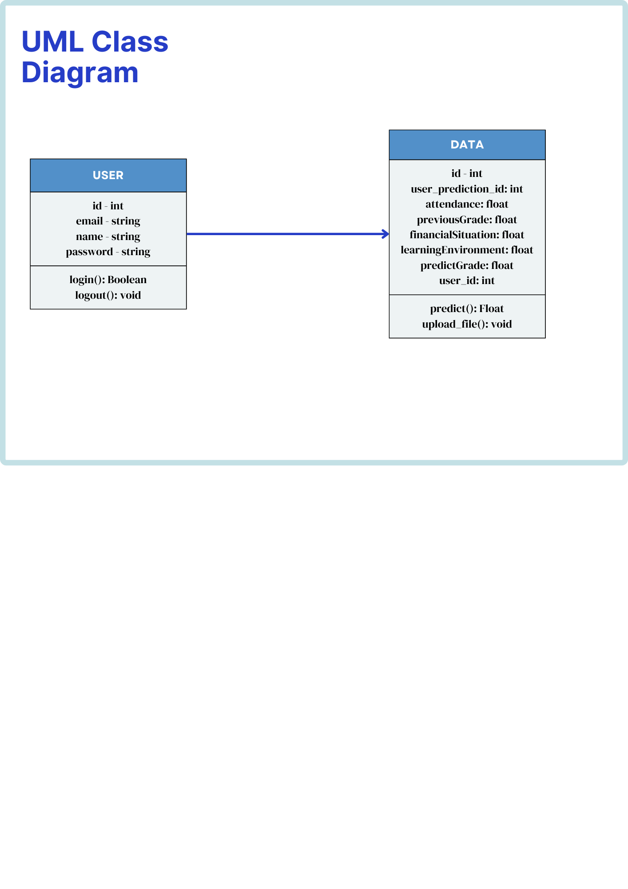

**Appendix R**

**Model Performance**

*Baseline Metrics*

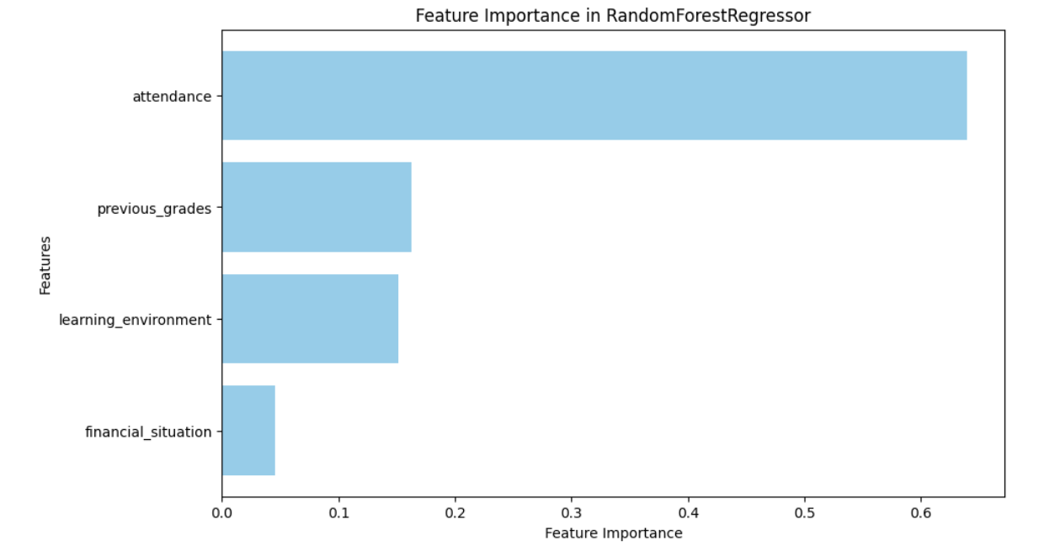

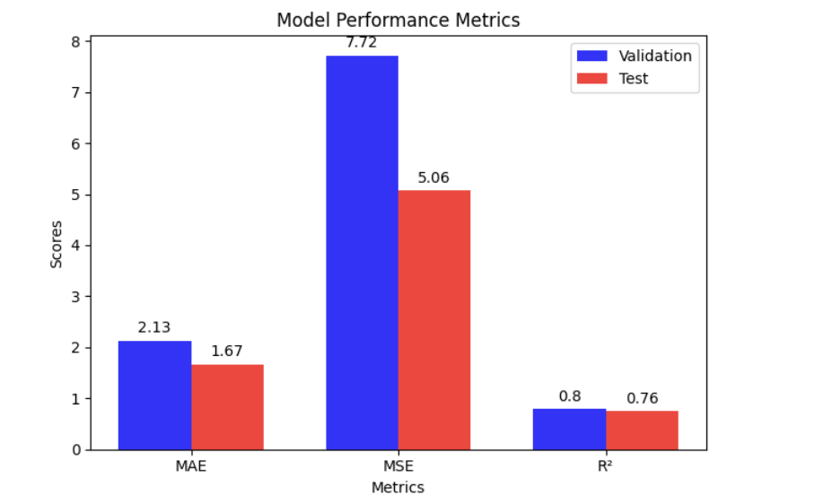

*Tuned Metrics*

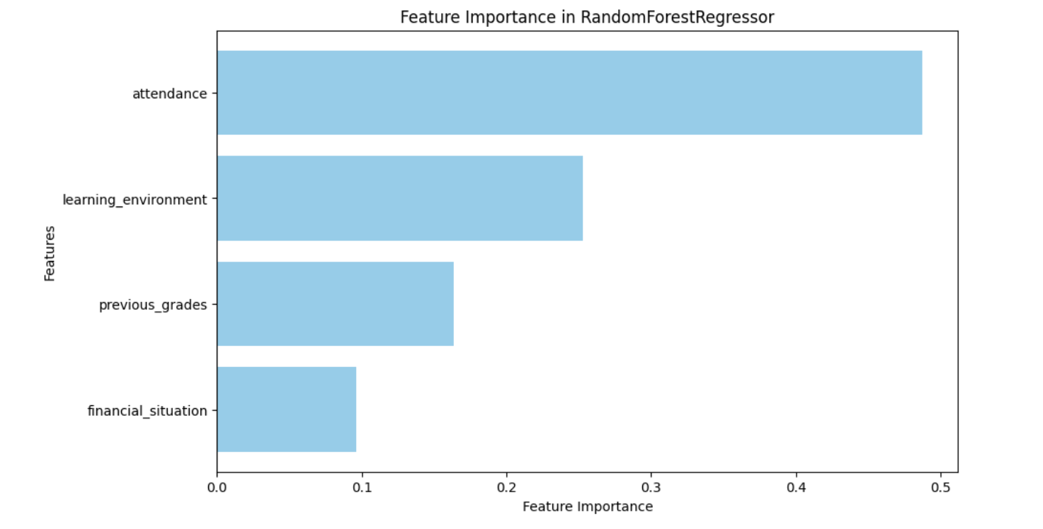



**Appendix S**

**Project Schedule**

*Work Breakdown Structure (WBS)*

|  |  |  |  |
| --- | --- | --- | --- |
| **#** | **Process** | **Predecessor** | **Duration (days)** |
| **Phase I: Planning** | | | |
| 1.1 | Group Creation and Brainstorming | N/A | 14 |
| 1.2 | Research Titles Proposal | 1.1 | 14 |
| 1.3 | Paper (Chapter 1): Proposal | 1.2 | 24 |
| 1.4 | Paper (Chapter 2): Proposal | 1.3 | 26 |
| 1.5 | Final Proposed Paper | 1.4 | 31 |
| 1.6 | Manuscript and Video Presentation | 1.5 | 31 |
| 1.7 | Proposal Defense | 1.6 | 1 |
| 1.8 | Proposal Revision | 1.7 | 8 |
| 1.9 | Proposal Submission | 1.8 | 2 |
| **Phase II: Project Preparation, Coding, and Implementation** | | | |
| 2.1 | Design and Planning | 1.9 | 18 |
| 2.2 | Model Structure | 2.1 | 28 |
| 2.3 | Meeting with Thesis Adviser | 2.1 | 5 |
| 2.4 | Data Collection Preparation | 2.3 | 22 |
| 2.4.1 | Data Gathering | 2.4 | 15 |
| 2.4.2 | Data Finalization | 2.4.1 | 15 |
| 2.4.3 | Data Analysis and Pre-processing | 2.4.2 | 8 |
| 2.5 | Troubleshooting and Debugging | 2.2 | 7 |
| 2.6 | Model Training | 2.5 | 4 |
| 2.7 | Website and Model Development | 2.6 | 3 |
| **Phase III: Project Testing and Deployment** | | | |
| 3.1 | First Iteration Testing | 2.7 | 7 |
| 3.2 | Second Iteration Testing | 3.1 | 7 |
| 3.3 | API Testing | 3.2 | 7 |
| 3.4 | Application Documentation | 3.3 | 10 |
| 3.5 | Website Deployment | 3.3 | 3 |
| **Phase IV: Reporting** | | | |
| 4.1 | Data Analysis | 3.2 | 4 |
| 4.2 | Report Writing | 4.1 | 3 |
| 4.3 | Thesis Defense | 4.2 | 1 |
| 4.4 | Thesis Revision | 4.3 | 14 |
| 4.3 | Thesis Submission | 4.4 | 2 |

*Gantt Chart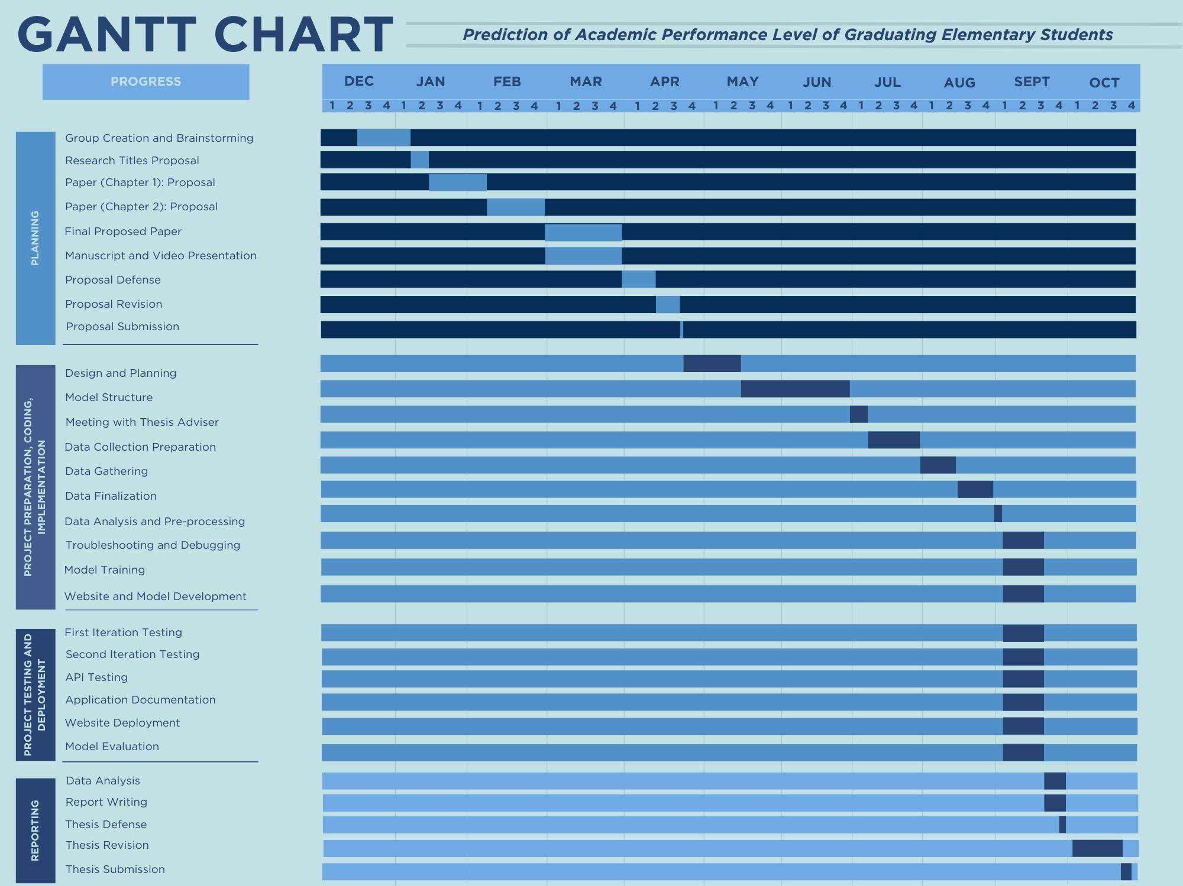*

**Appendix T**

**Predicted and Actual Grades**

|  |  |  |
| --- | --- | --- |
| **Student ID** | **Actual Grades** | **Predicted Grades** |
| 1 | 76 | 81.48 |
| 2 | 82 | 80.5 |
| 3 | 81 | 81.09 |
| 4 | 79 | 81.84 |
| 5 | 79 | 81.54 |
| 6 | 81 | 82.65 |
| 7 | 84 | 83.7 |
| 8 | 85 | 81.65 |
| 9 | 77 | 80.34 |
| 10 | 76 | 82.7 |
| 11 | 85 | 83 |
| 12 | 85 | 83.7 |
| 13 | 90 | 82.39 |
| 14 | 89 | 80.66 |
| 15 | 76 | 81.55 |
| 16 | 90 | 81.93 |
| 17 | 75 | 80.83 |
| 18 | 90 | 81.82 |
| 19 | 84 | 81.12 |
| 20 | 88 | 82.15 |
| 21 | 87 | 82.61 |
| 22 | 89 | 81.29 |
| 23 | 81 | 82.48 |
| 24 | 80 | 83.7 |
| 25 | 84 | 81.54 |
| 26 | 78 | 81.31 |
| 27 | 86 | 81.88 |
| 28 | 81 | 80.56 |
| 29 | 82 | 80.83 |
| 30 | 89 | 83.85 |
| 31 | 90 | 80.59 |
| 32 | 83 | 80.91 |
| 33 | 90 | 83.57 |
| 34 | 86 | 83.04 |
| 35 | 89 | 82.48 |
| 36 | 84 | 80.94 |
| 37 | 83 | 81.29 |
| 38 | 79 | 81.65 |
| 39 | 84 | 81.18 |
| 40 | 84 | 80.59 |
| 41 | 84 | 81.72 |
| 42 | 91 | 80.89 |
| 43 | 80 | 81.48 |
| 44 | 85 | 82.23 |
| 45 | 83 | 81.11 |
| 46 | 82 | 81.54 |
| 47 | 78 | 81.31 |
| 48 | 88 | 81.77 |
| 49 | 76 | 80.83 |
| 50 | 89 | 81.12 |
| 51 | 90 | 82.23 |
| 52 | 82 | 80.64 |
| 53 | 84 | 81.93 |
| 54 | 87 | 83.28 |
| 55 | 85 | 81.79 |
| 56 | 91 | 81.99 |
| 57 | 79 | 81.54 |
| 58 | 80 | 81.98 |
| 59 | 86 | 82.62 |
| 60 | 89 | 81.11 |
| 61 | 88 | 80.91 |
| 62 | 83 | 81.31 |
| 63 | 84 | 83.01 |
| 64 | 85 | 80.74 |
| 65 | 90 | 81.79 |
| 66 | 92 | 81.18 |
| 67 | 77 | 81.97 |
| 68 | 81 | 81.39 |
| 69 | 80 | 81.93 |
| 70 | 84 | 83.36 |
| 71 | 75 | 82.15 |
| 72 | 87 | 83.09 |
| 73 | 89 | 81.28 |
| 74 | 82 | 81.77 |
| 75 | 86 | 82.12 |
| 76 | 85 | 80.74 |
| Average | 83.92105 | 81.77342 |

**Appendix U**

**Experts’ Curriculum Vitae**

*Website Development Professionals*





**

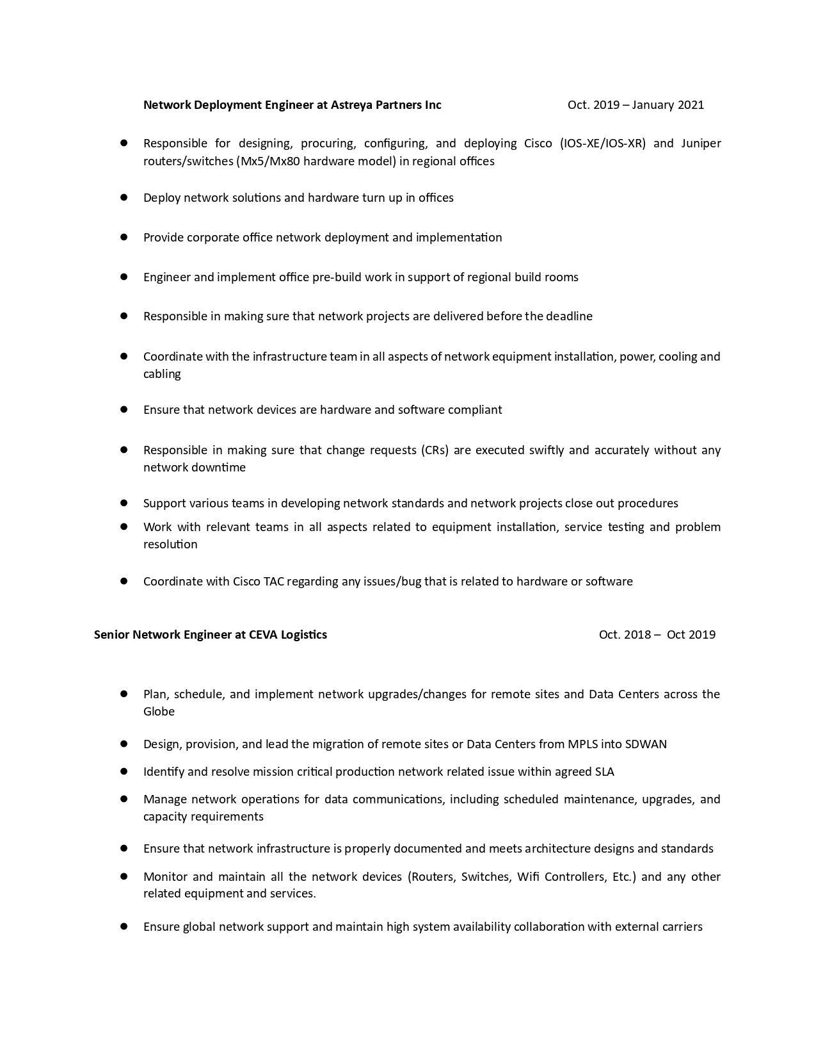

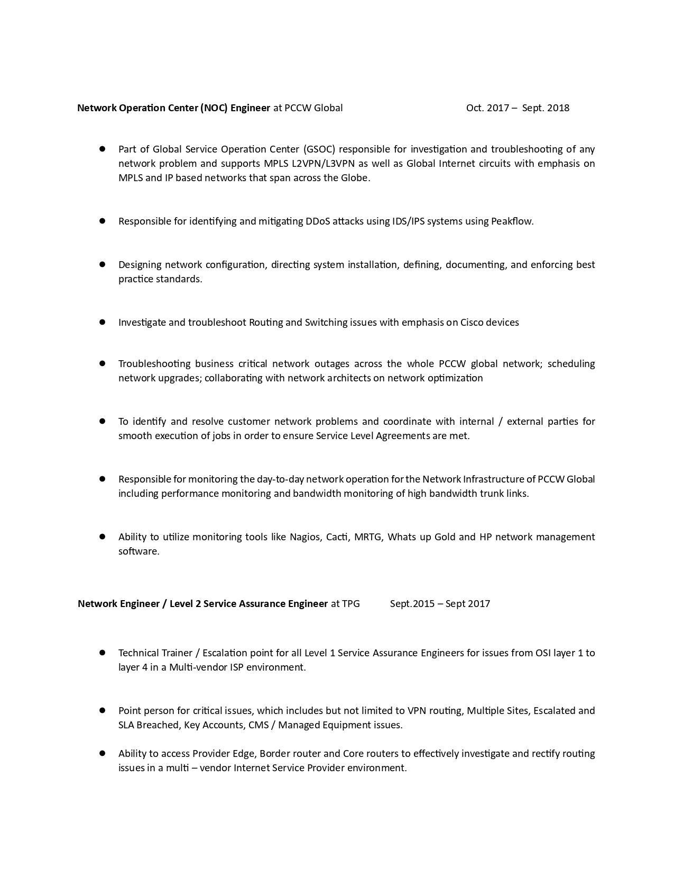

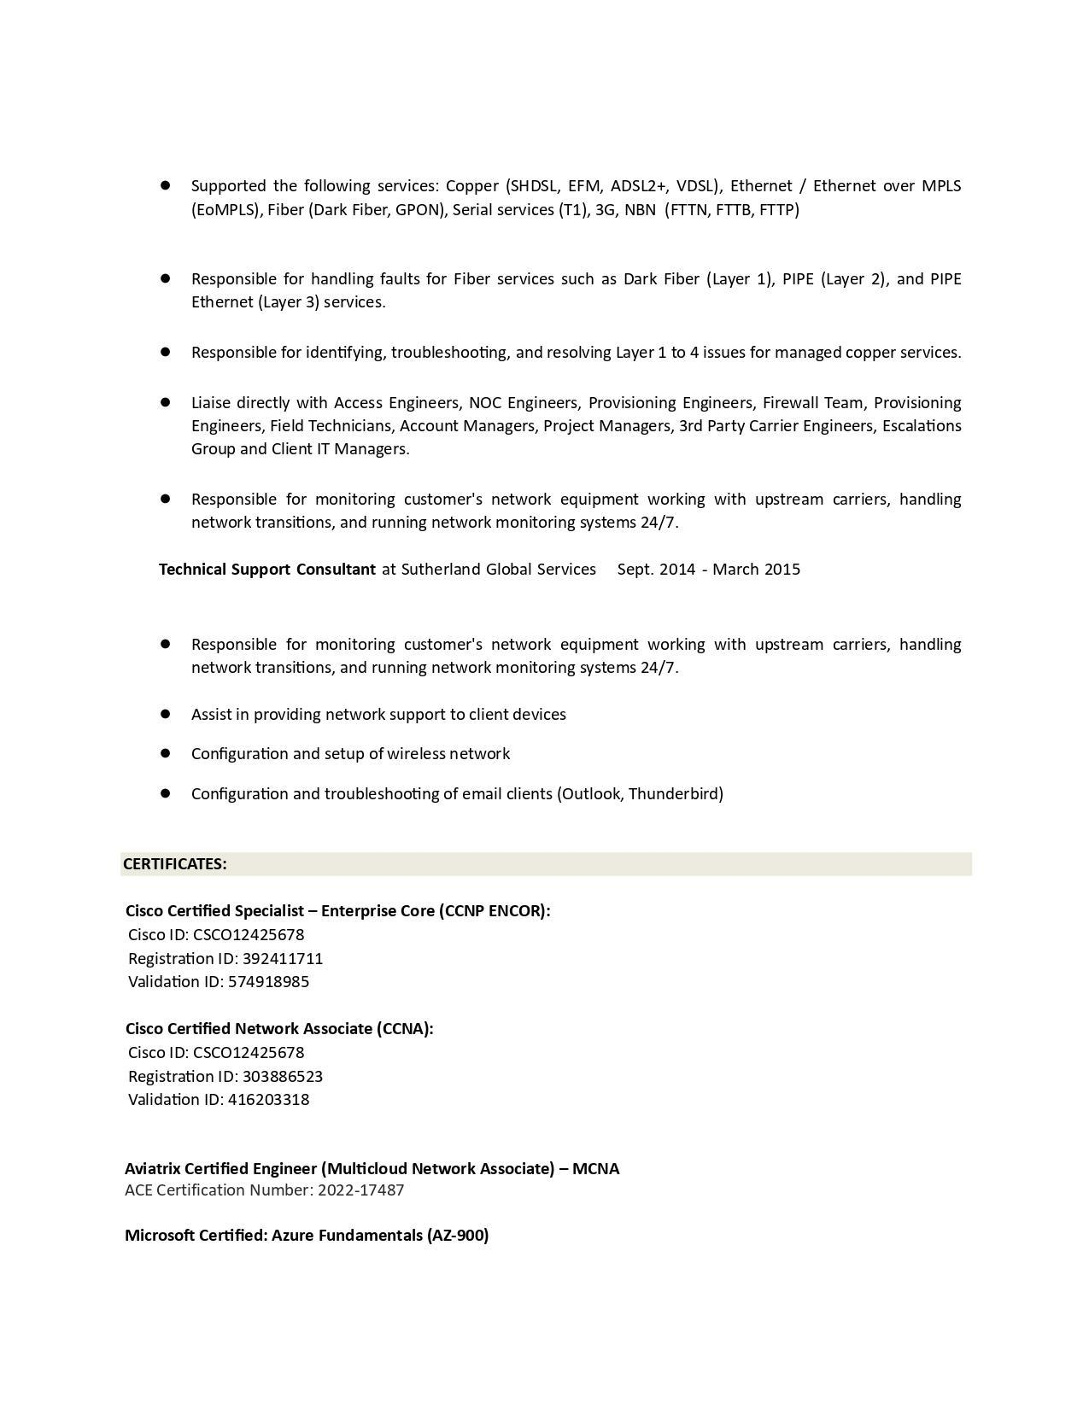

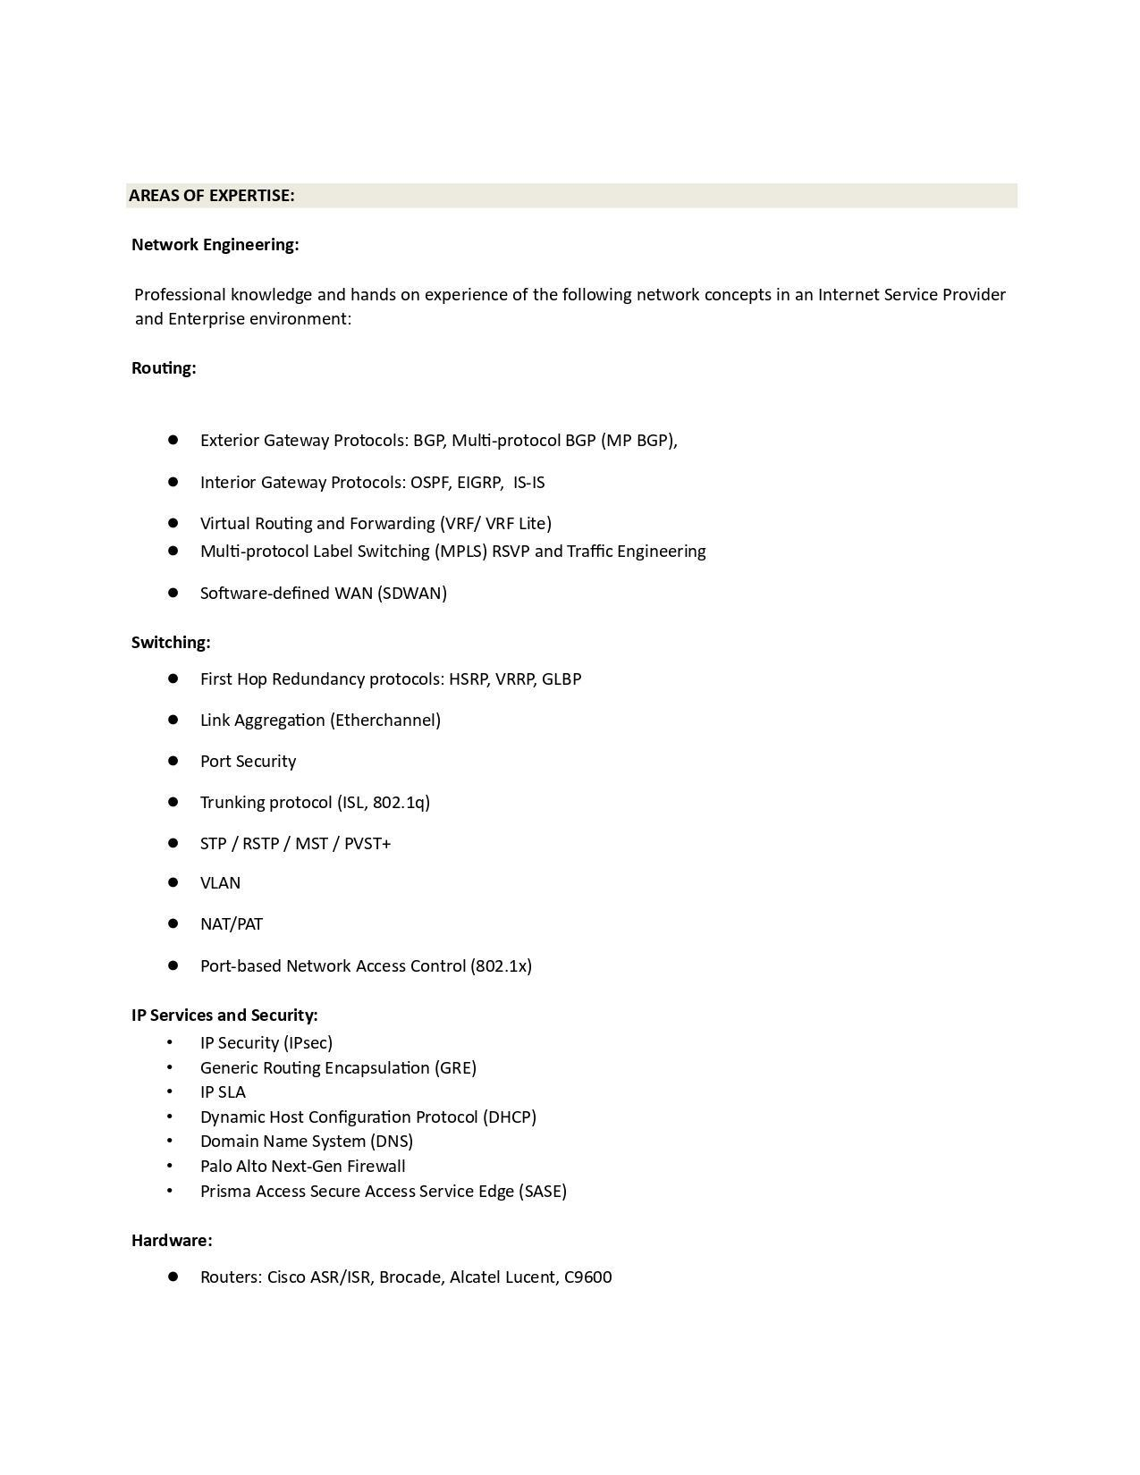

**

*Artificial Intelligence Expert*

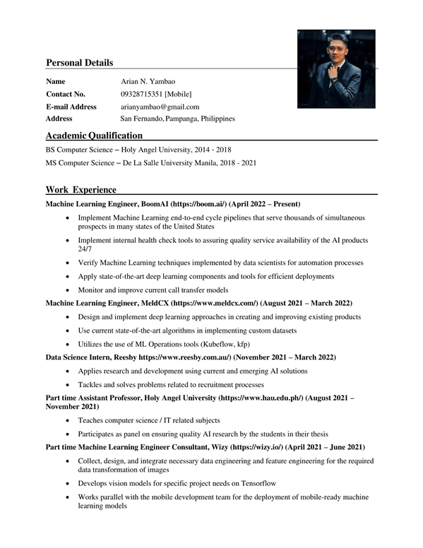

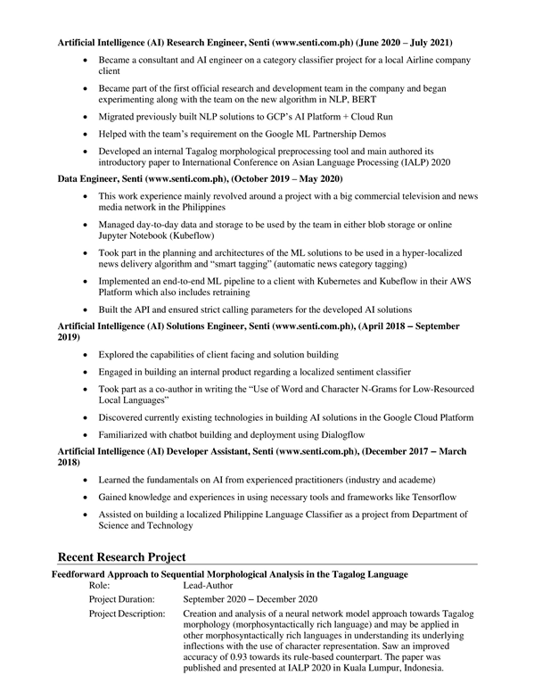

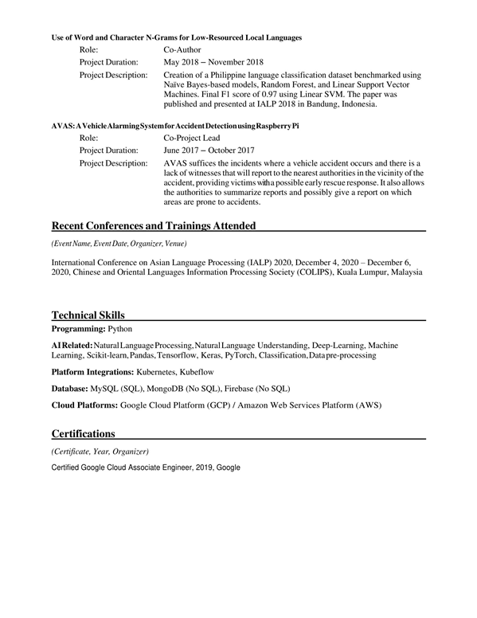

**Appendix V**

**Editor’s Note**



**Appendix W**

**University Plagiarism Certificate**

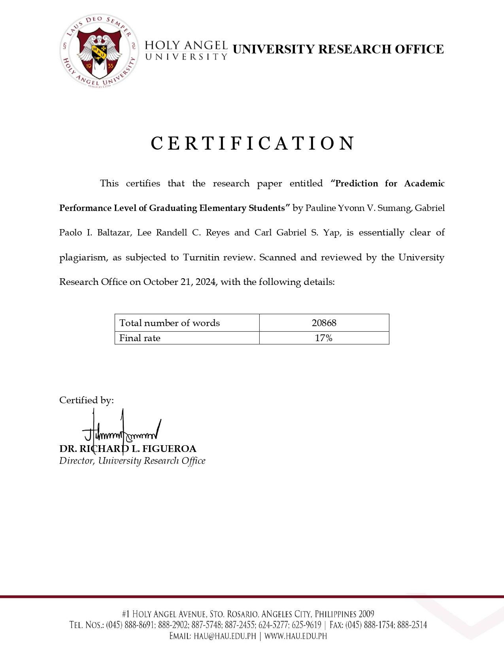

**Appendix X**

**Researchers’ Curriculum Vitae**



